TVA Projects

(Insert Contractor’s Company Name)

Safety & Health Plan

(Insert TVA Project Name and Number)
Approved By: Approved By:
Project/Site Manager |  | Date |  | Constructor Site Manager |  | Date
Reviewed By:
TVA Safety Professional |  | Date

Safety & Health Plan

(Insert Company Name)

(Insert TVA Location and Project Name)

Purpose
The purpose of this document is to provide guidance on the process for identifying Safety and Health hazards that could affect workers, procedures to prevent accidents, and steps to be taken when events occur on this project.

Scope
This plan will cover specific project workplace activities when contractors have direct TVA plant interface. It will cover how specific TVA Safety standards and OSHA requirements are to be applied during the project. It is understood that TVA Safety and Health procedures must be met at all times. You are responsible for subcontractors that you bring on site. (Exclusion - TVA’s Partner GUBMK will follow their current Safety and Health Plan format. Green field and Brown field sites will follow a different format as specified in TVA-SPP 18.004.)

Project Work Scope
  - (Insert - brief description of work to be performed. Include how many workers on site, outage duration in days and what shift rotation schedule is to be followed. Ex. 6 days x 10hrs or 5 days x 8hrs.)

Policy Statement
  - (Insert - your company’s Safety policy statement and include your company’s safety goals for this project.)

Responsibility & Emergency Notification
  - (Insert -list of responsible personnel and contact numbers who will be onsite. Include names for the following job classifications: project manager, construction manager, superintendent, foreman, safety lead or manager, nurse or person who will provide basic first aid or first responders and person who will provide training.)

  - (Insert -list of OSHA Competent personnel for this project. (i.e.,, confined Space supervisor, ATM testing, CPR, First Aid, personal fall arrest system, scaffold inspection, rigging, trenching/excavation, inspection of equipment, respiratory protection, cranes/derricks, concrete forms and shoring, demolition, lead and asbestos abatement. At least one competent person must be on site at all times when work is being performed.)

  - (Insert - describe how your management team and first-line supervisors will incorporate safety observations in the field. Also include how you will enforce compliance with all TVA and your company safety rules, )

Safety Orientation
  - The TVA Contractor Safety Orientation material will be reviewed with all contractors before beginning work. (TVA to provide safety orientation material.)
  - (Insert -List any additional topics to be covered in the safety orientation your company will provide.)

Safety Training
  - (Insert - list of OSHA required training that your company provides to your employees.)

Work Plans
  - (Insert - description of how tool box safety talks, daily safety messages, and weekly safety meetings will be performed on this project.)

  - (Insert- description on what work package and format will be used.)

  - (Insert - how your company will plan to use Job Safety Analysis’s [JSA’s] on this project.)

  - (Insert - describe how pre-job briefs will be conducted and include copy of format. Describe how the Two-Minute Rule card will be used.)

  - (Insert-description of how equipment removal and installation will be performed safely. Include safe start-up steps, if applicable.)

  - (Insert-description of controlling environmental hazards such as asbestos, lead paint, PCB’s waste oil or other hazardous materials. Describe where and how Safety Data Sheets will be maintained during this project.)

  - (Insert-description of safe handling and movement of material. Include established material laydown areas and location of tool crib. Identify crew lunch areas, restroom facilities, established smoking areas, gate access and parking for this project.)

  - (Insert-description of mobile equipment including type and size of units to be used. Also, include pedestrian control , operator visibility and spotter precautions.)

  - (Insert-description of rigging plans and approval process for rigging.)

  - (Insert-description of tool drop prevention plan. How employees will be protected when working below other workers.)

  - (No firearms, drugs or alcohol are allowed on TVA property. This includes parking lots. Also, seat belts are required in moving vehicle and mobile equipment. Please insert how your company will communicate to your employees and monitor compliance.)

Event Reporting and Investigations
  - All employees and subcontractors will be required to immediately report all injuries, no matter how small they appear, and near misses immediately to their supervisor. The supervisor of the employee will then immediately notify the TVA Project/Construction manager.
  - A written preliminary report must be developed and approved by the TVA project manager(s) within the injured employee’s work shift if possible, but no later than 8 hours after the event.)
  - The contractor will conduct a full investigation and provide a written final report to TVA outlining the description, apparent cause, and control measures to prevent a future event within 48 hours. The contractor will review the investigation report with their employees and incorporate key learnings into future pre-job brief for all employees.
  - (Insert - names and position of onsite personnel responsible for reporting events to TVA and issuing reports.)

Fire Prevention
  - (Insert-describe when bonding and grounding will be used to prevent unexpected electrical discharge of equipment or when handling solvents, flammables or combustibles.)

  - (Insert-describe how sparks will be controlled when grinding and welding. You must use the TVA Hot Work Permit.)

  - (Insert-describe method for properly labeling containers of flammables and combustibles.)

  - (Insert-location of designated smoking areas for project.)

Fitness For Duty
Managed task contractors shall provide their employees a fitness-for-duty examination to determine the workers’ ability to perform the task for which they are hired. Job offers should be made conditional upon successful completion of the medical exam. Medical exams to determine a workers’ ability to perform tasks associated with the work shall be applied uniformly to all entering employees in the same job category. This medical information shall be kept confidential.
  - (Insert - how your company will implement requirements for drug testing; random, for cause and post incident testing. Also, state how you will qualify worker’s ability to perform the task for which they are hired.

High Hazard Work
  - TVA requires documentation and communication to TVA management 24 hours before work begins on the attached 5 key topics titled High Hazard Work. (confined space, high hazard lifts, fall protection, arc flash/energized components, and fire protection. See attachments, when to report on these work activities.)

Housekeeping
  - (What steps will your company follow to keep work areas orderly and housekeeping adequate to prevent slips, trips and falls, potential fire hazards etc.?)

Human Performance Tools
  - TVA has 5 fundamental Human Performance (HU) Tools for contractors. They are; Pre-Job Brief, Two-Minute Rule, Stop When Unsure, Procedure Use/Adherence and Self Check. Your company is expected to incorporate these tools into your project work. You will receive training on these five HU tools.

Industrial Hygiene Sampling
  - (Insert - description of when and what samples will be collected to monitor employee’s potential exposures., including medical surveillance when required by OSHA, Ex. Welding/cutting/grinding on lead base paint, welding on stainless Steel for Hexavalent Chromium, etc.)

Inspections
  - (Insert - describe how often your management team, including first-line supervision, will conduct site safety inspections and safety observations on their employees.

  - (Insert - describe frequency of equipment such as rigging, fall protection, hand tools/extension cords, mobile equipment etc.)

Medical Facility
Managed task contractors must designate an occupational medical provider with the authority and ability to oversee injury assessment, care, and case management. This person and/or facility shall have authority to act on behalf of the contractor as the contractors’ Medical Director for all occupational medical care for contractor and subcontractor project employees. Case management shall include oversight and evaluation of initial care and therapy, development of return to work restrictions, and follow-up evaluations to ensure active case management. This person and/or facility shall be integrated into the contractors’ project-specific occupational surveillance, health, and safety program.
  - (Insert name, phone number and location of the nearest occupational health clinic. Include name of your worker’s compensation carrier.

Recordkeeping
  - (Insert - description on how you will record near misses, first aids and recordable injuries. TVA expects a weekly event summary report on injuries to the Project/Construction manager. See TVA form 21023 to be completed and submitted by COB Sunday of each week to the TVA Project/Construction Manager and email to TVA Safety at TVA_MTHSAFETY_HRS@tva.gov. Weeks will run from Monday to Sunday.)

Vehicle Safety
  - (Outline traffic patterns and pedestrian crossings. Summarize requirements for vehicle use on TVA property. Mandatory seat belt usage, backup alarms, non-smoking in vehicles and no-riding in the bed of the truck etc, use of ATV’s & UTV’s.)

Workplace Permits
  - (Insert - list of all critical permits to be used on project. i.e.,, hot work, confined space, scaffolding, rigging cards, trenching, clearance, etc. )

Zero Tolerance Policy
a) (Insert - describe your companies “zero tolerance” policy and your plan to handle corrective action on potential safety violations.)

TVA High Hazard Work - Confined Space Entry

TSP-801
Plant: |  | Unit: |  | Date:

Work Order:

Work Scope: (Include Name of Confined Space)

Confined Space Incident Prevention Checklist
Report All Permitted Confined Space Entries
Yes | No
 |  | Is this confined space listed on the plant site confined space log?
 |  | Has appropriate training been completed by all employees on their role in the confined space entry? (Entry Supervisor, Atmospheric Evaluator, Entrant/Attendant)
 |  | Have the appropriate Clearances been put in place to successfully isolate the space?
 |  | Have you verified that no "unplanned" chemicals or gases will be introduced into the space?
 |  | Has the TVA Hazard Evaluation Report been completed by Entry Supervisor?
 |  | Has the space been evaluated by an Atmospheric Evaluator using a calibrated air monitor to determine if ventilation is needed? (Atmosphere should be safe without relying on ventilation.)
 |  | Has the Entry Supervisor discussed hazards with the space or hazards with the work in the space created by all the scheduled work task?
 |  | Are the proper documents posted at the entrance of the confined space?
 |  | Has a rescue plan been developed and entry and non-entry rescue been reviewed?
 |  | Has a documented Pre-Job Brief been conducted with an approved JSA?
 |  | Has this form been submitted to the TVA Outage/Operations Team 24 hours prior to work starting?

Company/Supervisor’s Name

Management Official In Charge

TVA High Hazard Work - Crane Lifts

TSP-802
Plant: |  | Unit: |  | Date:

Work Order:

Work Scope:

High Hazard Lifts Incident Prevention Checklist
Report All High Hazard Lifts
Yes | No
 |  | Has a designated Crane Coordinator been selected for this lift?
 |  | Has the selected Crane Coordinator completed all required training for this designation?
 |  | Crane operator, rigger, and signal person all have completed appropriate training?
 |  | Have the crane coordinator, crane operator, rigger, and signal person reviewed the lift plan?
 |  | Is the High Hazard Lift plan documented on TVA form 17671?
 |  | Have items such as: load, stresses, support structures, lift, and swing paths been evaluated?
 |  | Has the load drop zone been clearly identified and properly barricaded to prevent pinch points and unauthorized personnel?
 |  | Has the rigging been inspected and color coded?
 |  | Will hand signals will be used to communicate with the crane operator?
 |  | If using electronic communication of crane signals, electronic communication has been tested before operations begin?
 |  | Has this form been submitted to the TVA Outage/Operations Team 24 hours prior to work starting?

Company/Supervisor’s Name

Management Official In Charge

TVA High Hazard Work - Fall Protection

TSP-305
Plant: |  | Unit: |  | Date:

Work Order:

Work Scope:

Fall Protection Incident Prevention Checklist
Report work involving temporary grating removal, floor and wall openings. Report jobs requiring fall protection such as suspensions platforms, lifelines, safety net systems, leading edge work, and/or fall protection safety monitoring systems. Do not report standard use of safety lanyards.
Yes | No
 |  | Has proper access to the work area been provided? (ladders, scaffold platforms, stairwells, etc…)
 |  | Has a JSA and a documented pre-job been completed with employees involved in the task?
 |  | Have all employees that will be working at unprotected heights of 4 feet or greater completed OSHA required training on Fall Protection Systems?
 |  | Has selection of proper fall protection system been completed for the appropriate fall distance? (harness and lanyard/retractable, lifeline, rope grabs, etc.)
 |  | If applicable, has an anchorage point capable of supporting 5000 pounds per employee been selected?
 |  | If applicable, has a suitable connecting device to the anchorage point been selected? (beam clamp, trolley, nylon fall protection anchor strap, bite back lanyard, etc.)
 |  | Have all parts of the fall protection system been inspected for wear, damage, and deterioration - and properly color coded?
 |  | Has a rescue plan been developed to rescue a worker should they fall?
 |  | Has this form been submitted to the TVA Outage/Operations Team 24 hours prior to work starting?

Company/Supervisor’s Name

Management Official In Charge

TVA High Hazard Work - Arc Flash & Energized Components

TSP-1021, 1022
Plant: |  | Unit: |  | Date:

Work Order:

Work Scope:

Arc Flash & Energized Components Incident Prevention Checklist
(Report arc flash exposures greater than 50 cal/cm2 and grounding evolutions of 480 V & greater.)
Yes | No
 |  | Have all employees performing any work on/with 480 V through 500 kV electrical power circuits completed required Arc Flash Hazard training?
 |  | Has a JSA been developed and used for work on 480 V - 500 kV electrical power circuits?
 |  | Has a documented pre-job brief been conducted with all responsible parties of electrical equipment?
 |  | Is equipment being worked on adequately labeled in regards to arc flash information? (i.e., warning signs, calorie ratings, etc…)
 |  | Has proper Arc Flash PPE been selected to be worn when working on/with 480 V through 500kV electrical power circuits?
 |  | Has Arc Flash PPE been inspected for defects or damage?
 |  | Has the proper Arc Flash Boundary been set up according to know arc flash potential?
 |  | Have Live Dead Live checks been performed per TVA-TSP-1021 or Appendix G of TVA-TSP-1022? AC and DC voltage may need to be verified.
 |  | Has it been determined that the work on electrical circuits and equipment can be done in a safe manner and is understood by each involved person?
 |  | Have minimum approach distances to exposed energized conductors/parts been established and communicated?
 |  | If necessary, have detailed temporary grounding plans been developed and approved by the applicable manager? (480v and up)
 |  | Are CPR trained personnel readily available?
 |  | Has this form been submitted to the TVA Outage/Operations Team 24 hours prior to work starting?

Company/Supervisor’s Name

Management Official In Charge

TVA High Hazard Work - Fire/Explosion/Burn Hazards

TSP-816, 906
Plant: |  | Unit: |  | Date:

Work Order:

Work Scope:

Fire/Explosion/Burn Incident Prevention Checklist
Report fire protection systems being removed from service, generator purging process, hydrogen system maintenance including trailer replacement, work involving ash with significant burn hazards, and fire hazards requiring fire watches.
Yes | No
 |  | Have the appropriate governing procedures been reviewed with the group conducting the work?
 |  | Has a Job Safety Analysis been developed and approved?
 |  | Has a documented pre-job briefing been conducted with those parties involved in the task?
 |  | Are adequate secondary measures of fire suppression/support available and staged?
 |  | Are areas barricaded appropriately to protect employees?
 |  | Is the adequate monitoring equipment onsite, inspected, and available for use? (i.e., Hydrogen, Oxygen, Temperature monitors, etc…)
 |  | Is the necessary PPE available and adequate for the hazards involved with the task? (hot suits, face shields, gloves, etc…)
 |  | If the atmosphere is flammable/explosive, is electrical equipment used in the area intrinsically safe? (radios, phones, lighting, etc…)
 |  | Has a fire watch been maintained for 30 minutes after work scope completed. ( In areas with combustible dust potential, including coal handling, the fire watch shall be maintained for not less than 2-hours after completion of hot work operations.)
 |  | Has this form been submitted to the TVA Outage/Operations Team 24 hours prior to work starting?

Company/Supervisor’s Name

Management Official In Charge
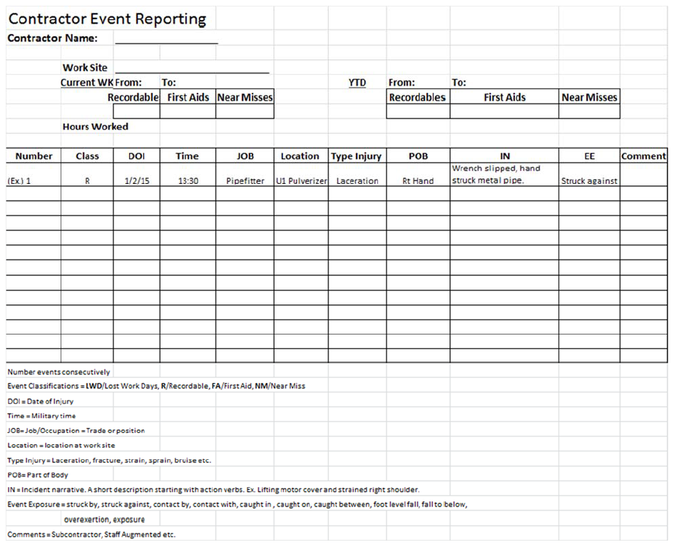
Example

