Tennessee River Valley Mapguide: https://www.tennesseerivervalleygeotourism.org/

How to Nominate:

- From the home page, create an account:

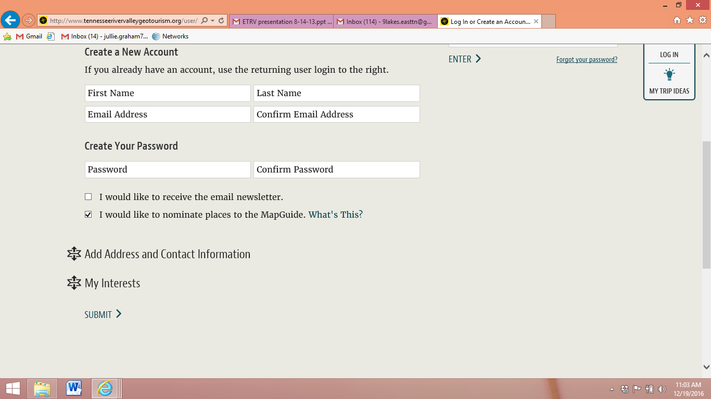
- Once an account is established, then nominations can be made. In the footer of each page, on the right hand side, there is a link to “nominate a place” Click on that link. 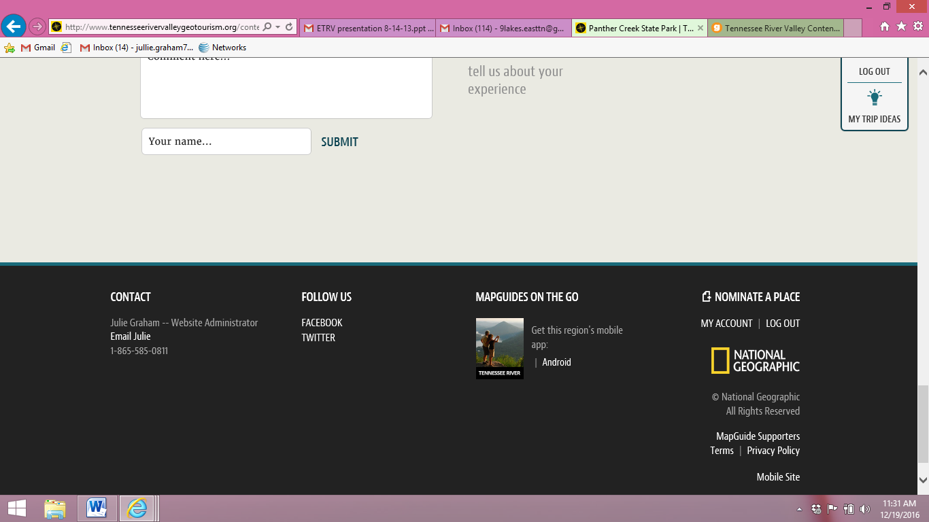
- Begin nomination- Be sure to complete all sections and to provide at minimum 2 pictures for the nomination. When the nomination is complete, mark the nomination as Pending.
- When nominating, there are 12 options for categories and then sub categories within those. EXAMPLE: Community, sub category might be Downtown or Outdoor Adventure- Boating
- Users can search by the pull down menus: Places to go, Places to stay, and Things to do.
  - EXAMPLE: If a State Park has lodging, it is best to do a second entry for lodging. From the analytics, campgrounds are the most popular search followed by cabins.
  - EXAMPLE: If a State Park has an annual event or robust programming, another entry could be added. Rocky Fort State Park has focused on their trails and the Chamber of Commerce was the nominator for the trails. http://www.tennesseerivervalleygeotourism.org/content/rocky-fork-state-park/tenbeaefc9aea2da48db
- Review your nomination by using the button marked “review” prior to completing the nomination. Check for readability and photo interest.
- The nominations are received centrally and reviewed for approval. This process takes about 3-5 business days. If the reviewer has questions about the nomination, then a comment will be sent back to the nominator for clarification. Once you have completed a nomination, mark as pending. This flags the reviewer that the nomination is ready to be moved to active.
- Pictures and videography must be credited to the individual providing the images. Pictures are key to the site. Make sure your photos are of high quality and do not look blurry. Do not use logos as your lead picture!
- Only counties within the TVR watershed are eligible to be on the mapguide.
- All WMAs, SP Parks, and State byways and blueways are eligible.

For general questions:
Julie Graham- tennesseerivervalleymapguide@gmail.com 865-585-0811

