Aqua Terra Column, Eco column
BIO1.LS2.3 Analyze through research the cycling of matter in our biosphere and explain how biogeochemical cycles are critical for ecosystem function.
BIO1.LS2.4 Analyze data demonstrating the decrease in biomass observed in each successive trophic level. Construct an explanation considering the laws of conservation of energy and matter and represent this phenomenon in a mathematical model to describe the transfer of energy and matter between trophic levels.
The Basics of Ecosystem Bottle Building
Eco Column
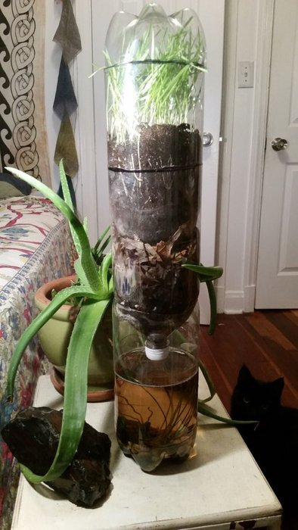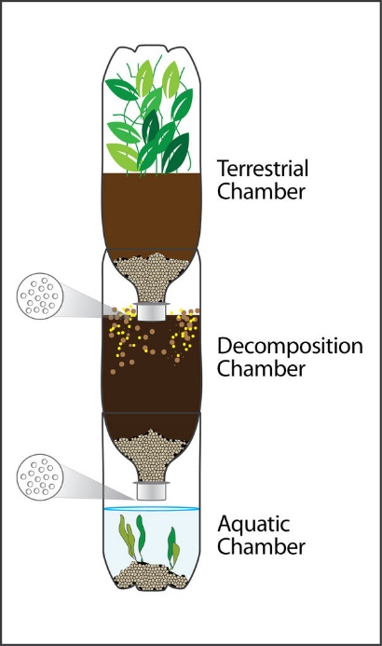
- Students work in groups of four to create their own personal column. Possible jobs
  - Materials
  - Data Collection
  - Maintenance
  - Presentation - Everyone
- Encourage creativity and the use of multiple bottles/containers.
- Lessons Learned
  - Energy Pyramid
  - Conservation of Energy
  - Importance of Cycles
  - Deepens the understanding that only a portion of energy goes toward biomass within each trophic level.
- Avoid vertebrates unless working closely with a pet store to be sure adequate needs are met.

