**A**quatic Biomes

Project/Problem Based Learning

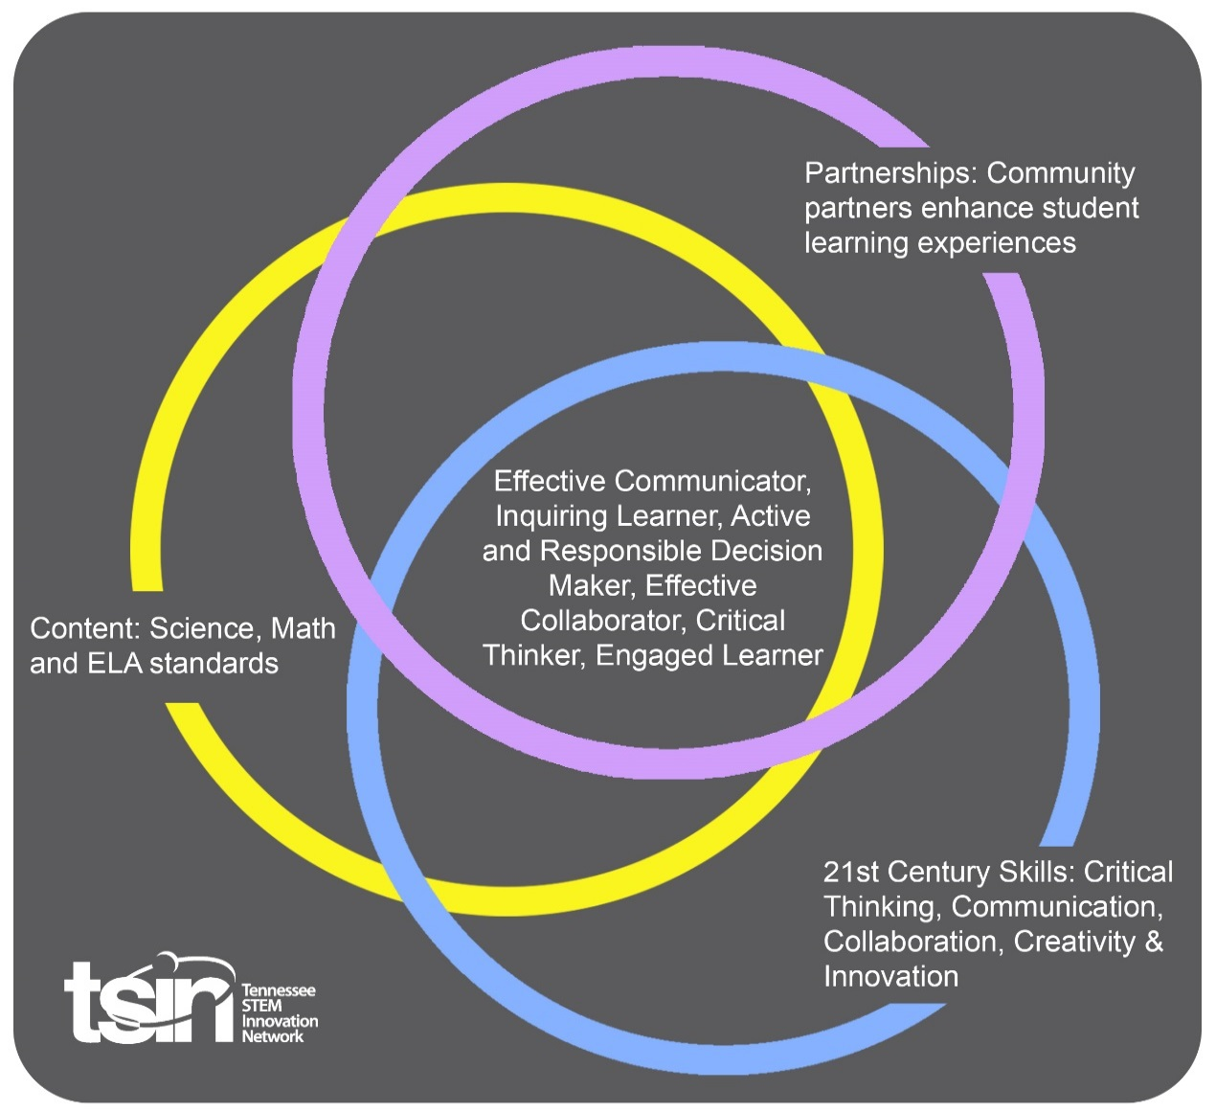

|  |  |  |  |
| --- | --- | --- | --- |
| **Created By:**  Allison Ledford | **Topic: Aquatic Biomes** | | **Grade Level or Subject: 3rd grade** |
| **Science Standards:**  3.LS4: Biological Change: Unity and Diversity  1) Explain the cause and effect relationship between a naturally changing environment and an organism's ability to survive.  2) Infer that plant and animal adaptations help them survive in land and aquatic biomes.  3) Explain how changes to an environment's biodiversity influence human resources. | | | |
| **Math Standards:**  3.MD.A.2 Measure the mass of objects and liquid volume using standard units of grams (g), kilograms (kg), milliliters (ml), and liters (l). Estimate the mass of objects and liquid volume using benchmarks. For example, a large paper clip is about one gram, so a box of about 100 large clips is about 100 grams.  A. Solve problems involving measurement and estimation of intervals of time, liquid volumes, and masses of objects. | | | |
| **ELA:** 3.RI.RRTC.10 Read and comprehend stories and informational texts at the high end of the grades 2-3 text complexity band independently and proficiently. | | | |
| **Additional Standards (Social Studies, Art, Physical Education):**  3.W.TP.2 Write informative/explanatory texts to examine a topic and convey ideas and information. a. Introduce a topic. b. Group related information together, including illustrations when needed, to provide clarity to the reader. c. Develop the topic with facts, definitions, and details. d. Provide a conclusion. e. Use linking words and phrases to connect ideas within categories of information. f. Use precise language to inform about or explain the topic. g. Apply language standards addressed in the Foundational Literacy standards.  **Speaking and Listening** 3 3.SL.PKI.6 Speak in complete sentences, when appropriate to task and situation, to provide requested detail or clarification. | | | |
| **PBL Summary:** Write a few sentences describing this PBL unit.  Students will be exposed to hands-on experiences with aquatic biomes. Students will have the opportunity to read about aquatic biomes, test water and become aquatic ecologists. | | **Driving/Multi-dimensional Question:** Think of a relevant problem with multiple solutions that will drive student learning.  How can we, as aquatic ecologists, determine the environmental impacts of our water?  **If your school or local area has a known body of water you could personalize this question to make it more meaningful to your students.  Ex: How can we, as aquatic ecologists, help the animals in John Doe Pond? | |
| **Tennessee Academic Standards for Science Connection** | | | |
| Disciplinary Core Idea(s): Life Science | Science & Engineering Practice(s):  Engaging in Argument from Evidence;  Obtaining, Evaluating and Communicating Information | | Cross Cutting Concept(s):  Patterns  Observed patterns in nature guide organization and classification and prompt questions about relationships and causes underlying them. |
| **21st Century Skills Addressed (check all that apply):**  X Creativity X Collaboration X Critical Thinking X Communication | | | |
| **Culminating Event:** What final student learning products will show student mastery of the content area standards?  Students will be responsible for assigning a health score based on several indicators from their water test kit. They will write an informative essay justifying their health score to be submitted to the TVA professional. The students will use information from research and their writing to create an informative flyer to be shared with classmates. | | | |
| **Hook Event:** Develop an introductory activity that will spark student interest and further questions.  Students will do a book talk with the cover of the story “The Water Princess,” by Susan Verde. Students will begin a K-W-L chart by asking questions they would like to know about the book. Students will then read the book and continue to ask questions and add to their chart throughout the read aloud. Finally, students will determine how this book is relevant to their lives locally by examining the driving/multi-dimensional question. | **Community Partners:** List potential business or industry partners that could add to the learning experience for students. Include websites or contact info.   1. Aquatic ecologists from the TVA 2. Representative from the local water company 3. Local university professional or wildlife professor | | What do you need from these partners (i.e. guest speaker, field trip, help facilitate an activity)?  1. Have the professional either make a short video explaining some of their responsibilities in their career or be a guest speaker. It would be ideal if students could present their report card to the professional at the end of the project.  2. Guest speaker to talk about his/her job and how he/she tests water  3. Someone to talk about getting into college; or a professor to come and talk about some things you learn when achieving a degree in Wildlife Fisheries and Science |
| **Daily Activities:** What activities will students complete to answer the multi-dimensional/driving question (that reinforces content from the standards)?  **Activity:**  **1. Ask:** Students will examine the first step in the engineering design process by asking themselves the problem. It would be ideal if your school had a pond, creek or was near any body of water so that the water would be most relevant to students. If you are near, you would be able to take students with you to gather your sample. Students will learn they are to become aquatic ecologists. They will learn the education required in order to be in this profession (at least a Bachelor’s in Wildlife Fisheries and Science). If there is a local university this would be a great opportunity to tie in a University guest speaker talking about taking classes at the school or a professor in that major.  **2. Imagine:** Students will need to know how to measure their samples, so before students begin with testing their water, they will use their math standards in estimating and then measuring their water samples in milliliters and liters. Students should have the opportunity to estimate and record their estimation, then to actually measure and record their actual capacity measurement. Teachers can have test tubes for estimation and measuring cups for actual measurement. This can be done in partners or groups. If students do not reach mastery right away, this can be continued later in small group settings with the teacher.  **3. Plan:** Next, students will research which part of the water they will be testing.  The water test kit comes with several indicators, so the teacher will decide how this lesson will be best taught to students, but she could divide the class into 4 different testing sections. For example, group A could test for pH, group B could test the water for ammonia, group C could test the water for phosphate, and group D could test for Nitrates, or all groups could test for each indicator in small groups.  Alternatively, each group could test for the same indicator, only pH. If each group only tests for pH, they could also research animals in the pond and how the pH affects the animals.  Each group would research their assigned area and why it is important for their water to have the right pH balance, or ammonia, etc.  Depending on the reading levels of the students, teachers could pull specific articles online for students to research. Students can also use kiddle.co for research. It is a search engine created by google, for kids to prevent pop ups or ads. For the teacher’s lower level students, a recording of the teacher reading those articles for the student could be developed by using a quick time recorder or Screencastify, a google extension.  The teacher will supply the students with a list of 5-10 guiding questions for students to answer during their research. They will later share their answers out loud to the rest of the class.  See example below from attached worksheet:  **Guiding Questions for research:**   1. **What is pH?** 2. **Why is pH important in water?** 3. **What should pH be in pond water?** 4. **What do I do if my pond water pH is too low?** 5. **What do I do if my pond water pH is too high?** 6. **What animals live in a pond?** 7. **How does pH level affect pond animals?** 8. **How do humans affect pH in pond water?**   **4. Create:** Students will use this day to test their sample and give their water a score on a report card. Students will then begin the writing process using their guiding questions and research. They will begin a draft. This draft should include a health score based on several indicators from their water test kit. They will write an informative essay justifying their health score to be submitted to the TVA professional.  The pond test kit comes with color cards suggesting what the pH level should be. Students should be able to explain from their research what they can do if their level is too high or too low. Students should use all guiding questions from their research to add to their writing. Students should be able to explain if their pH level was too high or too low and how that level affects the animals in the water.  **5. Improve:** Students will finish all of the steps in the writing process and publish their final draft to be submitted to a TVA professional. The students will use information from research and their writing to create an informative flyer to be shared with classmates. | | | **Resources/Materials Needed:**  **Hook: “The Water Princess,” by Susan Verde**  **Pond or local water to sample**  **Water test kit from local pet store or Amazon linked below**  <https://www.amazon.com/API-POND-MASTER-Water-500-Test/dp/B0002DJNN0>  **There are different test kits based on the different types of water you are using. The kit linked is $26 and includes test tubes.**  **Measuring cups or graduated cylinders for measuring activity day 2**  **Suggested articles for student research:**  <https://www.readworks.org/article/Acid-Rain-and-the-pH-Scale/dece3eb8-296a-414f-b633-62d1ff42e155#!articleTab:content/>  <https://www.epa.gov/wqs-tech/state-specific-water-quality-standards-effective-under-clean-water-act-cwa>  **Additional resource:**  **“One Well: The Story of Water on Earth,” Rochelle Strauss** |
| **Technology Integration:** How is technology embedded into this PBL unit?  Students will use technology such as test tubes, graduated cylinders and measuring cups. Students will also have the opportunity to use technology for online articles and research into pond water. | | | |
| **Capstone Presentation:** How will students present what they’ve learned publicly? This can be the culminating event if that event is presenting what has been learned publicly.  Students will be responsible for assigning a health score based on several indicators from their water test kit. They will write an informative essay justifying their health score to be submitted to the TVA professional. The students will use information from research and their writing to create an informative flyer to be shared with classmates. | | | |

**Performance Based Rubric**

|  |  |  |  |
| --- | --- | --- | --- |
| **Standards** | **Developing** | **On-Target** | **Mastery** |
| Science  3.LS4: Biological Change: Unity and Diversity  1) Explain the cause and effect relationship between a naturally changing environment and an organism's ability to survive.  2) Infer that plant and animal adaptations help them survive in land and aquatic biomes.  3) Explain how changes to an environment's biodiversity influence human resources. | Students will grasp what animals live in a pond. Students will understand that the water can affect the animals and their ability to survive with teacher support and peer discussion. Students will be able to explain this cause and effect relationship either verbally and/or in their writing with teacher support. | Students will be able to understand from research, peer discussion and teacher support how the environment’s changes affect their pond animals. Students will be able to explain this cause and effect relationship either verbally and/or in their writing. | Students will be able to understand from research how the environment’s changes affect their pond animals. Students will be able to explain this cause and effect relationship either verbally or in their writing. |
| Math:  3.MD.A.2 Measure the mass of objects and liquid volume using standard units of grams (g), kilograms (kg), milliliters (ml), and liters (l). Estimate the mass of objects and liquid volume using benchmarks.  A. Solve problems involving measurement and estimation of intervals of time, liquid volumes, and masses of objects. | Students will measure the liquid volume using standard units of measurement such as milliliters (ml) and liters (l). Students will estimate the liquid volume and answer questions about the measurement with less than 80% proficiency. | Students will measure the liquid volume using standard units of measurement such as milliliters (ml) and liters (l). Students will estimate the liquid volume and answer questions about the measurement with 80-90% or above proficiency. | Students will measure the liquid volume using standard units of measurement such as milliliters (ml) and liters (l). Students will estimate the liquid volume and answer questions about the measurement with 90% or above proficiency. |
| ELA  3.RI.RRTC.10 Read and comprehend stories and informational texts at the high end of the grades 2-3 text complexity band independently and proficiently. | Developing readers will be able to listen and follow along with grade level text. Students will be able to answer questions regarding their text with guidance. | Students will be able to mostly read and comprehend grade level text regarding their aquatic biome with some prompting. Students will be able to answer questions regarding their text with little assistance. | Students will be able to fully read and comprehend grade level text regarding their aquatic biome. Students will be able to answer questions regarding their text. |
| Writing  Wording taken from TN Holistic writing rubric on TN.gov website | The response:  • partially addresses the prompt.  • lacks the cohesion of a paragraph and may contain a limited, weak introduction and/or conclusion.  • includes some supporting details or evidence from the passage.  • may attempt to utilize a mode of writing.  The response:  • illustrates inconsistent command of language.  • utilizes basic and/or repetitive linking words and phrases.  • demonstrates inconsistent command of grade level conventions of standard written English.  • contains some errors in grammar, spelling, capitalization, and/or punctuation, and they may interfere with understanding. | The response:  • generally addresses the prompt.  • is a paragraph and includes an adequate introduction and conclusion.  • includes adequate supporting details or evidence from the passage.  • utilizes a mostly consistent mode of writing.  The response:  • illustrates adequate command of language.  • utilizes appropriate linking words and phrases.  • generally demonstrates adequate command of grade-level conventions of standard written English.  • contains errors in grammar, spelling, capitalization, and/or punctuation, but they do not interfere with understanding. | The response:  • fully addresses the prompt.  • is a cohesive paragraph and includes a clear introduction and conclusion.  • includes relevant and sufficient supporting details or evidence from the passage.  •utilizes a consistent mode of writing.  The response:  • illustrates consistent command of language  • utilizes a variety of appropriate linking words and phrases.  • demonstrates consistent command of grade level conventions of standard written English.  • contains few, if any, errors in grammar, spelling, capitalization, and/or punctuation. |
| Speaking and Listening  3 3.SL.PKI.6 Speak in complete sentences, when appropriate to task and situation, to provide requested detail or clarification. | Students will sometimes speak in complete sentences and will sometimes provide detail or clarification. | Students will mostly speak in complete sentences and will provide requested detail or clarification. | Students will speak in complete sentences and will provide requested detail or clarification. |