Local Weather and Climate
Project/Problem Based Learning Template
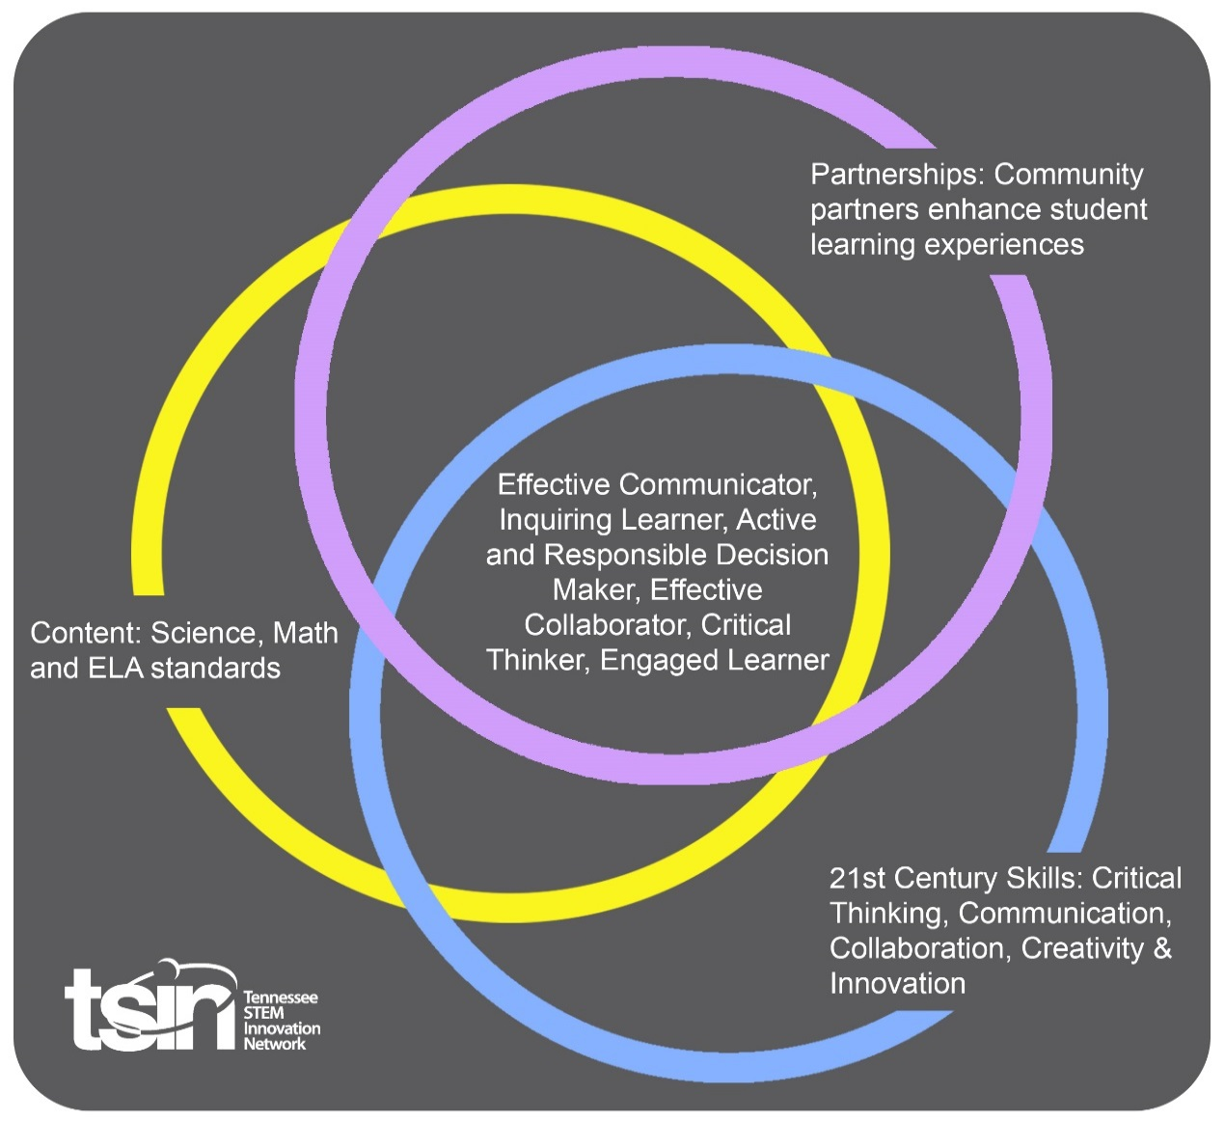

Created By: Allison Ledford | Topic: Local Weather and Climate |  | Grade Level or Subject: 3rd grade
Science Standards:
3.ESS2: Earth's systems

3) Use tables, graphs, and tools to describe precipitation, temp, and wind direction and speed to determine local weather and climate.
4) Incorporate weather data to describe major climates.

Math Standards:
3.ESS2.1:
Draw a scaled picture graph and a scaled bar graph to represent a data set with several categories. Solve one- and two-step “how many more” and “how many less” problems using information presented in bar graphs.

ELA Standards:
3.W.TTP.1:
Write opinion pieces on topics or texts, supporting a point of view with reasons.
Additional Standards:
Speaking and Listening
3. SL. CC.1 Prepare for collaborative discussions of 3rd grade level topics and texts, engage effectively with varied partners, building on others’ ideas and expressing their own ideas clearly.

PBL Summary: Write a few sentences describing this PBL unit.  Students will be hands on in creating weather tools in order to gain a strong understanding of weather. Students will make daily observations in order to plan a safe prescribed burn. |  | Driving/Multi-dimensional Question: Think of a relevant problem with multiple solutions that will drive student learning.  How can we, as Watershed Representatives, use weather information to plan a safe prescribed burn?
Tennessee Academic Standards for Science Connection
Disciplinary Core Idea(s):  Engineering, Technology and the application of Science | Science & Engineering Practice(s):  Analyzing and Interpreting Data |  | Cross Cutting Concept(s):  Patterns
21st Century Skills Addressed (check all that apply):

X Creativity X Collaboration X Critical Thinking X Communication

Culminating Event: What final student learning products will show student mastery of the content area standards?

Students will be able to identify the optimal weather conditions and suggest a date for a prescribed burn. Students will be able to justify their reasoning with graphs from their daily observations in their weather journal.

Hook Event: Develop an introductory activity that will spark student interest and further questions.  Students will be asked to research answers for the following questions:  What is a prescribed burn?  How are prescribed burns helpful?  Students will use approved websites and books to research the answer to these questions. Then, students will present their findings to the class.  Students will then watch a video from Goodfires.org about prescribed burns:  https://www.youtube.com/watch?v=NgFXBe-Zzdo | Community Partners: List potential business or industry partners that could add to the learning experience for students. Include websites or contact info.  - TVA professional  - Local meteorologist  - Firefighters |  | What do you need from these partners (i.e. guest speaker, field trip, help facilitate an activity)?  - Potential guest speaker or in the field speaker via Skype  - Potential guest speaker about predicting weather and using weather tools  - Potential guest speaker to speak about involvement in prescribed burns
Daily Activities: What activities will students complete to answer the multi-dimensional/driving question (that reinforces content from the standards)?  Activity:  - After the hook event, students will present their findings. Students will watch the video from goodfires.org to understand more about a prescribed burn. Students will then watch the video from TVA.org to meet the TVA Watershed Representative, and understand more about his career. Students will need to understand how the watershed representative decides whether or not to plan a prescribed burn. Students will be introduced with their guiding questions.  https://www.tva.com/Our-TVA-Story/Damien-Simbeck  - Students will construct and observe a wind vane in order to understand from which direction the wind is coming. Students will use their weather vane to record the wind direction. Students will confirm their data, by using theweatherchannel.com daily information. Students will deduct why this tool would be important for planning a prescribed burn and write in their weather journals.  - Students will construct and observe an anemometer to record the speed of the wind. Students will use their anemometer to record the speed of the wind and confirm their data using theweatherchannel.com. Students will deduct why this would be important for planning a prescribed burn and write in their weather journals.  - Students will observe and answer questions about a real thermometer and rain gauge. Students will decide what temperature would be best for a prescribed burn, and whether or not precipitation would be good during a prescribed burn. Students will begin 5 days of observation here. Students will graph 4 things each day: wind speed, wind direction, temperature and precipitation.  - After 5 days of filling out weekly weather on their graphs, students will determine if there was an appropriate day to have a prescribed burn. Students will explain their findings and justify their reasons using their graphs as a visual. Students can choose to present this by making a video, a presentation in front of their peers, or write a persuasive essay. |  |  | Resources/Materials Needed:  Approved websites to research prescribed burns:  https://goodfires.org/  https://smokeybear.com/en/about-wildland-fire/benefits-of-fire/prescribed-fires  “Tools Measure Weather, “ by National Georgraphic Learning  Weather vane tools:  Straw  Paper cup  Pencil  Tac  Plate  Anemometer tools:  6 straws  2 cups  Pencil  Tape  Plate  Glue  Thermometer  Rain gauge  Weather journals
Technology Integration: How is technology embedded into this PBL unit?

Students will use a variety of technology including weather tools, student made weather tools, weather journals, technology to complete research and technology to create a video of students presenting the chosen burn date.

Capstone Presentation: How will students present what they’ve learned publicly? This can be the culminating event if that event is presenting what has been learned publicly.

Students will present their weather data in graph form. Students will choose a day from the period we graphed to have a prescribed burn. Students will suggest a day based on their findings of precipitation, temperature, and wind direction to present this day using their graph to the class through choice of a video, presentation or persuasive essay.

Performance Based Rubric
Standards | Developing | On-Target | Mastery
Science | Student will use 1 out of 3:  -tables  -graphs  -tools  to describe precipitation, temp, and wind direction and speed, over a 5-day period, to determine local weather and climate. | Student will use 2 out of 3:  -tables  -graphs  -tools  to describe precipitation, temp, and wind direction and speed, over a 5-day period, to determine local weather and climate. | Student will use tables, graphs, and tools to describe precipitation, temp, and wind direction and speed, over a 5-day period, to determine local weather and climate.
Math | Students will be able to draw a scaled picture graph and a scaled bar graph to represent a data set with one category or fill in a template for more than one category. Students will solve one- and two-step “how many more” and “how many less” problems using information presented in bar graphs with less than 60% proficiency. | Students will be able to draw a scaled picture graph and a scaled bar graph to represent a data set with more than one category. Students will solve one- and two-step “how many more” and “how many less” problems using information presented in bar graphs with 60-80% proficiency. | Students will be able to draw a scaled picture graph and a scaled bar graph to represent a data set with several categories. Solve one- and two-step “how many more” and “how many less” problems using information presented in bar graphs with 80-100% proficiency.
ELA | Student writes an opinion piece on topics or texts. Student has a lack of supporting details or evidence. Student utilizes few, if any, linking words and phrases. Student contains numerous errors in grammar, spelling, capitalization and/or punctuation that impede understanding. | Student will be able to write an opinion piece on topics or texts, supporting a point of view with reasons. Student introduces a topic, develops an opinion and generally creates an organizational structure that lists supporting reasons. Students provide a closing section. Student uses some linking words. Student mostly applies language standards addressed in the foundational literacy standards. | Student will be able to write opinion pieces on topics or texts, supporting a point of view with reasons. Student will introduce a topic or text, develop an opinion with reasons to support the opinion, and create an organizational structure that lists supporting reasons. Student will be able to provide a closing statement or section and use linking words or phrases to connect opinion. Student will apply language standards addressed in the foundational literacy standards.
Speaking and Listening | Student attempted to engage in collaborative discussions of 3rd grade level topics and texts with varied partners. Student had difficulty building on others’ ideas and/or difficulty expressing his/her own ideas. | Student engaged in collaborative discussions of 3rd grade level topics and texts with varied partners. Student attempts to build on others’ ideas and attempt to express his/her own ideas. | Student prepared for collaborative discussions of 3rd grade level topics and texts, engage effectively with varied partners, building on others’ ideas and expressing his/her own ideas clearly.

