Project/Problem Based Learning Template
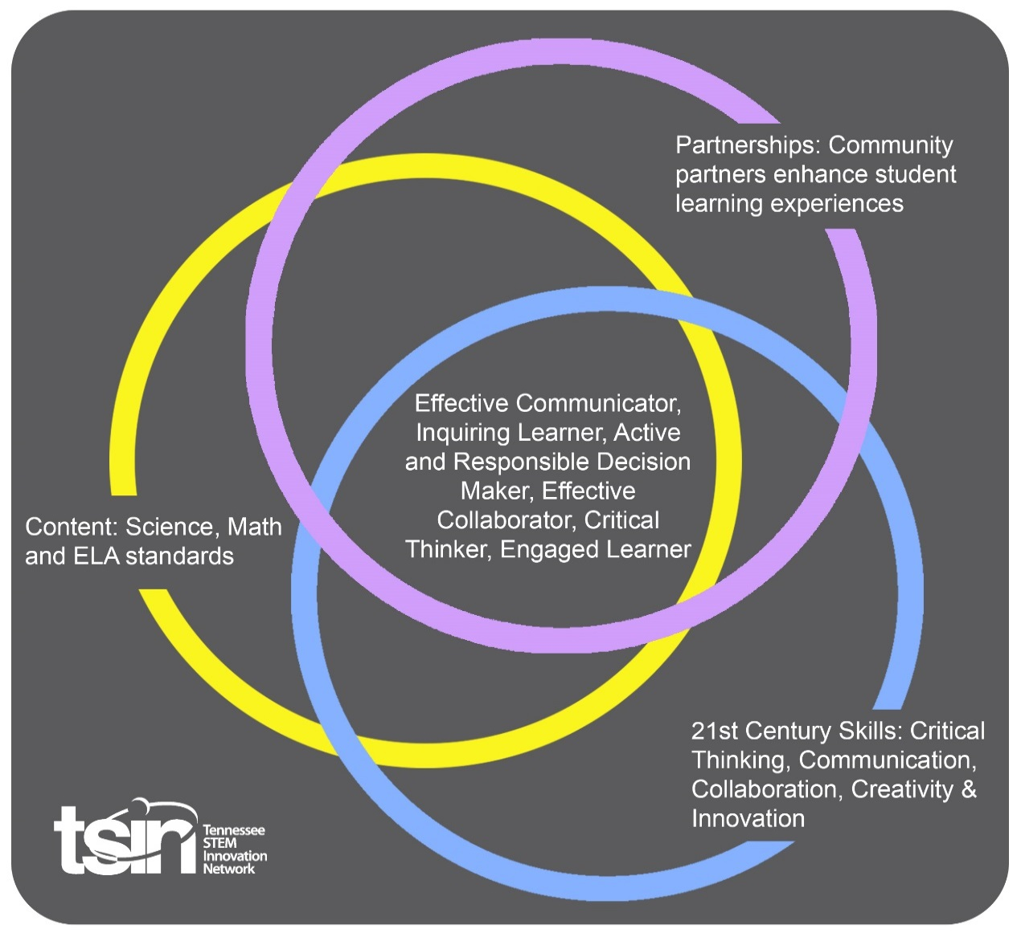

Created By:  Kattie Nash | Topic:  Water Quality and Environmental Stewardship |  | Grade Level or Subject:  3rd Grade
Science Standards:
3.ETS1.1 Design a solution to a real-world problem that includes specified criteria for constraints.

Math Standards:
3.NF.A Develop understanding of fractions as numbers.

ELA Standards:
SL1 Engage effectively in a range of collaborative discussions.

Additional Standards (Social Studies, Art, Physical Education):
3.67 Read and interpret information about the impact of people on the environment.

PBL Summary: Write a few sentences describing this PBL unit.  Water quality is imperative for all living things. TVA monitors water conditions and supports a broad range of clean-water initiatives. They are committed to clean water for their region. However, TVA doesn’t have the power to regulate water pollution, but they care deeply about the quality of the water.  In this PBL, students will analyze and discuss environmental stewardship along with the role environmental engineers play in maintaining water quality. Students will explore the importance of water quality while using ordinary materials to design portable water filters. Filtration systems will be used to clean polluted water. |  | Driving/Multi-dimensional Question: Think of a relevant problem with multiple solutions that will drive student learning.  How can we, as environmental engineers, create a filtration system to clean polluted water?
Tennessee Academic Standards for Science Connection
Disciplinary Core Idea(s):  Engineering, Technology, and the Application of Science | Science & Engineering Practice(s):  Constructing Explanations and Designing Solutions |  | Cross Cutting Concept(s):  Systems and System Models
21st Century Skills Addressed (check all that apply):

x Creativity x Collaboration x Critical Thinking x Communication

Culminating Event: What final student learning products will show student mastery of the content area standards?

Students will design a solution to a real-world problem, water pollution, and present their design to the class. A rubric will be used to asses mastery.
Hook Event: Develop an introductory activity that will spark student interest and further questions.  In this PBL, students will focus on the importance of clean water. Students will use the engineering design process to design and build a portable water filtration system to remove contaminants from “polluted” water.  Begin the lesson by creating a “polluted” water bucket. Fill a large bucket with water and start adding various items to represent water pollution:  -Food coloring to represent chemicals  -Torn pieces of paper to represent liter  -Soil or dirt  -Dried beans to represent human/animal waste  As you add these items, explain to the students that we will think like environmental engineers to design and create a water filtration system to filter the polluted water. | Community Partners: List potential business or industry partners that could add to the learning experience for students. Include websites or contact info.  1. TVA  https://www.tva.gov  2. Local Clean Commission Organization  3. Local TN Department of Environment & Conservation |  | What do you need from these partners (i.e. guest speaker, field trip, help facilitate an activity)?  1. Environmental information, resources, and career guest speakers  2. Guest speaker, provide resources for recycling and how to stop pollution  3. Starting point for environmental questions and concerns, provide resources and guest speakers
Daily Activities: What activities will students complete to answer the multi-dimensional/driving question (that reinforces content from the standards)?  Activity:  Environmental Stewardship refers to protecting the environment through recycling, conservation, regeneration, and restoration. Throughout this PBL students should focus on and list ways they can become good stewards of the environment. They will use their thoughts to think like environmental engineers to solve a real-world problem, polluted water. The following questions should be addressed:  -Why is it important to have clean drinking water?  -What does a filter do?  -Is water safe to drink after filtration? (Introduce purification as an extension)  1. ASK:  -What is the problem?  -What do you already know?  -What have others done?  -What are the constraints?  After the hook event, students will begin working through the Engineering Design Process to build a broader understanding about filtration. Students will begin by defining the problem and researching to see what others have done. During this step, the teacher will need to list the constraints for the design challenge. Students will use the “ASK” planning sheet to record their responses.  Constraints:  -Work with a group of 2-3 students  -Build a portable water filtration system using only one plastic bottle (2-liter or 10-ounce bottle)  -Analyze materials and pick no more than 4 items for filtration  -Set time limit for the create phase (30 minute build time suggested)  2. IMAGINE:  -Brainstorm ideas.  -List possible solutions.  -Research to find out more.  -Choose the best solution.  During the Imagine phase, students will research filtration systems and begin to brainstorm ideas for their design. Allow time for students to research commercial and homemade filtration systems. Teams will list possible solutions to the problem. After multiple solutions have been discussed, student teams will choose the best solution before moving to the planning phase.  3. PLAN:  -Draw a diagram.  -List supplies you will need.  -Make a list of the steps you will take.  After a solution has been chosen, students will begin to plan their design. Students will use the “PLAN” template to list materials needed along with creating a diagram of their portable filter. Students will need to clearly label each material in their filter. Students will list materials as a fraction to show accurate representation and amounts to be used. Ask the following questions:  -What materials did you choose and why?  -What items (contaminants) do you predict will be caught by your filter?  -Will you place materials in a particular order?  4. CREATE:  -Follow your plan.  -Build a prototype.  -Test your design.  Student teams will now follow their labeled diagram to construct their portable water filtration system. After designs have been constructed by all teams, students will use their filter to test the “polluted” water. Students will pour “polluted” water in their filter and observe the effectiveness of their design. Discuss the results after each team has tested their filter.  -Were all contaminants removed?  -Were natural or manmade contaminants easier to remove?  -If you changed the order of your layered materials, would you remove more contaminants?  5. IMPROVE:  -What worked?  -What didn’t work?  -Make changes.  -Redesign and test again!  Students will now redesign their water filters. Students should make changes based on what worked or didn’t work during their original test. Allow teams time to work on a new plan before creating their final filter. Test filters again and compare results. |  |  | Resources/Materials Needed:  -Plastic 2-liter bottle  -Plastic 16-ounce bottle  -Pebbles/gravel  -Sand  -Sponges  -Coffee filters  -Cotton balls  -Panty hose  -Clay  -Mesh  -Scissors  -Tape (masking or duct tape)
Technology Integration: How is technology embedded into this PBL unit?

A variety of technology will be used throughout the daily activities. Students will
use web based devices to research filtration systems, student made systems, and capstone videos.

Capstone Presentation: How will students present what they’ve learned publicly? This can be the culminating event if that event is presenting what has been learned publicly.

Students will present their final filter design and explain the effectiveness of their design. Students will analyze materials and discuss the importance of each material in their filter.

Students will create an advertisement to showcase their water filtration system. Students will choose between a billboard, newspaper, or video advertisement. Students will create a catchy name for their filter and use graphics to grab the attention of their intended customers.

Performance Based Rubric
Engineering, Technology, and Applications of Science
Engineering Design | Developing | On-Target | Mastery
Defining and Delimiting Engineering Problems | The student does not define the problem OR ask a relevant question. | The student defines the problem OR asks a relevant question. | The student defines the problem AND asks a relevant question.
Developing Possible Solutions | The student does not develop a possible solution OR details a plan. | The student develops a possible solution OR details a plan. | The student develops a possible solution and details a plan.
Optimizing the Solution Design | The student does not reflect on the design through journaling OR detail ways to improve. | The student reflects on the design through journaling OR details ways to improve. | The student reflects on the design through journaling AND details ways to improve.

Applications of Science | Developing | On-Target | Mastery
Science Practices: Utilization in Developing and Conducting Original Scientific Research | The student does not participate in scientific research OR summarize the findings of the research. | The student participates in scientific research OR summarizes the findings of the research. | The student participates in scientific research AND summarize the findings of the research.
Practice of Peer Review | The student does not present his or her prototype OR accept peer feedback. | The student presents his or her prototype OR accepts peer feedback. | The student presents his or her prototype AND accepts peer feedback.

