Human Impact & the Environment
Project/Problem Based Learning Template
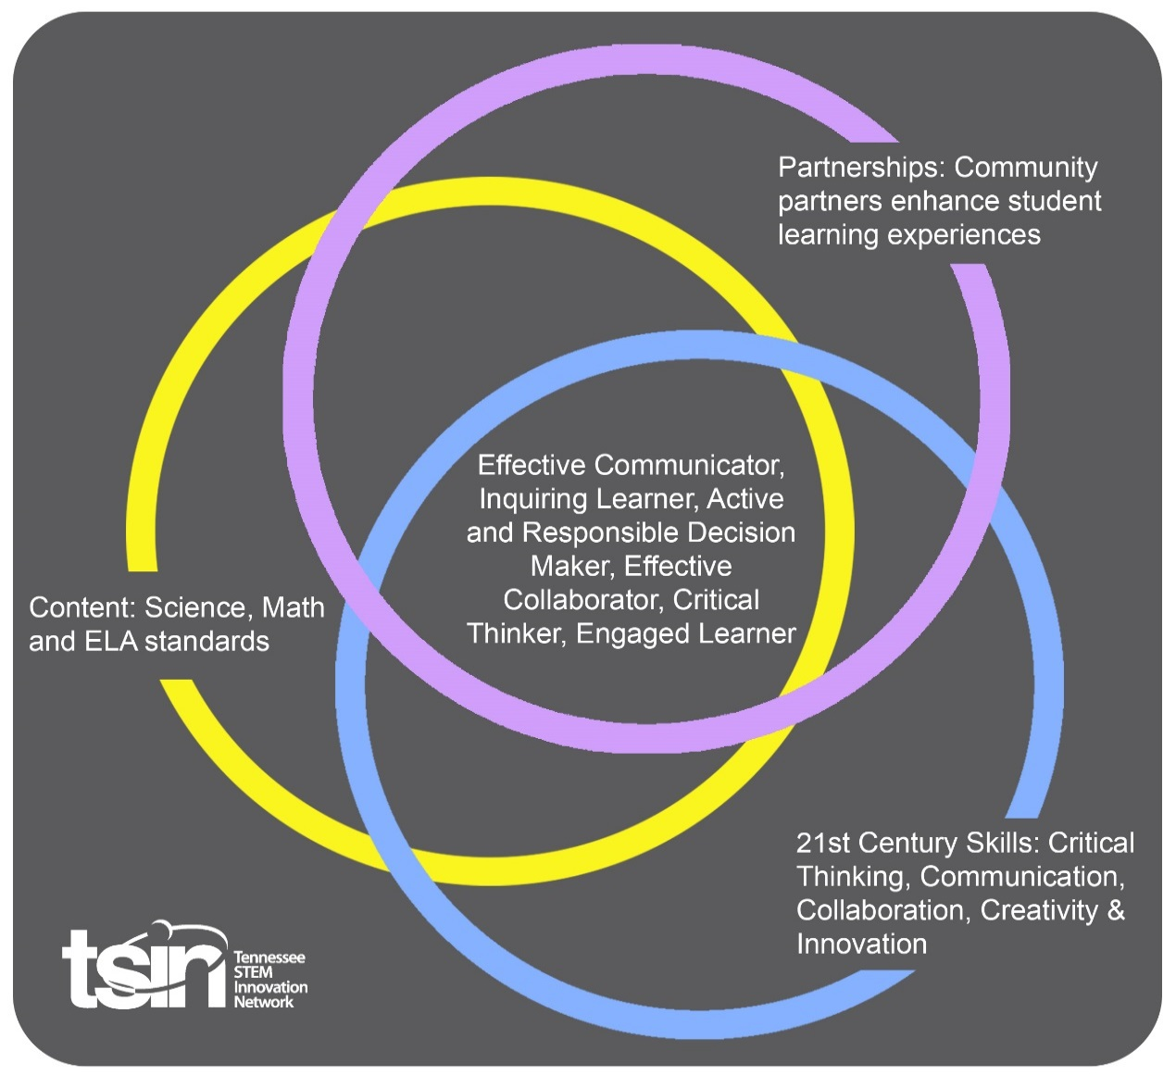

Created By:  Emily Wong and Brittany Crouch | Topic:  Human Impact and the Environment |  | Grade Level or Subject:  Fourth Grade
Science Standards:
4.ESS3.2 Create an argument, using evidence from research, that human activity can affect the land and ocean in positive and/or negative ways.

Math Standards:

ELA Standards:
4.FL.SC.6 Demonstrate command of the conventions of standard English grammar and usage when speaking and conventions of standard English grammar and usage, including capitalization and punctuation, when writing.

Additional Standards (Social Studies, Art, Physical Education):

PBL Summary:  According to the Cross Cutting Concept for Cause and Effect, students will routinely search for cause and effect relationships in systems they study. Based on the days of lessons and the Science and Engineering Practices, the students will create and identify evidence-based arguments and consider whether an argument is supported by evidence or relies on opinions or incomplete representations of relevant evidence. Explanations will be derived from the activities practiced in the course of several days as well as the culminating event regarding the student projects and presentations. |  | Driving/Multi-dimensional Question:  How does regular human activity affect the environment?
Tennessee Academic Standards for Science Connection
Disciplinary Core Idea(s):  Earth and Human Activity | Science & Engineering Practice(s):  Engaging in an argument from evidence |  | Cross Cutting Concept(s):  Cause and Effect
21st Century Skills Addressed (check all that apply):

X Creativity X Collaboration X Critical Thinking X Communication

Culminating Event:
Students will use their knowledge of resources (natural, renewable, and non-renewable) as well as human impacts to develop an informational presentation. This PBL addresses the culminating event as a poster, but could truly be altered to fit a more specific need in the classroom. This might also be an opportunity to connect more technology into the classroom.

Students should use their experiences learned through the activities to influence their poster. Students will select one of the many human impacts that have been studied and how it affects the environment. Students will continue further research (as needed) to create a poster (sample here). The poster will include a description of the human impact, connections to student learning, sample solutions to the impact, personal thoughts/arguments, and any key vocabulary used. Students may also want to include drawings or pictures for their presentation.

Hook Event:  Video:  https://www.youtube.com/watch?v=6HBtl4sHTqU  Watch the video on the Great Pacific Garbage Patch (pause 6:45).  -Allow students an opportunity to construct a solution to the garbage in our oceans.  -Students may want to discuss changes that they are already making to their daily lives.  -This could easily turn into a more in-depth writing activity. | Community Partners:  - Waste Management  - Water Supply Manager—TVA Gary Springston 423-751-7336  - Environmental Lab Manager (local water company) |  | - Discuss with students how our waste is transported to the landfill, where landfills are located, and what kinds of precautions they take to ensure little impact on the environment.  - Discuss with students the continuous efforts the TVA implements to manage Tennessee’s water supply levels.  - This person tests river water, storm water, drinking water, and waste water.
Daily Activities:  - Freddy the Fish—Students will see the impact of the pollution entering our oceans, and other waterways.  - Conservation vs. Replanting—Students will see how industry can affect different aspects of the environment, and investigate and form an opinion (based off of evidence) regarding forest conservation and replanting.  - Soil Erosion—Students will study the positive and negative effects of farming.  - Water Management in Tennessee—Students will research how the TVA manages our water supply, discuss water management, and see it in action.  - Mining—Students will use what they know about resources to show how mining can change the land.  - Final Project—Students will create a poster (see below for further description)  Activity:  - Read: Oil Spill By: Melvin Berger  Freddy the Fish Directions/Instructions: https://www.earthsciweek.org/classroom-activities/freddy-fish  - Read: The Lorax By: Dr. Seuss  If you don’t have the book, here is a link to a read aloud:  https://www.youtube.com/watch?v=EdWesdMfyd4  Use the book to discuss cause and effect. Here is an example found online of a T-Chart:  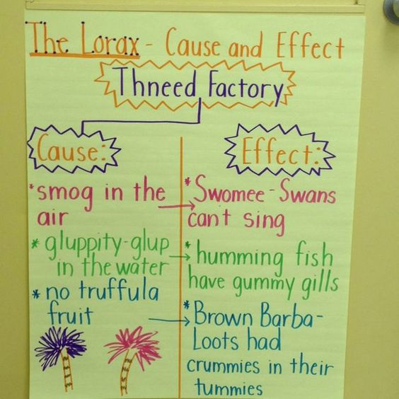  Here is a fun website specific to the Lorax that has other activities and information:  http://www.seussville.com/loraxproject/  Separate students into small groups and allow them to research reforestation and forest preservation. Students will utilize the information within the articles to form an opinion to answer the following question: Should we preserve (maintain)/keep the forests we currently have, or replant trees to make up for deforestation?  Students will cite their evidence by creating a graphic organizer to represent their thinking. They will need to present their information and reasoning behind their answer to the given question.  - This website offers information on how farming/agriculture positively affects the environment:  https://greentumble.com/positive-effects-of-agriculture-on-the-environment/  This website offers information on how farming/agriculture negatively affects the environment:  https://www.worldatlas.com/articles/what-is-the-environmental-impact-of-agriculture.html  Activity:  https://www.lapappadolce.net/science-experiment-on-soil-erosion/  Writing Prompt:  “How does farming positively and negatively affect the environment?”  *Students must use evidence from experiments and/or research.  - This video is about how much water we actually use:  https://www.youtube.com/watch?v=On9WRrFHVjY  *Did you know that the Tennessee Water System is the most used water source in the United States?  This is TVA’s website that discusses its stewardship to managing Tennessee’s water supply:  https://www.tva.com/Environment/Managing-the-River/Managing-Water-Supply  Activity:  Students will navigate the best way to stop a water leak in a pipeline with this activity.  http://www.teachersareterrific.com/2018/03/how-many-ways-can-you-stop-pipeline-leak.html#more  Field Trip:  Visit your local dam to discuss water management and see it in action.  https://tennessee.hometownlocator.com/features/cultural,class,dam.cfm  - This is an amazing activity that describes the aspect of mining and the affect that is has on the land:  https://www.calacademy.org/educators/lesson-plans/fossil-fuels-chocolate-chip-mining  This is another activity where students will study the impact that mining has on the environment and ways to mine in a more environmentally friendly way:  https://www.digintomining.com/sites/digintomining.com/files/content-files/DIMActi  Video:  https://www.youtube.com/watch?v=ynN39sfqT8w  This is a site that will give students a better idea of where Appalachia actually is (in reference to the video):  https://www.wonderopolis.org/wonder/where-is-appalachia  https://www.digintomining.com/digital-explorations  Virtual Field Trip:  https://www.digintomining.com/virtualfieldtrips/archive  - Students should use their experiences learned through the activities to influence their poster. Students will select one of the many human impacts that have been studied and how it affects the environment. Students will continue further research (as needed) to create a poster (sample here). The poster will include a description of the human impact, connections to student learning, sample solutions to the impact, personal thoughts/arguments, and any key vocabulary used. Students may also want to include drawings or pictures for their presentation. |  |  | Resources/Materials Needed:  - Book: Oil Spill  Materials:  -one-gallon jar  -sponge cut in shape of a fish  -fishing line tied to a pencil (Freddy should hang in the middle of the jar)  -small amounts of: soil, pancake syrup, salt, paper dots, brown sugar, soapy water, red and green food coloring  -copy of Freddy the Fish note cards  - Book: The Lorax  - Materials:  -3 2-liter bottles  -scissors  -hot glue  -planting soil  -3 20 oz. bottles  -seed packet  -twigs, bark, leaves, dead roots  -string  - Materials:  -small disposable cups  -tongue depressors  -masking tape  -plastic straws  -real towels (in case of major leak)  - Materials:  -cookies  -plates  -toothpicks  -cookie mining sheet (attached to activity site)
Technology Integration:
Technology is embedded throughout this PBL. There are various websites, videos, and virtual fields trips/experiences that students will have the opportunity to take part in. Students will also utilize online information to conduct research to further their understanding.

Capstone Presentation:
As a summative assessment, students will work towards a project that meets the disciplinary core idea for this PBL. Students will work independently to create a visual (poster) to show their understanding of the human impact and how it affects the environment. Students will also be asked to extend their thinking by continuing further research and implementing their own personal thoughts and arguments. Depending on teacher discretion, students may be asked to present their findings.

Performance Based Rubric
Standards | Developing | On-Target | Mastery
Science  4.ESS3.2 Create an argument, using evidence from research, that human activity can affect the land and ocean in positive and/or negative ways. | Understand that humans affect the world around them based on their choices to live more comfortably. Students should know that humans can make changes to their everyday lives to impact the environment in a positive way. | Understand how specific human activities affect the world around them. Students should know more specific ways that humans can impact the environment positively and develop an opinion of human impact based on evidence. | Understand, have an opinion, and develop an argument based on human impact on the environment. Student’s opinion and argument should be supported by evidence from research.

