Natural Resources
Project/Problem Based Learning
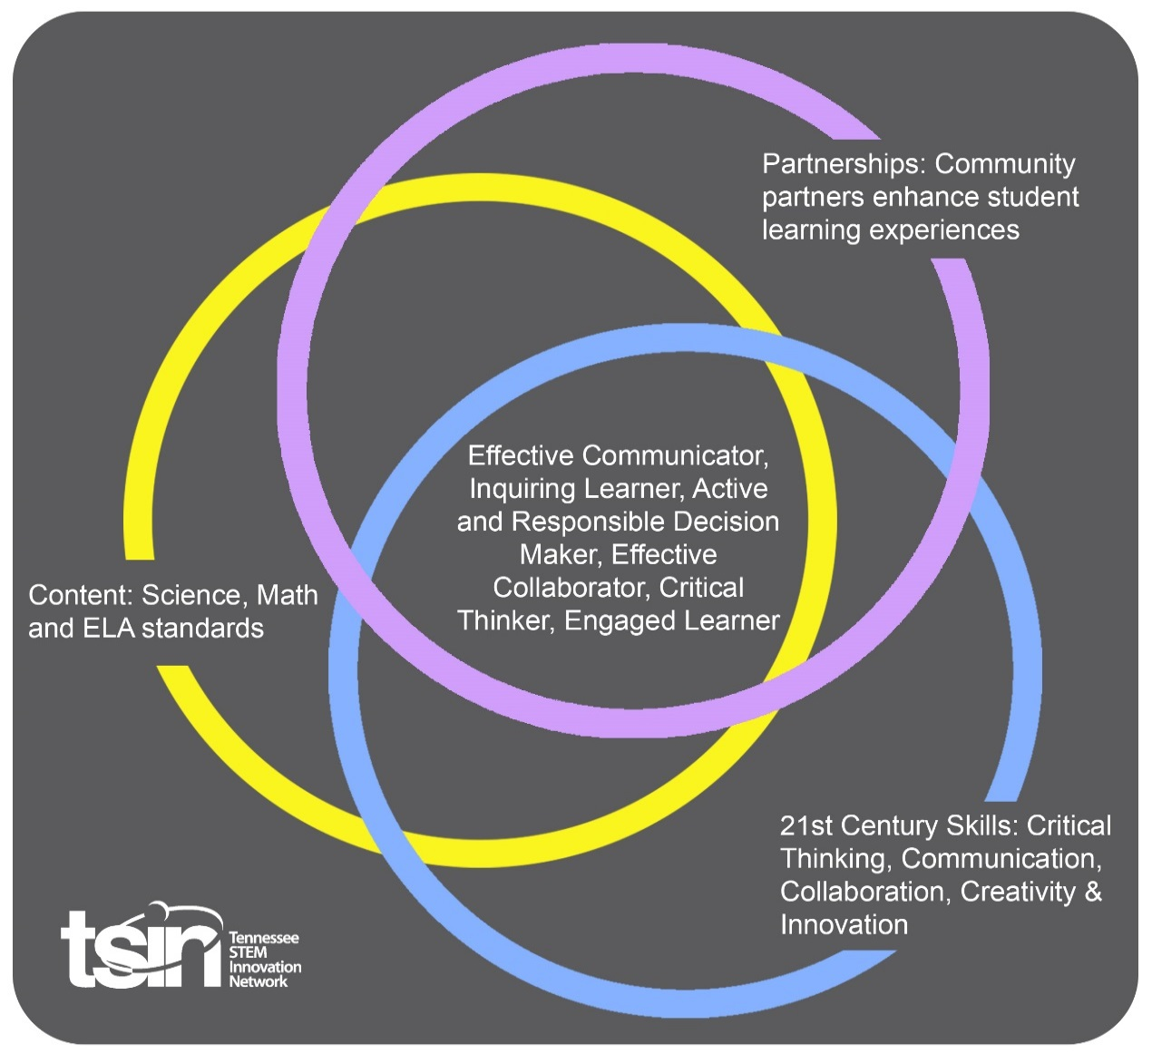

Created By:  Brittany Crouch and Emily Wong | Topic:  Natural Resources |  | Grade Level or Subject:  4th Grade  Science
Science Standards:
4.ESS3.1 Obtain and combine information to describe that energy and fuels are derived from natural resources and that some energy and fuel sources are renewable (sunlight, wind, water) and some are not (fossil fuels, minerals).

PBL Summary: Students will obtain and combine information from multiple sources such as videos, articles, and virtual experiences to describe that energy and fuel are derived from natural resources. Students will also obtain information on the difference between a renewable and non-renewable resource by experiencing a virtual field trip and completing several interactive games online. Students will be challenged to apply their knowledge in order to “Save The World” from an energy crisis. Finally, students will be evaluated on their understanding of this standard by creating a presentation in which they will compare a renewable and a non-renewable resource on a poster or by using a digital presentation such as a Powerpoint, prezi, etc. |  | Driving/Multi-dimensional Question:  Our everyday life is very different from how our ancestors lived hundreds of years ago. How have humans been able to provide energy and fuel for all of these changes to occur, and for us to live the high functioning, ever growing, and fast paced lives we do now? What is the difference between a renewable and non-renewable resource?
Tennessee Academic Standards for Science Connection
Disciplinary Core Idea(s):  Earth and Human Activity | Science & Engineering Practice(s):  Constructing explanations and designing solutions |  | Cross Cutting Concept(s):  Energy and Matter
21st Century Skills Addressed (check all that apply):

X Creativity X Collaboration X Critical Thinking X Communication

Culminating Event:
.
Natural Resource Poster/Presentation Project

For the Natural Resource Poster Project, you will choose one renewable and one nonrenewable resource and create a poster to highlight important information about each resource.
Requirements: For each resource you must include the following:
1) Name of each resource you chose and whether it is renewable or nonrenewable.
2) At least one picture of each resource. You may draw the pictures or use pictures from a magazine, newspaper or the Internet (but you must include the source of the picture on your poster).
3) A 5 – 7 word sentence description of the resource, which may include what it is, where it is found, how it is collected, environmental impact, etc.
4) Five bulleted important facts or notes about the resource.
5) A work cited page with a minimum of two sources. You must include the sources of information you utilized for the poster project. Remember to use APA format. Attach the work cited page to the poster.
6) Creativity is always welcome! Feel free to make your poster appealing, colorful, unique, etc. In addition, feel free to utilize different means of presenting the information such as a PowerPoint, poster, prezi, diagram and/or poster board.
All requirements must be presented on the poster/presentation for each resource.

Hook Event:  Natural Resource Relay Race  1. The teacher will need to write several natural resources on a sticky note (one resource per sticky note). Then write several man-made resources on a sticky note (one resource per sticky note).  a. Natural Resources- rock, minerals, grass, oil, natural gas, water  b. Man-made Resources- house, shoe, eraser, pencil, paper, light bulb  2. The teacher will group students into groups of 6. Each student needs two sticky notes.  3. The teacher will either draw a line down the board or provide a large piece of paper split in half. Label one side “Natural Resources” and the other side “Man-made Resources.”  4. The students must stand in a straight line. One at a time they will take their sticky note and place it on the correct side to represent if their object is a natural resource or man-made resource. Students must come back to their group and get at the end of their group’s line. The relay race continues until the first group has placed all of their sticky notes on the board correctly. The teacher will want to have an answer key handy so he/she can quickly check for correct placement of sticky notes. The teacher can decide what the winning team receives. Some ideas could be the winning team gets to make a wish, play 30 seconds of rock, paper, scissors with a partner, 1-minute dance party, or pick their seat for Science time. | Community Partners:  1. Forbes, 10 companies using 100% renewable power.  - Retail - Whole Foods, Kohl's  - Banking - TD, HSBC, Deutsche Bank  - Government - Environmental Protection Agency  - Natural Resources - Mohawk  - Food & Beverages - Dannon  - Consulting - Pearson  - Non-profit - The World Bank  2. Guest speaker from any local company that uses non-renewable or renewable resources. Guest speaker/expert on fuel efficient cars. |  | What will we need from our Community Partners?  1. Virtual field trips could be set up to many of these facilities if guest speakers are not available.  2. Guests could come and either speak about how their fuel efficient cars help the environment, or the students could do an activity with the speaker.
Daily Activities:  Activity:  1. Students will obtain information by watching several videos this can be done in small groups, stations, or as mini whole group lessons.  A. Watch video-https://www.generationgenius.com/renewable-and-nonrenewable-energy-for-kids/  B. Watch Video- https://www.generationgenius.com/videolessons/renewable-vs-nonrenewable-energy-for-kids/  C. Watch Video- Currents of Change Video- Renewable Energy- https://newsela.com/read/elem-sci-natural-resources/id/29504/  2. Students will obtain information through reading articles, completing viewing guides, completing investigations, and answering assessment questions.  A. Read Newsela Article- https://newsela.com/read/elem-sci-natural-resources/id/29504/  B. Teacher Pay Teacher Resource 4.ess3.1 ‘Natural Resources’ by Friends Frappes and Fourth Grade (cost $6.00)  a. Active Inspire Flip Chart or Powerpoint Presentation included that matches all documents included in the ZIP file.  b. Students will complete a ‘See and Wonder’  c. Students will complete the Investigation Recording Sheet daily  d. Watch a video and complete viewing guide  e. Complete vocabulary graphic organizer  f. Read article and complete comprehension questions  g. Complete Natural Resource Task  h. Complete Natural Resource Assessment  3. Students will complete the following with the Virtual Field Trip  A. Virtual Field Trip- https://www.natureworkseverywhere.org/resources/powering-the-planet/  B. Students will complete Powering The Planet Before and After log  C. Students will complete Powering The Planet Nature Spy activity while experiencing the virtual field trip.  D. Students will complete the Powering The Planet Vocabulary Graphic Organizer  E. Students will complete the Powering The Planet Discussion Questions independently or with a small group.  4. Students will complete the following interactive online activities.  A. Students will play interactive online game- https://www.brainpop.com/games/sortifynaturalresources/  B. Students will play kahoot. This can be played in partners or individually for an assessment piece. -https://play.kahoot.it/#/?quizId=1734891a-a189-455b-9226-03349bbefacc  C. Students or teachers can choose from several interactive games using this link https://www.legendsoflearning.com/learning-objectives/natural-resources/  5. To save the world from the energy crisis students will have to travel to 7 different regions of the world and install alternative energy devices that get power from the Earth’s natural resources. (Free Resource) https://ngss.wonderville.org/asset/save-the-world  6. Final Project  Students will create a poster or digital presentation to compare one renewable resource and one non-renewable resource. Students must follow rubric guidelines. |  |  | Resources/Materials Needed:  1. Computers or tablets  2. Video links  3. NewsELA article  4. ‘Natural Resource’ ($6.00) from TeacherPayTeacher seller Friends Frappes and Fourth Grade  5. Powering the Planet Virtual Field Trip  a. Before and After log  b. Spy activity  c. Vocabulary graphic organizer  d. Discussion questions  5. Brain Pop game link, kahoot quiz link, and interactive game links  6. Computers or tablets and interactive challenge link.  7. Poster board, craft items, or computers and tablets for students to create digital presentations.
Capstone Presentation:
Students will present their final projects to the class.

Performance Based Rubric
Requirements | Excellent (4) | Very Good (3) | Satisfactory (2) | Unsatisfactory (1)
Name of Resource | Names of each resource are present and directly observable | Names of each resource are present but not directly observable | Name of only one resource is present and directly observable | Name of only one resource is present and not directly observable
State Renewable or Nonrenewable | Type of each resource are present and directly observable | Type of each resource are present but not directly observable | Type of only one resource is present and directly observable | Type of only one resource is present and not directly observable
Pictures | Pictures of each resource are present and properly cited (2 total) | Picture of each resource are present but only one is properly cited (2 total) | Picture of only one resource is present and properly cited (1 total) OR picture of each resource but both are not properly cited (2 total) | Picture of only one resource is present and not properly cited (1 total)
Description | 5-7 sentences long and provides a in-depth, clear explanation of the resource | 4 sentences long and provides a brief and clear explanation of the resource | 3 sentences long and provides a brief explanation for resource | 1-2 sentences long and provides an unclear explanation of resource
Important Facts | 5 important facts present | 4 important facts present | 3 important facts present | 1-2 important facts present
Work Cited Page | APA formatting  ALL sources are cited properly | APA formatting  Majority of sources are cited properly | APA formatting  Majority of sources are not cited properly | APA formatting
Sources | 2 credible sources present |  | 1 credible source present

