Archaeology
Project/Problem Based Learning Lesson
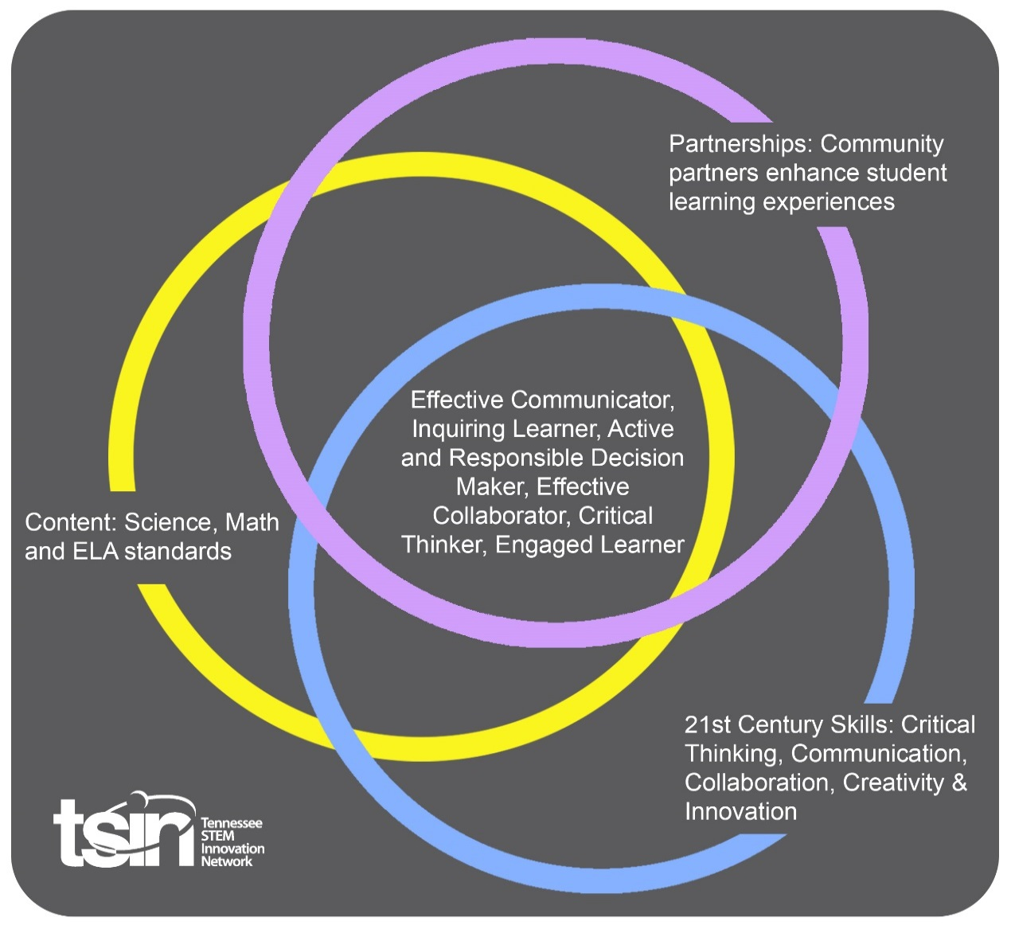

Created By:  Kattie Stevens | Topic:  Cultural Management- How to Protect Artifacts |  | Grade Level or Subject:  5th
Science Standards:

5.ETS1.1
Research, test, re-test, and communicate a design to solve a problem.
5.ETS2.3
Identify how scientific discoveries lead to new and improved technologies.
Math Standards:
5.NF.B.6
Solve real-world problems involving multiplication of fractions and mixed numbers by using visual fraction models or equations to represent the problem.
Social Studies Practice:
SSP.01
Gather information from a variety of primary and secondary sources, including:
- Printed materials
- Graphic representations
- Artifacts
- Media and technology sources

PBL Summary: Write a few sentences describing this PBL unit.  In 1974, Tennessee Valley Authority (TVA) began hiring its own full-time archeology staff. The goal was for this staff to preserve and document the historic sites and structures owned or impacted by TVA. Today, TVA manages over 11,500 archaeological sites. These sites include many dams, powerhouses, and numerous historic structures. TVA works with local groups and communities to protect archaeological sites to preserve them for future generations.  Human beings are one of the greatest threats to historic objects. Many objects are damaged because people vandalize or touch them. In this PBL, students will focus on human impact on archaeological sites and devise an action plan to protect these sites. |  | Driving/Multi-dimensional Question: Think of a relevant problem with multiple solutions that will drive student learning.  How can we, as Archeologists, use scientific ideas and modern technology to solve problems concerning environmental preservation of artifacts?
Tennessee Academic Standards for Science Connection
Disciplinary Core Idea(s):  ESS- Earth and Space Science | Science & Engineering Practice(s):  Constructing Explanations and Designing Solutions |  | Cross Cutting Concept(s):  Cause and Effect
21st Century Skills Addressed (check all that apply):

x Creativity x Collaboration x Critical Thinking x Communication

Culminating Event: What final student learning products will show student mastery of the content area standards?
As an archeologist, students will develop a plan of suggested actions, based on evidence, to show how humans can protect archeological sites in their area.
Hook Event: Develop an introductory activity that will spark student interest and further questions.  Watch TVA Archaeologist video  TVA oversees some 11,500 archaeological sites across the country. Erin Pritchard, an archaeological specialist with TVA, says it is a constant challenge to deal with illegal excavating and looting of artifacts on these sites. (Video by J. Miles Cary/New Sentinel)  Read more about Senior Archaeological Specialist, Erin Pritchard and the Valley’s Legacy. | Community Partners: List potential business or industry partners that could add to the learning experience for students. Include websites or contact info.  1. Erin Dunsmore, TVA Archaeological Specialist  2. Citizen Archivist  3. Archaeological Institute of America |  | What do you need from these partners (i.e. guest speaker, field trip, help facilitate an activity)?  1. Guest speaker  eepritchard@tva.gov  2. Join the National Archives and Records Administration to help transcribe its vast historical records.  www.archives.gov/citizen-archivist  3. Skype an Archaeologist
Daily Activities: What activities will students complete to answer the multi-dimensional/driving question (that reinforces content from the standards)?  Archaeology is the study of people and artifacts from ancient times. Archaeology provides us with the opportunity to learn about past cultures through the study of artifacts, animal bones, and historical structures. Studying various artifacts provides insight and allows us to piece together history.  Activity:  1. What is an Archaeologist? What does and Archaeologist do?  Learn to think like an archaeologist by researching the career expectations of an archaeologist.  - What education is required to be an archaeologist?  - How long does it take to become an archaeologist?  - How much do archaeologist make a year?  - What does and archaeologist do on a daily basis?  2. What Can We Learn from Artifacts?  Students will work in teams to determine what artifacts are, how they are discovered, and what information can be learned from them. Students will use trash to learn about people today, much like archaeologist use ancient “trash” to gain insight about people’s lives in the past.  Materials:  -Rubber gloves  -Trash can filled with garbage  -Newspaper or plastic  Archaeologists dig to look for clues about life in the past. Ancient trash can tell a lot about the past. Long ago, people buried their trash in pits. Objects that don’t decay give a lot of insight about ancient civilization.  - Spread out the newspaper or plastic on the floor or a table.  - Put on rubber gloves.  - Take trash out one piece at a time and place it on the newspaper/plastic.  - Make note of the trash and what kind of story it could tell about the person/family disposing of the trash.  3. Artifact Ethics  Students will work in groups to create an action plan regarding site and artifact protection after exploring the Tennessee Division of Archaeology website .  - Have students examine their own values and views about archaeological site protection.  - Each group should list possible actions they could take regarding site and artifact protection.  - Create a multimedia presentation outlining their Artifacts Ethics Action Plan. |  |  | Resources/Materials Needed:  Hook Activity:  TVA Archaeologist video  Erin Pritchard video  Activity 2:  -Rubber gloves  -Trash can filled with garbage  -Newspaper or plastic  Activity 3:  Tennessee Division of Archaeology
Technology Integration: How is technology embedded into this PBL unit?

Technology is embedded and integrated throughout this PBL by conducting research to gain background knowledge. Students will also use technology to present their “action plan.”
Capstone Presentation: How will students present what they’ve learned publicly? This can be the culminating event if that event is presenting what has been learned publicly.

As an archeologist, develop a plan of suggested actions, based on evidence, to show how humans can protect archeological sites in your area.

Performance Based Rubric
Standards | Developing | On-Target | Mastery
Action Plan Presentation | Presentation did not relate to topic. Included few details and relied heavily upon unsupported opinion. | Presentation related to topic. Included details and relied heavily upon fact. | All content directly related to the topic. Content was thoroughly developed and demonstrated detailed knowledge of the topic.  Opinions were supported by fact wherever possible.

