Eco-Friendly Transportation
Project/Problem Based Learning
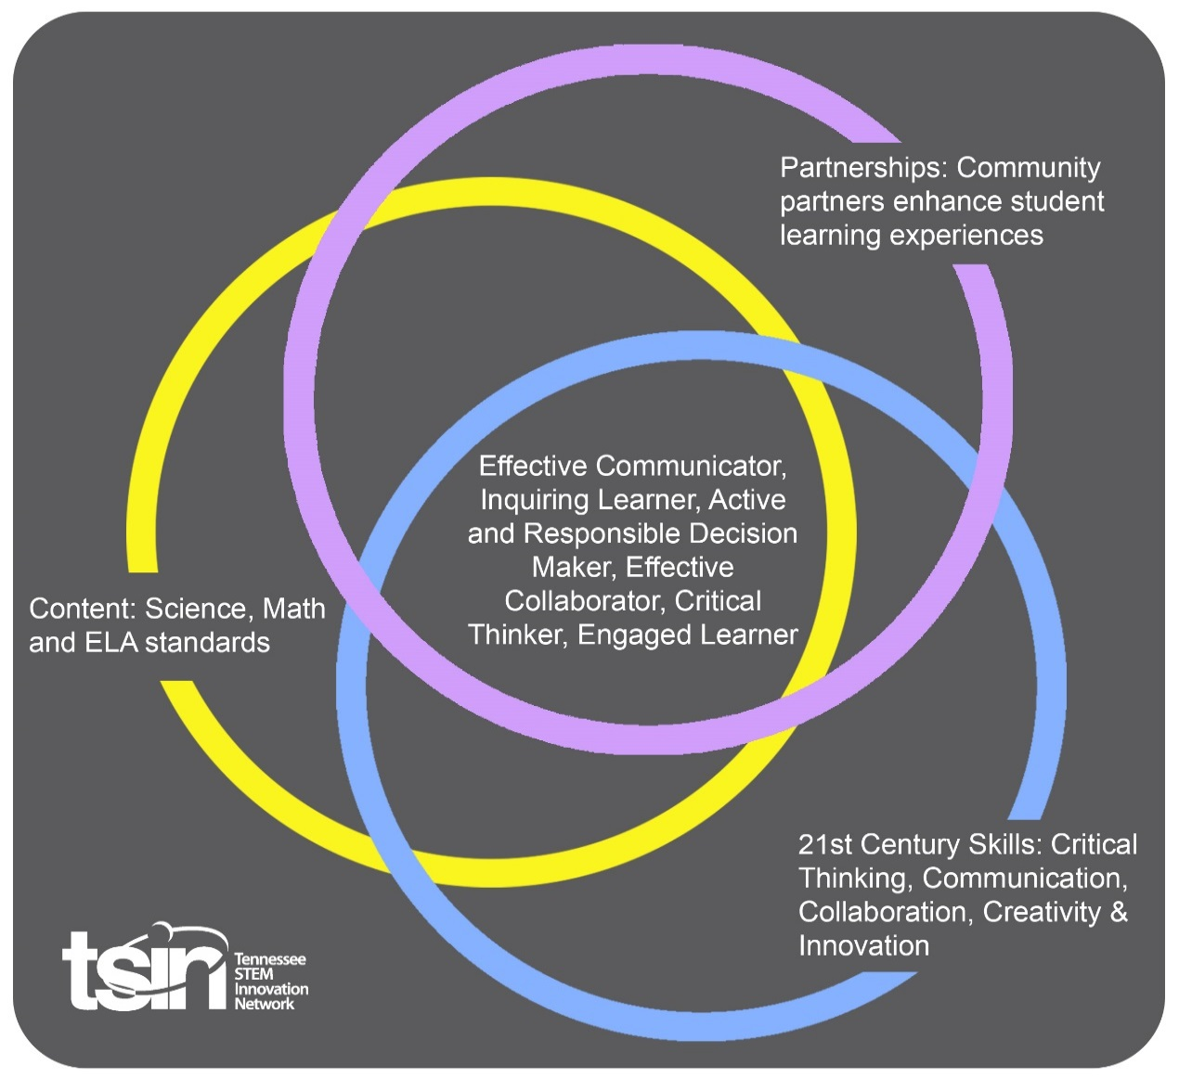

Created By:  Kattie Nash | Topic:  Eco-Friendly Transportation Systems |  | Grade Level or Subject:  5th Grade
Science Standards:
5.ETS2.3 Identify how scientific discoveries lead to new and improved technology.

Math Standards:
5.NF.B.5 Interpret multiplication as scaling.
ELA Standards:
5.SL.CC.1 Prepare for collaborative discussions on 5th grade level topics and texts; engage effectively with varied partners, building on others’ ideas and expressing one’s own ideas clearly.

PBL Summary: Write a few sentences describing this PBL unit.  Innovation is part of TVA’s mission. TVA is embracing electric transportation and developing technologies to encourage the potential for electricity to replace petroleum as the fuel of choice for drivers.  In this PBL, students will analyze and discuss technology innovation along with the role engineers play in developing new energy efficient vehicles. Students will explore the importance of eco-friendly transportation while using ordinary materials to design improved transportation systems. |  | Driving/Multi-dimensional Question: Think of a relevant problem with multiple solutions that will drive student learning.  How can we, as transportation engineers, design an eco-friendly transportation system?

Tennessee Academic Standards for Science Connection
Disciplinary Core Idea(s):  Energy- Renewable and Nonrenewable Resources | Science & Engineering Practice(s):  Asking Questions and Defining Problems | Cross Cutting Concept(s):  Cause and Effect, Mechanisms and Explanation
21st Century Skills Addressed (check all that apply):

x Creativity x Collaboration x Critical Thinking x Communication

Culminating Event: What final student learning products will show student mastery of the content area standards?

Students will design a solution to a real-world problem, eco-friendly transportation, and present their design to the class. A rubric will be used to assess mastery.
Hook Event: Develop an introductory activity that will spark student interest and further questions.  Public transportation plays a role in many environmental challenges. Public transportation can help improve air quality by reducing vehicle emission. Most rail transit vehicles emit little to no pollution, and busses using compressed natural gas produce fewer pollutants. How can we, as Transportation Engineers, design an eco-friendly transportation system for our hometown?  Watch: Air Pollution: Toxins in Car Exhaust | Community Partners: List potential business or industry partners that could add to the learning experience for students. Include websites or contact info.  1. TVA  https://www.tva.gov  2. City Transportation Coordinator  3. Local Civil Engineer | What do you need from these partners (i.e. guest speaker, field trip, help facilitate an activity)?  1. Environmental information, resources, and career guest speakers  2. Explain role and discuss transportation concerns  3. Explain civil engineering and job details
Daily Activities: What activities will students complete to answer the multi-dimensional/driving question (that reinforces content from the standards)?  Activity:  1. Ask:  What is the problem?  What do you already know?  What have others done?  What are the constraints?  How can we, as Transportation Engineers, design an eco-friendly transportation system for our hometown?  -Have students list all transportation options for their town/city.  -Have students research and look at transportation systems in various cities around the world.  Look at futuristic public transportation systems: The Next Level of Public Transport  2. Imagine:  -Brainstorm ideas.  -List possible solutions.  -Research to find out more.  -Choose the best solution.  -Identify renewable energy sources and research alternate forms of transportation.  -Have students look at a city map of their hometown and identify current transportation issues.  -List possible solutions for a new and improved transportation system that is eco-friendlier.  3. Plan  -Draw a diagram.  -List supplies you will need.  -Make a list of the steps you will take.  -Students will work in small groups to design a plan for their eco-friendly transportation system.  -Using poster board, students will sketch out a labeled design. Designs will need to address the current travel issues and design a new system that will produce less pollutants.  Consider how transportation systems are designed before finalizing plans: Why Moving People is Complicated  4. Create  -Follow your plan.  -Build a prototype.  -Test your design.  -Students will use their labeled designs to create a scaled cardboard prototype and a multi-media presentation. Prototypes will be designed to resemble their transportation system and presentations will need to include the following information:  -Current transportation issues  -Plan for eco-friendly transportation  -How their transportation system is more environmentally friendly than cars, trucks and SUVs  5. Improve:  -What worked?  -What didn’t work?  -Make changes.  -Redesign and test again!  -Allow students time to make changes to their design and presentation after initial creation. |  | Resources/Materials Needed:  -Cardboard  -Poster board  -Recycled materials for protypes
Technology Integration: How is technology embedded into this PBL unit?

A variety of technology will be used throughout the daily activities. Students will use web-based devices to research transportation systems, student-made systems, and capstone videos.

Capstone Presentation: How will students present what they’ve learned publicly? This can be the culminating event if that event is presenting what has been learned publicly.

How can we, as Transportation Engineers, design an eco-friendly transportation system for our hometown?

Students will present their final transportation design and explain the anticipated effectiveness of their idea.

Students will create an advertisement to showcase their water transportation system. Students will choose between a billboard, newspaper, or video advertisement. Students will create a catchy name for their transportation system and use graphics to grab the attention of others.

Performance Based Rubric
Engineering, Technology, and Applications of Science
Engineering Design | Developing | On-Target | Mastery
Defining and Delimiting Engineering Problems | The student does not define the problem OR ask a relevant question. | The student defines the problem OR asks a relevant question. | The student defines the problem AND asks a relevant question.
Developing Possible Solutions | The student does not develop a possible solution OR details a plan. | The student develops a possible solution OR details a plan. | The student develops a possible solution and details a plan.
Optimizing the Solution Design | The student does not reflect on the design through journaling OR detail ways to improve. | The student reflects on the design through journaling OR details ways to improve. | The student reflects on the design through journaling AND details ways to improve.

Applications of Science | Developing | On-Target | Mastery
Science Practices: Utilization in Developing and Conducting Original Scientific Research | The student does not participate in scientific research OR summarize the findings of the research. | The student participates in scientific research OR summarizes the findings of the research. | The student participates in scientific research AND summarize the findings of the research.
Practice of Peer Review | The student does not present his or her prototype OR accept peer feedback. | The student presents his or her prototype OR accepts peer feedback. | The student presents his or her prototype AND accepts peer feedback.

