Protecting Earth’s Water Resources

Project/Problem Based Learning

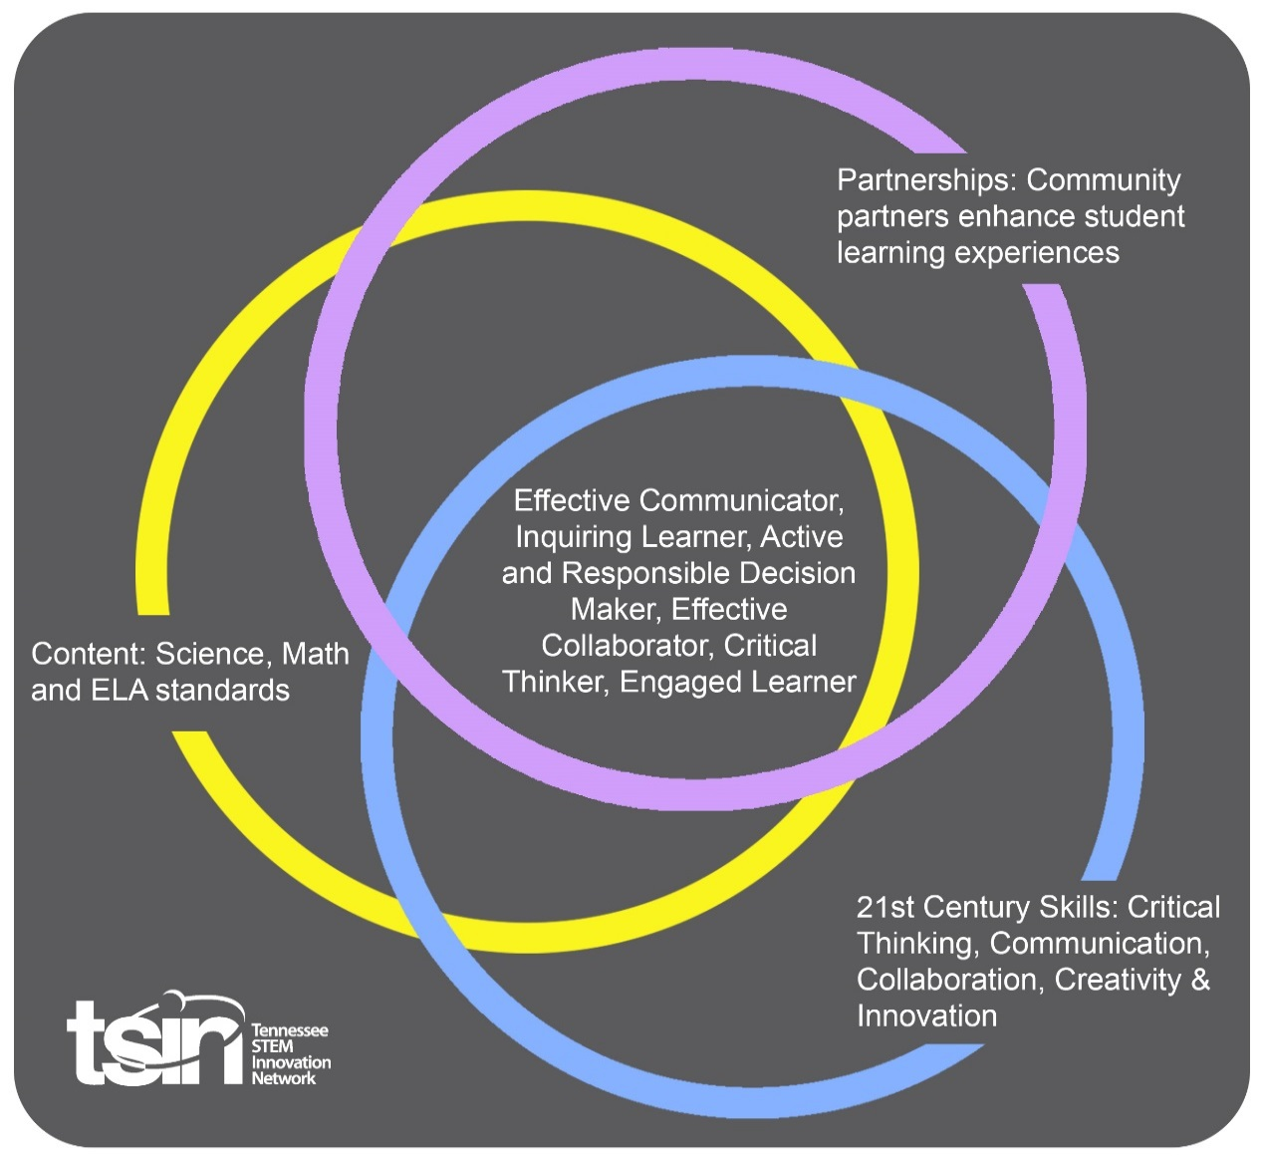

|  |  |  |  |
| --- | --- | --- | --- |
| **Created By:**  Kattie Stevens | **Topic:**  Protecting Earth’s Water Resources | | **Grade Level or Subject:**  5th |
| **Science Standards:**  5.ESS3-1  Obtain and combine information about ways individual communities use science ideas to protect the Earth’s resources. | | | |
| **Math Standards:**  5.NF.B.6  Solve real-world problems involving multiplication of fractions and mixed numbers by using visual fraction models or equations to represent the problem. | | | |
| **PBL Summary:** Write a few sentences describing this PBL unit.  Humans use renewable and nonrenewable resources every day in different aspects of life. Their use can have negative effects on the environment. There is a lot of water on the Earth, but not much of it cannot be used for drinking water or other water supply.  Tennessee Valley Authority (TVA) is committed to protecting the Valley’s natural resources. Environmental stewardship is very important to the mission of service. TVA manages the Tennessee River by monitoring the health of the reservoirs, rivers, and streams.  In this PBL, students will focus on human use of natural resources and develop ways to protect Earth’s water by applying scientific ideas and technology. | | **Driving/Multi-dimensional Question:** Think of a relevant problem with multiple solutions that will drive student learning.  How can we, as Hydrologists, use scientific ideas and modern technology to solve problems concerning water quality and availability? | |
| **Tennessee Academic Standards for Science Connection** | | | |
| Disciplinary Core Idea(s):  ESS- Earth and Space Science | Science & Engineering Practice(s):  Constructing Explanations and Designing Solutions | | Cross Cutting Concept(s):  Cause and Effect |
| **21st Century Skills Addressed (check all that apply):**  x Creativity x Collaboration x Critical Thinking x Communication | | | |
| **Culminating Event:** What final student learning products will show student mastery of the content area standards?  As a hydrologist, use scientific ideas and technology to create a Water Resource Action Plan. Your plan should define actions to reduce water pollutions and ways to reduce negative impacts on local water resources. Begin by identifying a problem with water resources in your community. Explain the cause of the problem, describe the solution, and actions needed. Create a multimedia presentation to present your “action plan” publicly. | | | |
| **Hook Event:** Develop an introductory activity that will spark student interest and further questions.  Roughly 70 percent of the Earth’s surface is covered in water. Even though water seems to be everywhere, not all of it is suitable for use as drinking water. Using a 5-gallon tub, demonstrate how much of all the water on earth is freshwater.   * Fill the 5-gallon tub with water and explain that the water in the tub represents all the water   in the world.  -Types of water supplies represented in the tub: ocean water, ground water, rivers, icecaps/glaciers, freshwater lakes, inland seas/salt lakes and the atmosphere.   * Using a measuring cup, remove 18 ounces of water from the aquarium.   -This water is proportionate to the water that is NOT ocean water   * Color the remaining water in the aquarium green with food coloring.   -This water represents the proportionate amount of water that is in our oceans.     * Pour 15 ounces of the 18 ounces into an ice cube tray.   -This water represents the amount of water held in glaciers and icecaps  -This water is NOT readily available for our use   * The remaining 3 ounces represents the world’s fresh water.   -Of the remaining 3 ounces, only a fraction of an ounce is held in the world’s fresh water lakes and river.  -Use a dropper to remove the “fresh water” and place it in a cup   * Pour the remaining water into the container of sand.   -This water represents the ground water that is held in pore spaces of soil and bedrock  Things that humans do in their everyday life can affect the world around them. However, they can make choices that reduce their impacts on land, water, air, and other living things. In this PBL, students will focus on protecting Earth’s water. | **Community Partners:** List potential business or industry partners that could add to the learning experience for students. Include websites or contact info.  1. Local water treatment facility  2. TVA  3. Local hydrologist | | What do you need from these partners (i.e. guest speaker, field trip, help facilitate an activity)?  1. Field trip or guest speaker  2. Facilitate activity, provide resources, guest speaker  3. Guest speaker, provide resources |
| **Daily Activities:** What activities will students complete to answer the multi-dimensional/driving question (that reinforces content from the standards)?  Where does the water you drink come from? Sure, water is easily accessible from a sink faucet, but where was it before then? Discuss the pathway of water after it is used or after it rains. Complete the following activities to discover the importance of protecting Earth’s water resources.  **Activity:**  **1.** **How Does Water Pollution Spread?**  A watershed is an area of land from which streams, ponds, lakes, and wetlands drain to the same location. A watershed can be large, like the Tennessee River watershed, or small, such as water that drains to a pond. The shape of the land affects how and where the water flows. Watersheds transport pollutants such as, pesticides, fertilizers, sediment, and gas and oil from cars.  TVA’s Watershed Offices are staffed with specialist focused on protecting and improving water and shoreline conditions on the 40,900 square miles of the Tennessee River watershed. TVA focuses on management practices reduce pollutant in a watershed.  Build a simple model of a landscape to learn how water droplets flow and how the shape of the land helps collect the water. This process will depict how pollutants enter the water system from various land use activities and how humans can prevent water pollution.  [Make a Watershed Model](https://serc.carleton.edu/eslabs/drought/2a.html)   * Crumble several pieces of newspaper into balls and rolls of different sizes and shapes. Place them into your roasting pan or paint tray. Use tape to keep them in place. * Lay your plastic bag out flat on a table top or the floor and smooth out the wrinkles. * Place one end of the pan on wood blocks or a notebook, then cover the entire pan and its contents with the plastic. Gently press the plastic down around the crumpled paper balls. Leave the excess plastic around the outside of the box to protect the area from getting wet. * The plastic cover represents Earth's surface. The lumps represent mountains and hills, and the areas between them represent valleys. Use your imagination to visualize your model as a portion of Earth's surface. * Fill your spray bottle with water and add a few drops of blue food coloring to make the water easy to see. Spray just enough rain over your model to see how the water interacts with your model landscape. * Look for these features in your model.   + Streams or Rivers—linear flows of water running downhill;   + Ponds or Lakes—areas where water pools up in low areas; and   + Drainage divides—imaginary lines along which the "rain" goes to one side or another. * Use your cloth or paper towels to absorb the water from your model. Adjust the paper balls and plastic to make your landscape as realistic as you can, then spray it with model rain again. * When you think you can predict the locations of streams and drainage divides on a model landscape, wipe your plastic dry and set up the model again. Use markers to draw your predictions for the locations of streams and divides directly on the plastic. * Pair up with another group and test each groups' predictions about the location of their streams and divides. Discuss the results and your ideas for improving the model.   How do human impacts affect watershed and their associated wildlife?  **2. Cleaning Water**  All animals and plants need water to live. Water is essential to life, and we all depend on fresh, clean water to keep us healthy. Human activities use and pollute water. When water quality is polluted, it can adversely affect all living things.  Should we be concerned with how humans affect the quality of water? What human activities could affect the quality of water?  The Safe Drinking Water Act requires that all drinking water go through a treatment process before it is sent to our taps. The treatment process removes dirt particles, leaves, sticks and contaminants from the water.  Cleaning Water Activity:  **STEP 1:** Place two cups on a flat surface.  **STEP 2:** Add some sand to a third cup, and fill that cup with water.  **STEP 3:** Place the mesh strainer over one of the empty cups. Pour some of the sandy water into that cup, through the mesh strainer.  **STEP 4:** Place a coffee filter in the remaining empty cup. Pour some of the sandy water into that cup, through the coffee filter.  **STEP 5:** Repeat steps 1 through 4 using soil in a cup instead of sand.  **STEP 6:** Record your observations  Visit the [EPA](https://www.epa.gov/waterdata/surf-your-watershed) website to locate and learn more about your local watershed. Identify where the local treatment plant is located and list what communities it provides service to.  List several sources of water pollution and describe how each harms the environment and human health.  **3.** **What Does a Hydrologist Do?**  Hydrologists study how water moves across and through the Earth’s crust. They study how rain, snow, and other forms of precipitation impact river flow or groundwater levels, and how surface water and groundwater evaporate back into the atmosphere or eventually reach the oceans. Hydrologists analyze how water influences the surrounding environment and how changes to the environment influence the quality and quantity of water. They use their expertise to solve problems concerning water quality and availability.  Divide students into groups to research and create a multimedia presentation defining the duties of a hydrologist.  -What does a hydrologist study?  -How much do hydrologists make a year?  -Is a hydrologist an engineer?  -What tools does a hydrologist use?  -What are the duties and responsibilities of a hydrologist?  -What are the education requirements and qualifications to become a hydrologist?  Understanding the role of a hydrologist will be important for students to complete the culminating activity.  4. **How Can We Protect Our Local Water Resources**  As a class, create a larger T chart. Label the left column *Water Users* and the right column *How is Water Used?* On the chart have students list any and all “water users”. Direct students to think about specific places (i.e. schools, farms, business) along with animals and other living things. Divide students into groups to discuss and determine “how water is used” by each type of user. Record responses on the class T chart.  Students drink and use water every day but rarely think about how their bodies NEED and USE water. Most living things are at least half water. This seems like a lot but a fresh carrot is about 88 percent water. Just like humans, carrots would not survive without water.  Have students refer back to the T chart and discuss what would happen if the “water users” didn’t have clean water anymore.  Access to fresh, clean water is essential to society, human health, and the environment. Hydrologist study how water moves across the Earth’s surface and collect water samples daily to ensure clean water is accessible to all. Hydrologist work with city managers, natural resource experts, and legal experts to develop water management plans.  As a hydrologist, use scientific ideas and technology to create a water resource action plan. Your plan should define actions to reduce water pollutions and ways to reduce negative impacts on local water resources. Begin by identifying a problem with water resources in your community. Explain the cause of the problem, describe the solution and actions needed. Create a multimedia presentation to present your “action plan” publicly. | | | Resources/Materials Needed:  **Hook:**  **-5-gallon clear tub or aquarium filled with water**  **-24 oz measuring cup**  **-green food coloring**  **-ice cube tray**  **-ice pack**  **-dropper**  **-clear container (6 ounces or more) filled with sand**  **Activity 1:**  **-Large aluminum roasting pan or paint tray**  **-6 to 10 pages of newspaper**  **-Masking Tape**  **-Sheet of white plastic, slightly larger than the pan (a trash compactor bag cut into single sheet works well)**  **-Spray bottle**  **-Blue food coloring**  **-Absorbent cloth or paper towels**  **-2 different colors of permanent markers**  **-Blocks of wood or a notebook to lift one end of the tray** |
| **Technology Integration:** How is technology embedded into this PBL unit?  Technology is embedded and integrated throughout this PBL by conducting research to gain background knowledge. Students will also use technology to present their “action plan.” | | | |
| **Capstone Presentation:** How will students present what they’ve learned publicly? This can be the culminating event if that event is presenting what has been learned publicly.  As a hydrologist, use scientific ideas and technology to create a water resource action plan. Your plan should define actions to reduce water pollutions and ways to reduce negative impacts on local water resources. Begin by identifying a problem with water resources in your community. Explain the cause of the problem, describe the solution and actions needed to take. Create a multimedia presentation to present your “action plan” publicly. | | | |

**Performance Based Rubric**

|  |  |  |  |
| --- | --- | --- | --- |
| **Standards** | **Developing** | **On-Target** | **Mastery** |
| Science | Does not obtain and combine information about ways individual communities use science ideas to protect the Earth’s resources. | Obtains and combines some information about ways individual communities use science ideas to protect the Earth’s resources. | Obtain and combine information about ways individual communities use science ideas to protect the Earth’s resources. |
| Action Plan Presentation | Presentation did not relate to topic. Included few details and relied heavily upon unsupported opinion. | Presentation related to topic. Included details and relied heavily upon fact. | All content directly related to the topic. Content was thoroughly developed and demonstrated detailed knowledge of the topic.  Opinions were supported by fact wherever possible. |