Wind Turbines
Project/Problem Based Learning
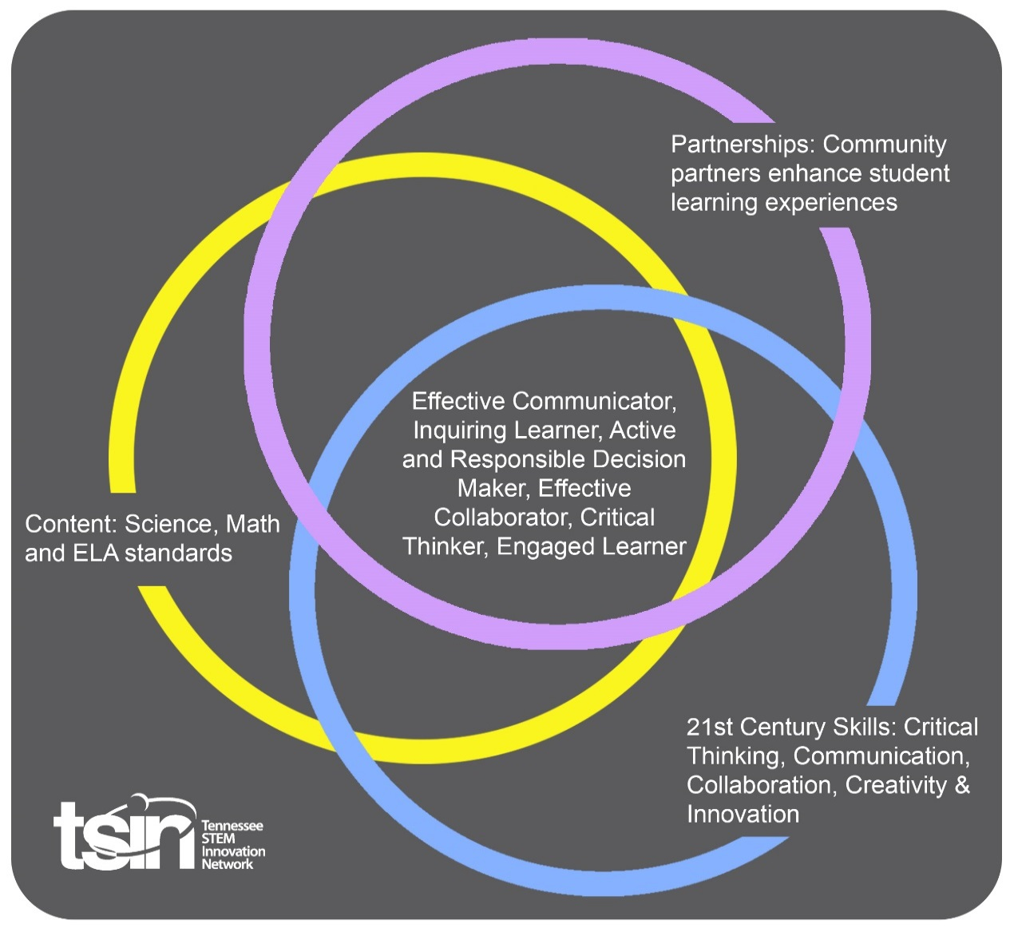

Created By:  Allison Ledford | Topic:  Wind Turbines |  | Grade Level or Subject: 5th grade
Science Standards:
5.ETS1: Engineering Design 1) Research, test, re-test, and communicate a design to solve a problem. 2) Plan and carry out tests on one or more elements of a prototype in which variables are controlled and failure points are considered to identify which elements need to be improved. Apply the results of tests to redesign the prototype. 3) Describe how failure provides valuable information toward finding a solution.

Math Standards:

5.G.A.1 Graph ordered pairs and label points using the first quadrant of the coordinate plane. Understand in the ordered pair that the first number indicates the horizontal distance traveled along the x-axis from the origin and the second number indicates the vertical distance traveled along the y-axis, with the convention that the names of the two axes and the coordinates correspond (e.g., x-axis and x-coordinate, y-axis and y-coordinate).

ELA Standards:
5.W.TTP.2 Write informative/explanatory texts to examine a topic and convey ideas and information.
a. Introduce a topic by providing a general observation and focus.
b. Group related information logically, including formatting features, illustrations, and multimedia when needed to provide clarity to the reader.
c. Develop the topic with facts, definitions, concrete details, quotations, or other information and examples related to the topic.
d. Provide a conclusion related to the information or explanation presented.
e. Link ideas within and across categories of information using words, phrases and clauses.
f. Use precise language and domain-specific vocabulary to inform about or explain the topic.
g. Apply language standards addressed in the Foundational Literacy Standards.
PBL Summary: Write a few sentences describing this PBL unit.  Students will learn about wind energy and experiment with different variables on a wind turbine to find which produces the most energy. Finally, students will identify and solve problems with wind turbines. |  | Driving/Multi-dimensional Question: Think of a relevant problem with multiple solutions that will drive student learning.  How can we, as engineers, design a better wind turbine?
Tennessee Academic Standards for Science Connection
Disciplinary Core Idea(s):  Engineering Design | Science & Engineering Practice(s):  Developing and Using Models |  | Cross Cutting Concept(s):  Energy and Matter
21st Century Skills Addressed (check all that apply):

X Creativity X Collaboration X Critical Thinking X Communication

Culminating Event: What final student learning products will show student mastery of the content area standards?

Students will identify and solve problems with current wind turbines and solve these problems using the engineering design process. Students will present their design ideas by designing a brochure, social media account for their product, or a YouTube video. Students will be graded on a rubric.

Hook Event: Develop an introductory activity that will spark student interest and further questions.  Students will read the book “Energy Island,” as a mentor text. Students will analyze renewable vs. nonrenewable resources. | Community Partners: List potential business or industry partners that could add to the learning experience for students. Include websites or contact info.  - TVA  https://www.tva.com/Our-TVA-Story/Ruth-Horton  - Local meteorologist  - Local Power Company |  | What do you need from these partners (i.e. guest speaker, field trip, help facilitate an activity)?  - Guest speaker  - Guest speaker, hands on with creation of wind turbines  - Guest speaker, hands on with creation of wind turbines, donation of materials
Daily Activities: What activities will students complete to answer the multi-dimensional/driving question (that reinforces content from the standards)?  Activity:  - Ask: What is the problem? Students learn about wind energy. Provide students with 4-5 approved websites and allow them time to research in groups answering the following questions:  -Where does wind come from?  -Where is wind going?  -Who developed the first wind turbines?  -When did wind energy become popular?  Students should be able to find answers about the density of the air and how the air moves sideways as well as upward. Students should be able to explain the wind turbines can be dated as far back as 5000 B.C. when people traveled along the Nile River to propel their boats with wind. Students also might note the Dutch using windmills and those becoming turbines as early as 1890.  Suggested websites for research:  - kiddle.co  - https://poweralliance.org/  - Imagine: Students will understand how wind turbines work and the parts of a modern wind turbine. As the wind blows, the force of the air pushes the blades around. The denser the air the more force it will exert on the blades, hence cold winter air can produce more electricity. The spinning of the blades turns the shaft into the generator which creates the electrical current.  - Plan & Create: Students will then participate in small groups in order to complete today’s challenge. Students experiment with different variables (shape, number of blades, length, and angle in order to see who can produce the most wind energy). Have students come up with the different variables and list them on the board. Optional, students can choose their own groups and come up with a group name.  Students will work through the different steps of the engineering design process: ask, imagine, plan, create and improve with their groups just like real engineers. Allow time for students to sketch out ideas and communicate them with group members.  Optional extension, students could have a budget to purchase necessary materials. Students would have to submit an actual line item budget as a real engineer would on a project before “purchasing materials.”  Once students have had time to imagine and plan with groups, students can either receive or “purchase” their materials they will need to create their turbines. Suggested materials: pencils, scrap paper, cardboard, scissors, dowels, hubs and rulers. The hubs come from a kit with kidwind.org. If this is not an available option, there are free wind turbine templates online  https://www.koolkidscrafts.com/paper-wind-turbine.html  Once students have had the opportunity to build their turbines, allow students to test them and record their data.  If students used a KidWind product they can record voltage, or how fast their turbine is spinning. Alternately, if you are using a paper turbine students can mark one of their blades in a bright color to note how many times their turbine spins in 1 minute time span. Students will record this data on an x,y axis. The number of blade rotations would be the x variable and the y would be amount of time in seconds.  With KidWind kit the x variable would be speed of turbine rotation and the y would be voltage.  - Students should be able to identify and discuss what characteristics made their design successful or not and discuss them as a group. Students will communicate failures and use that knowledge to redesign and then improve their turbine by recreating a turbine. Students will compare their data with their previous attempts. Students will have a class discussion of what went well and what didn’t when their improved designs are completed and tested.  - In this lesson, students will research wind turbines and identify common complaints with current wind turbine design. Students will use what they know as engineers from previous lessons to determine the best design for a wind turbine of the future and address one complaint of current turbines.  Students will determine which presentation mode they will use to present their designs. Rubric attached.  Suggested current event: https://www.mvtimes.com/2019/02/22/stormy-argument-halts-vineyard-wind-hearing/ |  |  | Resources/Materials Needed:  TVA career connection:  https://www.tva.com/Our-TVA-Story/Ruth-Horton  Mentor texts:  “Energy Island,” by Allan Drummond  “The Boy Who Harnessed the Wind” by William Kamkwamba  Kidwind.org
Technology Integration: How is technology embedded into this PBL unit?
Students will be using technology to research wind turbines and multimeters to calculate the energy of each design.

Capstone Presentation: How will students present what they’ve learned publicly? This can be the culminating event if that event is presenting what has been learned publicly.
Students will identify and solve problems with current wind turbines and solve these problems using the engineering design process. Students will present their design ideas by designing a brochure, social media account for their product, or a YouTube video. Students will be graded on a rubric.

Performance Based Rubric
Standards | Developing | On-Target | Mastery
Science  Students will research, test, re-test, and communicate a design to solve a problem. Plan and carry out tests on one or more elements of a prototype in which variables are controlled and failure points are considered to identify which elements need to be improved. Apply the results of tests to redesign the prototype. Describe how failure provides valuable information toward finding a solution. | Students will use some of the steps of the engineering design process to solve a problem. Students will attempt to identify failures. | Students will use most of the steps of the engineering design process to solve a problem. Students will identify failures in their original design and attempt to use them to guide their redesign. | Students will research, test, and communicate a design to solve a problem. Students will complete all steps of the engineering design process, and be able to use failures to guide their redesign.
Math  5.G.A.1 Graph ordered pairs and label points using the first quadrant of the coordinate plane. Understand in the ordered pair that the first number indicates the horizontal distance traveled along the x-axis from the origin and the second number indicates the vertical distance traveled along the y-axis, with the convention that the names of the two axes and the coordinates correspond (e.g., x-axis and x-coordinate, y-axis and y-coordinate). | Students will turn in a coordinate plane with 2 attempts documented. 1 of the original design, 1 of the redesign. | Students will turn in a coordinate plane with 4 attempts documented. 2 of the original design, 2 of the redesign. | Students will turn in a coordinate plane with 6 attempts documented. 3 of the original design, 3 of the redesign.
ELA
See attached rubric from TN Department of Education
Current wind turbine design issue addressed | Student does not address a common issue with the design of a current wind turbine. | Student addresses 1 issue/common complaint with the current design of a wind turbine. | Student addresses 1 issue/common complaint with the current design of a wind turbine. Student discusses how their design will remedy that issue.
Variables (shape, number of blades, length and angle) | During presentation or project students will list 1 variables and how it affects the performance of their turbine. | During presentation or project students will list 2 variables and how it affects the performance of their turbine. | During presentation or project students will list 3 variables and how it affects the performance of their turbine.

