The Nutrient Cycle
Project/Problem Based Learning
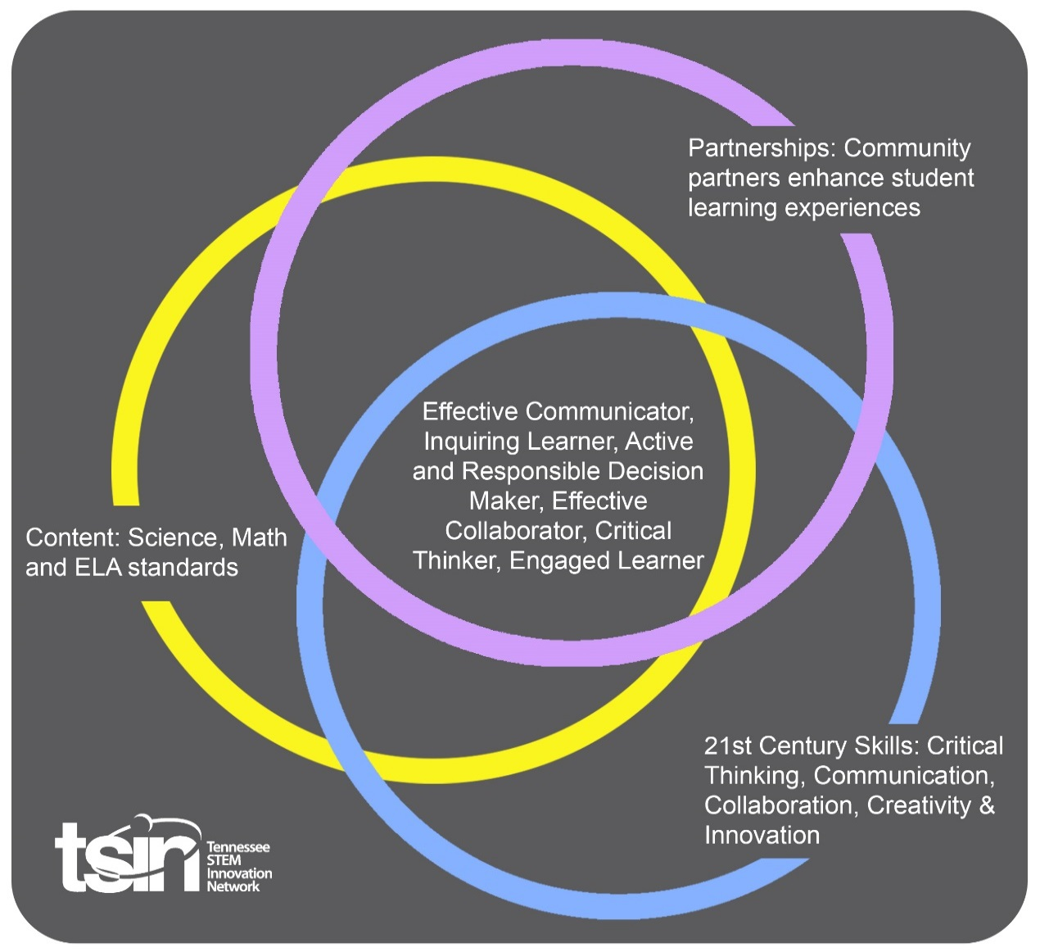

Created By: Sally Rodgers | Topic: The Nutrient Cycle |  |  | Grade Level or Subject: 6-8 science
Science Standards:
MS-LS2-3. | Develop a model to describe the cycling of matter and flow of energy among living and nonliving parts of an ecosystem.

Math Standards:

ELA Standards:

Additional Standards (Social Studies, Art, Physical Education):

PBL Summary: Write a few sentences describing this PBL unit.  Students will explore why living things consume various foods for fuel. As in the commercial, https://www.youtube.com/watch?v=bXL8QPWLbBo all animals need proper nutrition which in turn builds the food web. |  |  | Driving/Multi-dimensional Question: Think of a relevant problem with multiple solutions that will drive student learning.  Why do various living things have varied diets in an ecosystem?
Tennessee Academic Standards for Science Connection
Disciplinary Core Idea:  LS2B: Cycle of Matter and Energy Transfer in Ecosystems  - Food webs are models that demonstrate how matter and energy is transferred between producers, consumers, and decomposers as the three groups interact within an ecosystem. Transfer of matter into and out of the physical environment occur at every level. |  | Science & Engineering Practice(s):  Developing and Using Models  - Modeling in 6-8 bilds on K-5 experiences and progresses to developing, using and revising models to describe, test and predict more abstract phenomena and design systems.  - Develop a model to describe phenomena (MS-LS2-3) |  |  | Cross-Cutting Concepts  Energy and Matter  The transfer of energy can be tracked as energy flows through a natural system (MS-LS2-3)
21st Century Skills Addressed (check all that apply):

X Creativity X Collaboration X Critical Thinking X Communication

Culminating Event: What final student learning products will show student mastery of the content area standards?

Students will design a model of a food web tracking the nutrients through an ecosystem.

Hook Event: Develop an introductory activity that will spark student interest and further questions.  Pick an ecosystem within your county. Research the living (animals and plants) and nonliving (rocks, water, soil) components of the system. What eats what in your ecosystem? Make a diagram to show how the living and nonliving components are interacting. | Community Partners: List potential business or industry partners that could add to the learning experience for students. Include websites or contact info.  - TVA  - Tennessee Department of Environment and Conservation  - TWRA |  |  | What do you need from these partners (i.e. guest speaker, field trip, help facilitate an activity)?  - TVA resources on the each of the ecosystems.  - TDEC resources on the invertebrates often forgotten in a system.  3. TWRA wildlife resources
Daily Activities: What activities will students complete to answer the multi-dimensional/driving question (that reinforces content from the standards)?  Activity:  - Watch the Betty White Snickers commercial to introduce food as fuel. Place students in groups of 4-5. Decide on roles within the group. Groups will select a specific TVA area, referred to as an ecosystem, to research.  - Groups will research living and non-living components of the chosen ecosystem.  - Students will watch the energy flow introduction- https://www.khanacademy.org/science/high-school-biology/hs-ecology/trophic-levels/v/flow-of-energy-and-matter-through-ecosystems  Students will research the flow of energy in their group’s ecosystem.  - Students will create a Food Web model design, representing producers and consumers. Students will label all living and non-living components as either producer or consumer. The food web will represent the flow of energy.  - Students will finalize models and build a presentation to present their model. Peers will review each other’s presentations.  - Students will present their Food Web model to their classmates. |  |  |  | Resources/Materials Needed:  Candy bar video  https://www.youtube.com/watch?v=bXL8QPWLbBo  Pick an area  https://www.tva.com/Environment/Recreation/Small-Wild-Areas  Google doc to share information and images; Google sheet to begin building the model  Internet resources. TDEC, TVA, TWRA  Textbook online or physical  Khan Academy energy flow  https://www.khanacademy.org/science/high-school-biology/hs-ecology/trophic-levels/v/flow-of-energy-and-matter-through-ecosystems
Technology Integration: How is technology embedded into this PBL unit?

Students will use Google docs and Google sheets to communicate with each other in the group. By sharing a document and the sheet all students in the group can review and edit the food web model and information.

Capstone Presentation: How will students present what they’ve learned publicly? This can be the culminating event if that event is presenting what has been learned publicly.

Students will present the digital Food Web models to the class, highlighting the producers and consumers as well as the specific energy flow. The model will be on Google sheets so students can use digital images and present on the Promethean Board. Presentations can be in cartoon strips, rap song, or diorama.

The Nutrient Cycle
Performance Based Rubric
Standards | Developing | On-Target | Mastery
Science | Slight indication of flow of energy for all producers (minimum of 5), consumers (minimum of 2 of any kind), and include decomposers’ (minimum of 1) role in the flow of energy. | Clear indication of flow of energy for all producers (minimum of 3), consumers (minimum of 5 of any kind), and include decomposers’ (minimum of 2) role in the flow of energy. | Clear indication of flow of energy for all producers (minimum of 10), consumers (minimum of 5 of any kind), and include decomposers’ (minimum of 3) role in the flow of energy.
Math
ELA

Social Studies

