Native vs. Non-Native Plants
Project/Problem Based Learning Lesson
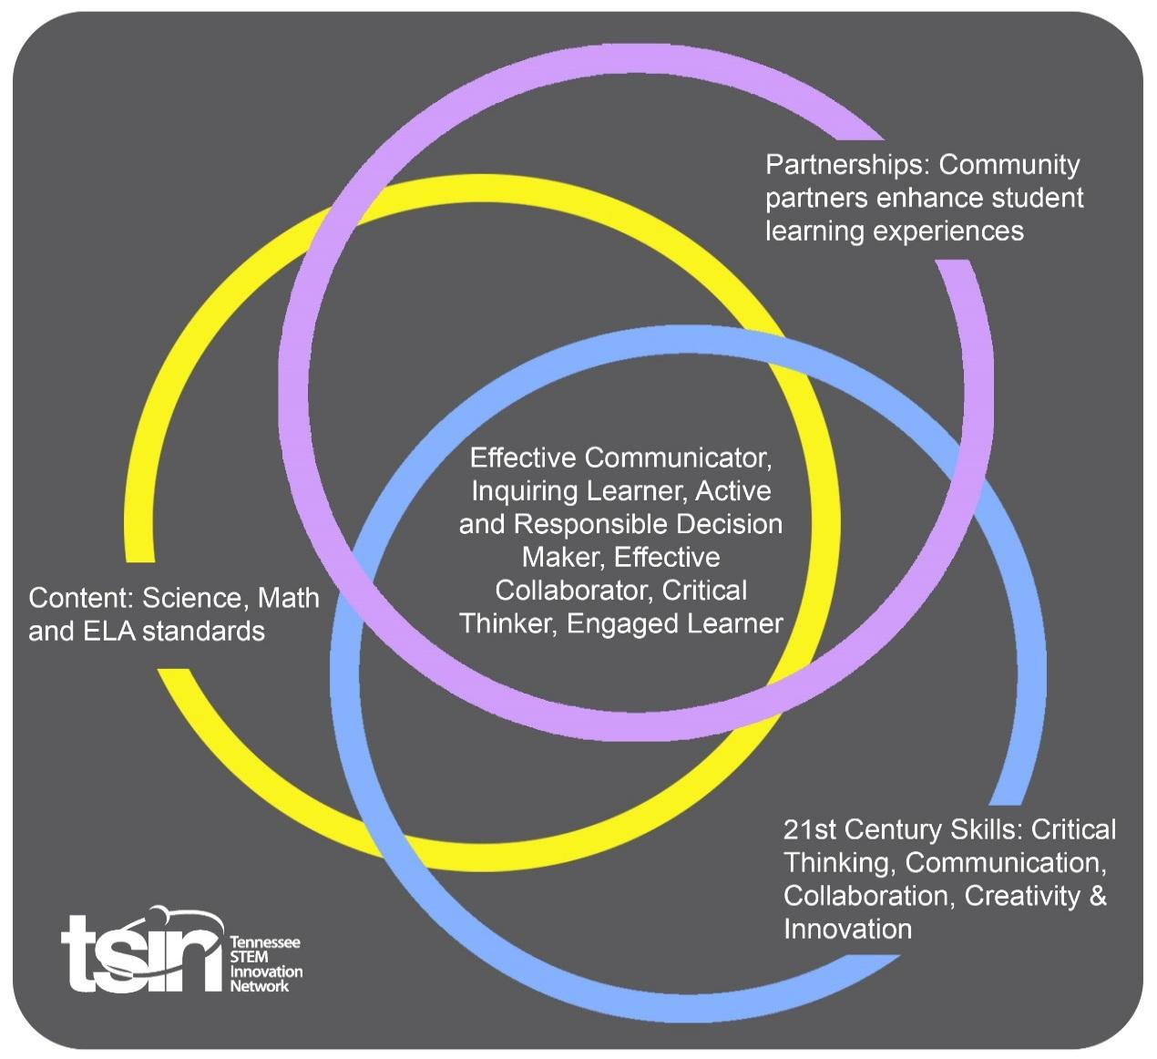

Created By: Molly Plyler | Topic: Native vs. Non-Native Plants |  | Grade Level or Subject: 6th Grade
Science Standards:
6.LS4: Biological Change: Unity and Diversity 1) Explain how changes in biodiversity would impact ecosystem stability and natural resources.

6.LS2: Ecosystems: Interactions, Energy, and Dynamics 3) Draw conclusions about the transfer of energy through a food web and energy pyramid in an ecosystem.

Math Standards:
6.SP.A.2 Understand that a set of data collected to answer a statistical question has a distribution which can be described by its center (mean, median, mode), spread (range), and overall shape.
ELA Standards:
6.SL.PKI.5 Include multimedia components and visual displays in presentations to clarify information.

6.SL.PKI.6 Adapt speech to a variety of contexts and tasks, demonstrating command of formal English when indicated or appropriate.

Additional Standards (Social Studies, Art, Physical Education):

Digital Readiness (Computer Science):
AIT.6 Collect, organize, analyze, and interpret data to identify solutions and/or make informed decisions.

CCP.22 Interpret the flow of execution of algorithms and predict their outcomes.

PBL Summary: Write a few sentences describing this PBL unit.  This PBL unit will ask students to explore proper resource management techniques as students identify native and non-native plants found in the Tennessee Valley. This unit will require students to identify common native and non-native plants found in the Tennessee Valley.  In addition, students will identify non-native, invasive plants found in the Tennessee Valley and explain how their presence impacts ecosystem stability. Then they will create a PSA (public service announcement) to help others understand the effects of introducing non-native species into the environment and provide solutions to prevent further spread of and/or eradicate these non-native plants. |  | Driving/Multi-dimensional Question: Think of a relevant problem with multiple solutions that will drive student learning.  You have been asked to create a PSA to inform others of the dangers that non-native plants have on ecosystem stability in the Tennessee Valley. The PSA should explain how non-native species cause ecosystem instability, provide solutions for avoiding their introduction and/or create a plan to eradicate current non-native plants.
Tennessee Academic Standards for Science Connection
Disciplinary Core Idea(s):  LS – Life Sciences | Science & Engineering Practice(s):  CEDS – Constructing explanations and designing solutions to explain phenomena or solve problems. |  | Cross Cutting Concept(s):  SC – Stability and change of systems  EM – Energy and matter conservation through transformations that flow or cycle into, out of, or within a system
21st Century Skills Addressed (check all that apply):

X Creativity X Collaboration X Critical Thinking X Communication
Culminating Event: What final student learning products will show student mastery of the content area standards?

Students will create a PSA video or poster to inform others of the dangers that non-native species have on ecosystem stability in the Tennessee Valley. Students will present their PSAs at a school STEM night.

Hook Event: Develop an introductory activity that will spark student interest and further questions.  Think-Pair-Share Activity  Imagine that aliens have invaded this planet. Have students think about how an alien invasion could negatively impact us. Then students will pair with a fellow classmate and share their thoughts. | Community Partners: List potential business or industry partners that could add to the learning experience for students. Include websites or contact info.  - TVA Natural Resource Management professional  - National or State Park Ranger  - Local nursery or landscaping company |  | What do you need from these partners (i.e. guest speaker, field trip, help facilitate an activity)?  - Guest speaker - discusses common native and non-native plants local to the area  - Field trip - students travel to a national or state park to see firsthand how non-native species impact local ecosystems  - Guest speaker - discusses the advantages of using native plants in residential landscaping
Daily Activities: What activities will students complete to answer the multi-dimensional/driving question (that reinforces content from the standards)?  Activity:  - Alien Invaders: A Threat to Ecosystem Stability  KWL Organizer for Non-Native Species  In the first column, students will write what they know about non-native species and how they impact biodiversity and ecosystem stability. In the second column, students will write what they want to know about non-native species and how they impact biodiversity and ecosystem stability. After students watch the provided videos, they will complete the last column with what they learned about non-native species and how they impact biodiversity and ecosystem stability.  - Food Chains & Ecosystem Disruptions  Creative Coding  Using Brain Pop’s Creative Coding website, create a newscast to review your knowledge about food chains and energy flow through ecosystems. Remember to change the Creative Coding “backgrounds” to see how food chain disruptions can impact an ecosystem’s stability.  - Plants of the Tennessee Valley  Memory Game  Students will research native and non-native plants found in the Tennessee Valley. A list of relevant websites has been provided.  Using note cards, students will paste a picture of one labelled plant on one card and the plant's name and identification as native or non-native plant on the second card. Students will repeat this process for 8 different plants, four native and four non-native.  Once students have created their note cards (16 total = 8 with pictures and 8 with name and native vs. non-native identification), they will find a partner and play a game of “Memory.”  All note cards will be face down. One person will select two cards and try to match a plant’s picture to its identification and name. If the person correctly matches the two cards, they may keep the cards. If the cards are not a match, they will place the cards face down and the other student will have a turn.  The game will continue until all plant cards are correctly matched. The person with the most pairs will win.  - Tracking the Invaders  Case Study: Hydrilla (Hydrilla verticillata)  After viewing the provided resources, students should answer the following questions:  - What trends do you see with regards to the spread or range of Hydrilla?  - What do the maps, provided in the U.S. Fish & Wildlife Service document, tell you about hydrilla’s climate preference? Think in terms of mean, median and mode.  - If hydrilla continues to invade other U.S. states, which states do you think will be next? Explain your answer.  - Public Service Announcement (PSA)  Tennessee Valley Non-Native Species PSA  Students will create a PSA video or poster about one or more non-native plant species found in the Tennessee Valley. The PSA should inform others of the dangers that non-native species have on ecosystem stability, solutions for avoiding their introduction and/or a plan to eradicate their presence.  Students will present their PSA to the class. Later PSAs will be presented at a school STEM night.  - Optional Extension: Informative Website  Students learn how to create a webpage or website using HTML and CSS using the Hour of Code tutorial from HTML Academy. They will then pair program to create a webpage or website using Code.org’s Web Lab. The webpage or website must be about a particular aspect of resource management with regards to native and non-native plants of the Tennessee Valley  - Optional Extension: Field Trip to State or Federal Park  Go on a class field trip to a State or Federal Park. Work with local natural resource management personnel to remove non-native species and plant native species. |  |  | Resources/Materials Needed:  - 1. National Park Service: Managing Invasive Species https://www.nps.gov/subjects/invasive/index.htm  Knoxville News Sentinel: TVA Manages Invasive Species in Area Waterways https://www.youtube.com/watch?v=LCEKI41H_bI  Tennessee Aquarium: A Battle Worth Carping About (Part 1): The Asian Invasion https://www.youtube.com/watch?v=pjAvV5cN0WA&feature=emb_logo  2. Science: Food Chain (Vidcode) https://go.brainpop.com/vidcode/foodchains  3. Tennessee Valley Authority  https://www.tva.gov/file_source/TVA/Site%20Content/Environment/Environmental%20Stewardship/Land%20Management/plantguide.pdf  Tennessee Valley Authority  https://www.tva.gov/Environment/Environmental-Stewardship/Anglers-Aquatic-Plant-ID/How-TVA-Manages-Aquatic-Plants  USGS (note: plants are at the end of the list)  https://nas.er.usgs.gov/queries/SpeciesList.aspx?Group=&Sortby=1&state=TN  Tennessee Invasive Plant Council  https://www.tnipc.org/invasive-plants/  Wild Ones: Tennessee Valley Chapter  https://tennesseevalley.wildones.org/learn/invasive-pest-plants/  Tennessee State Government  https://www.tn.gov/protecttnforests/forest-health/invasive-plants.html  4. Tennessee Valley Authority  https://www.tva.gov/Environment/Environmental-Stewardship/Anglers-Aquatic-Plant-ID/Hydrilla-(D%E2%80%93Hyrdilla,-M%E2%80%93Hydrilla)  Cornell University’s Naturalist Outreach (11 minute video)  https://www.youtube.com/watch?v=syyl039vAZA&feature=emb_logo  U.S. Fish & Wildlife Service  https://www.fws.gov/fisheries/ANS/erss/highrisk/Hydrilla-verticillata-dioecious-ERSS-FINAL.pdf  5. Center for Digital Education: How to Create the Perfect PSA  https://www.govtech.com/education/news/how-to-create-the-perfect-public-service-announcement.html  Tennessee Invasive Plant Council: Plant Alternatives to Non-Native Invasives  https://www.tnipc.org/wp-content/uploads/2017/10/alternatives_printableweb2016.pdf  6. Pair Programming video - https://www.youtube.com/watch?v=q7d_JtyCq1A&vl=en  Hour of Code tutorials on how to create a webpage using HTML and CSS can be found at https://hourofcode.com/htmlmuffin  Code.org’s Web Lab - https://studio.code.org/projects
Technology Integration: How is technology embedded into this PBL unit?

Students will use digital productivity tools, Brain Pop’s Creative Coding website and the Internet for research, assignments and PSA creation. As an extension activity, students may also use Code.org’s Web Lab programming environment and HTML Academy’s “HTML and CSS Basics” website development online tutorial.

Capstone Presentation: How will students present what they’ve learned publicly? This can be the culminating event if that event is presenting what has been learned publicly.

Students will create a PSA video or poster to inform others of the dangers that non-native species have on ecosystem stability in the Tennessee Valley and provide solutions for avoiding their introduction and/or eradicating them. Students will present their PSAs at a school STEM night.

Performance Based Rubric
Standards | Developing | On-Target | Mastery
Science - Biological Change | Student is unable to explain how changes in biodiversity would impact ecosystem stability and natural resources in their PSA. | Student is somewhat able to explain how changes in biodiversity would impact ecosystem stability and natural resources in their PSA. | Student is able to explain how changes in biodiversity would impact ecosystem stability and natural resources in their PSA.
Science - Ecosystems | Student is unable to draw conclusions about the transfer of energy through a food web and energy pyramid in an ecosystem when disruptions occur due to non-native species. | Student is somewhat able to draw conclusions about the transfer of energy through a food web and energy pyramid in an ecosystem when disruptions occur due to non-native species. | Student is able to draw conclusions about the transfer of energy through a food web and energy pyramid in an ecosystem when disruptions occur due to non-native species.
Math | Student is unable to understand that a set of data collected on invasive species in order to answer a statistical question has a distribution which can be described by its center (mean, median, mode), spread (range), and overall shape as presented on maps. | Student is somewhat able to understand that a set of data collected on invasive species in order to answer a statistical question has a distribution which can be described by its center (mean, median, mode), spread (range), and overall shape as presented on maps. | Student is able to understand that a set of data collected on invasive species in order to answer a statistical question has a distribution which can be described by its center (mean, median, mode), spread (range), and overall shape as presented on maps.
ELA - Multimedia Components and Visual Displays | Student includes incomplete multimedia components and visual displays in their PSA. | Student includes clear and informative multimedia components and visual displays in their PSA. | Student includes exceptional multimedia components and visual displays in their PSA.
ELA - Speech | Student demonstrates appropriate command of formal English when indicated or appropriate while presenting their PSA. | Student demonstrates clear and articulate command of formal English when indicated or appropriate while presenting their PSA. | Student demonstrates exceptional command of formal English when indicated or appropriate while presenting their PSA.
Digital Readiness - Analytical & Innovative Thinking | Student is unable to collect, organize, analyze, and interpret data to identify solutions and/or make informed decisions when creating their PSA and researching non-native species. | Student is somewhat able to collect, organize, analyze, and interpret data to identify solutions and/or make informed decisions when creating their PSA and researching non-native species. | Student is able to collect, organize, analyze, and interpret data to identify solutions and/or make informed decisions when creating their PSA and researching non-native species.
Digital Readiness - Coding & Computer Programming | Student is unable to interpret the flow of execution of algorithms and predict their outcomes during the Creative Coding activity. | Student is somewhat able to interpret the flow of execution of algorithms and predict their outcomes during the Creative Coding activity. | Student is able to interpret the flow of execution of algorithms and predict their outcomes during the Creative Coding activity.

