Benefits of Pollinator Plants
Project/Problem Based Learning Template
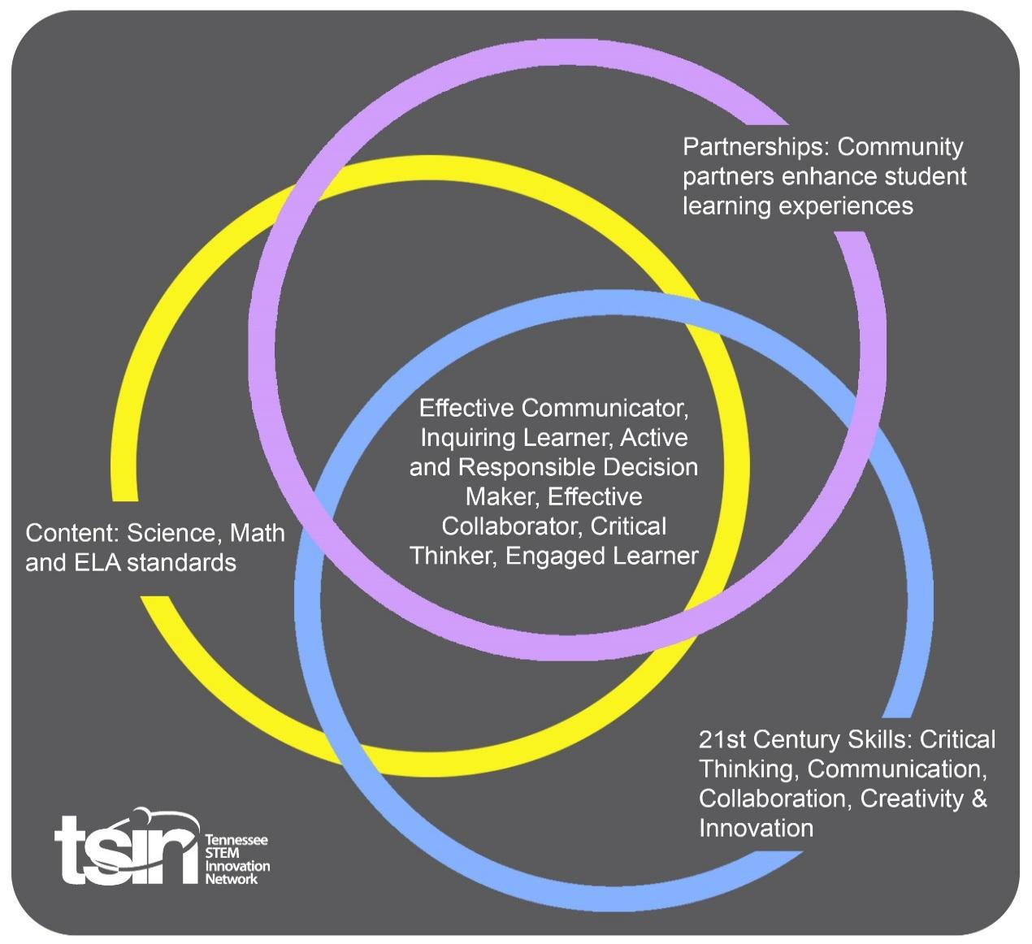

Created By: Molly Plyler | Topic: Benefits of Pollinator Plants | Grade Level or Subject: 7th Grade
Science Standards:
7.LS1: From Molecules to Organisms: Structures and Processes 6) Develop an argument based on empirical evidence and scientific reasoning to explain how behavioral and structural adaptations in animals and plants affect the probability of survival and reproductive success.

Math Standards:
7.G.B.5 Solve real-world and mathematical problems involving area, volume, and surface area of two- and three-dimensional objects composed of triangles, quadrilaterals, polygons, cubes, and right prisms.
ELA Standards:
7.W.TTP.1 Write arguments to support claims with clear reasons and relevant evidence.

7.SL.PKI.5 Include multimedia components and visual displays in presentations to clarify claims and findings and to emphasize major points.

Additional Standards (Social Studies, Art, Physical Education):

Digital Readiness (Computer Science):
AIT.6 Collect, organize, analyze, and interpret data to identify solutions and/or make informed decisions.

CCP.22 Interpret the flow of execution of algorithms and predict their outcomes.

PBL Summary: This PBL unit will ask students to explore proper resource management techniques as students learn the benefits of planting pollinator plants. Students will further explain how behavioral and structural adaptations increase a species’ survival and reproductive success.  This unit will require students to identify common, native pollinator plants found in the Tennessee Valley. Then they will design and build a school garden or greenspace utilizing these plants. |  | Driving/Multi-dimensional Question: Think of a relevant problem with multiple solutions that will drive student learning.  You have been asked to design and build a garden or greenspace at your school using pollinator plants found in the Tennessee Valley. Your design should also take into consideration the behaviors and structures of pollinators in order to increase survival and reproductive success.  Once your garden / greenspace is built, you will create visual displays to communicate the benefits of planting pollinator plants to those visiting your garden / greenspace.
Tennessee Academic Standards for Science Connection
Disciplinary Core Idea(s):  LS – Life Sciences | Science & Engineering Practice(s):  Engaging in argument from evidence - Students present an argument based on empirical evidence, models, and invoke scientific reasoning. |  | Cross Cutting Concept(s):  Cause and Effect - Students infer and identify cause and effect relationships from patterns.
21st Century Skills Addressed (check all that apply):

X Creativity X Collaboration X Critical Thinking X Communication

Culminating Event: What final student learning products will show student mastery of the content area standards?

Students will design and build a school garden or greenspace which incorporates pollinator plants native to the Tennessee Valley. The garden will have information posted communicating to visitors the benefits of pollinator plants.

Hook Event: Develop an introductory activity that will spark student interest and further questions.  Draw-Pair-Share Activity  Imagine the school is going to start a garden. What items do you need to include in your garden in order for plants to grow, even when school is not in session and no one is around to care for the garden? Have students draw their garden. Then students will pair with a fellow classmate and share their thoughts. | Community Partners: List potential business or industry partners that could add to the learning experience for students. Include websites or contact info.  - TVA Natural Resource Management professional  - National or State Park Ranger  - Local nursery or landscaping company  - Local beekeeper / member of local beekeeper association | What do you need from these partners (i.e. guest speaker, field trip, help facilitate an activity)?  - Guest speaker - discuss the benefits of planting pollinator plots  - Field trip - students travel to a national or state park to see firsthand how pollinators benefit the ecosystem  - Guest speaker / Activity facilitator - discuss the advantages of using native, pollinator plants in residential landscaping; assist students as they design their school garden  - Guest speaker - discuss native pollinator plants and how the presence of these plants influence local honey production

Daily Activities: What activities will students complete to answer the multi-dimensional/driving question (that reinforces content from the standards)?  Activity:  - The Importance of Pollinators  KWL Organizer on the topic “Pollinators”  In the first column, students will write what they know about pollinators. In the second column, students will write what they want to know about pollinators. After students watch the provided videos, they will complete the last column with what they learned about the importance of pollinators.  - Insect Pollinators  Tracking Monarch Butterflies  Monarch butterflies are one example of a pollinator. Through the Monarch Watch Tagging Program, scientists track and study monarchs as they migrate each fall.  In this activity, students work with a partner to study the data provided on the Monarch Watch 2019 Season Tag Recoveries - Domestic Google sheet. Students are encouraged to pay special attention to the data in the “Notes” column.  Groups should be prepared to share with the class their observations of the data and provide informed decisions on how to best design a school greenspace or garden which could attract Monarch butterflies.  - Native Pollinator Plants & the Pollinators They Attract  Dear Pollinator Letter  Students will practice letter composition and point of view writing. Using knowledge of pollinators and their needs, students should select one animal pollinator and write a letter to that pollinator. The letter should provide clear and relevant evidence on the benefits of visiting that pollinator in a particular garden.  Visit benefits should include the following:  - Pollinator plants present in the garden which are native to the Tennessee Valley and appealing to the designated pollinator  - Specific pollinator plant structure(s) which aids in that animal’s probability of survival and reproductive success  - Components of garden’s design which aid in the survival and reproductive success of the pollinator  - Pollinator Habitats  Virtual Habitat Design  Students will design and program a virtual habitat for a pollinator of their choice using Code.org’s Game Lab. Students should include a pollinator and a pollinator plant which that particular pollinator is attracted to. Habitats may be coded to resemble an interactive postcard OR a video game.  Students may source images of their selected pollinator and pollinator plants from the Internet. These images can then be uploaded into Code.org’s Game Lab under the “Animation” tab and used in programming their virtual habitat, interactive postcard OR video game.  Code may be written in Blockly or JavaScript. Sample Game Lab projects are provided on the Code.org website. Students may “Remix” an existing project and customize it with their own images.  - Pollinator Garden / Greenspace Layout  Design and Build a School Garden or Greenspace  Students will work in groups to design and build a school garden or greenspace, as dictated by their teacher.  Groups will need to be able to explain how their garden/greenspace’s design will increase the probability of pollinator survival and/or reproductive success. This can include items such as which pollinator plants are in their garden and/or nesting opportunities.  Groups will be asked to calculate the quantity of garden supplies needed. This can include the amount of wood needed to build the bed; volume of water needed per garden; soil needed for planting.  Once groups have successfully designed and built their pollinator garden, students should create visual displays to explain the benefits of pollinator plants for individuals visiting these school pollinator gardens.  - Optional Extension: Monarch Tagging  Teachers order Monarch Watch Tagging Kits so students can tag and track Monarch butterflies that appear in the school garden/greenspace.  Provided video gives instructions for properly catching and tagging the butterflies.  Note: it may be easier to order Monarch butterflies to release  - Optional Extension: 3D Print a Hummingbird Feeder  Hummingbirds are another example of a pollinator. Students can use a 3D printer to design a hummingbird feeder for their school garden/greenspace.  Students can use software such as Tinkercad to design their 3D printer file. OR students can print using completed digital files found on Thingiverse. | Resources/Materials Needed:  - 1. California Academy of Science: Why Protect Pollinators?  - https://www.calacademy.org/educators/why-protect-pollinators  - Tennessee Wildlife Resource Agency: Habitat Pollinator Plot  - https://www.youtube.com/watch?v=E0RGH0G4bVI  Knoxville WVLT News: Rare animals thrive beneath TVA power lines (Cumberland Plateau)  https://www.wvlt.tv/content/news/Under-TVA-power-lines-rare-animals-thrive-563652341.html  2. MonarchWatch.org: Tagging Monarchs  https://monarchwatch.org/tagging/  Google Sheet: Monarch Watch 2019 Season Tag Recoveries - Domestic  https://docs.google.com/spreadsheets/d/1GKkZIEXjI5BjOOvNo40hsCJoWNJq2pucj01GpQVFynM/edit#gid=1710298744  3. Google Slide Deck: Attracting Butterflies to Your Yard (created by Master Gardener, Jennifer Johnson)  https://drive.google.com/file/d/1VXjN9fN5cYnVdO3_cNxNpnperTg4sAzZ/view?usp=sharing  Wild Ones Tennessee Valley Chapter: Native Plants for Pollinators  https://tnvalleywildones.org/wp-content/uploads/2018/09/Plant-Growing-Requirements.pdf  Southeastern Grassland Initiative: TVA Rights-of-Way: Ruderal Habitats or Pre-settlement Savanna Conditions?  https://www.segrasslands.org/news-page/2019/6/18/exciting-news-from-the-first-surveys-of-the-tva-rights-of-way-project  City of Gallatin: Save the Monarch  https://www.youtube.com/watch?v=Vg7bciQHO6I&feature=emb_logo  4. Code.org: Game Lab  https://code.org/educate/gamelab  Code.org’s CSD Unit 3 - Animations and Games: Lesson 14 Project “Interactive Card” tutorial  https://studio.code.org/s/csd3-2019/stage/14/puzzle/1?section_id=2652742  Code.org’s CSD Unit 3 - Animations and Games: Lesson 22 Project “Design a Game” tutorial  https://studio.code.org/s/csd3-2019/stage/22/puzzle/1?section_id=2652742  Code.org Gardening Game: Click Make My Own (allows you to remix the project so you can add your own images)  https://studio.code.org/projects/gamelab/DmRPNYR3n7bMO--_KkP7r6mOoGynBVyi3BMVPWDiVeI  NOTE: This activity can also be completed on other coding platforms such as Scratch or Bitsbox.  Scratch - https://scratch.mit.edu/  Bitsbox - https://bitsbox.com/code.html  5. UT Institute of Agriculture: Create Your Own Butterfly Garden!  https://ag.tennessee.edu/tnyards/Documents/Butterfly_garden_website.pdf  U.S. Forest Service: Gardening for Pollinators  https://www.fs.fed.us/wildflowers/pollinators/gardening.shtml  Tennessee Department of Transportation: Pollinator Habitat Program  https://www.tn.gov/tdot/environmental-home/environmental-highway-beautification-office/beautification-pollinator-habitat-program.html  Gardener’s Supply Company: Garden Design “Pollinator Gardens”  https://www.gardeners.com/how-to/pollinator-garden-design-for-bees/9144.html  Pollinator Gardens: Simple Tips for Creating a Pollinator-Friendly Landscape  https://pollinatorgardens.org/2016/01/12/design-ideas-for-gardeners/  The Tennessee Magazine: Pollinator gardens: a trend that puts some buzz in your landscape  https://www.tnmagazine.org/pollinator-gardens-a-trend-that-puts-some-buzz-in-your-landscape/  6. Monarch Watch Tagging Kits  https://monarchwatch.org/tagging/  Monarch Watch: Butterfly School  https://www.youtube.com/watch?v=SbBW3LUFZ6M&feature=emb_logo  7. Tinkercad: Create 3D Digital Designs  https://www.tinkercad.com/  Thingiverse: Digital Designs  https://www.thingiverse.com/  Thingiverse: Hummingbird Feeder 3D Printer Files  - https://www.thingiverse.com/search?q=hummingbird+feeder&type=things&sort=relevant
Technology Integration: How is technology embedded into this PBL unit?

Students will use digital productivity tools, Code.org’s Game Lab and the Internet for research and PBL assignments. As an extension activity, students may also use a 3D printer and relate digital resources to print a hummingbird feeder.

Capstone Presentation: How will students present what they’ve learned publicly? This can be the culminating event if that event is presenting what has been learned publicly.

Students will communicate the benefits of pollinator plants to visitors using displays posted around the school garden or greenspace. Students and their families will be encouraged to work in the garden on school STEM nights.

Performance Based Rubric
Standards | Developing | On-Target | Mastery
Science - Structures and Processes | Student is unable to develop an argument based on empirical evidence and scientific reasoning to explain how behavioral and structural adaptations in animals and plants affect the probability of survival and reproductive success when writing their pollinator letter and designing their school pollinator garden/greenspace. | Student is somewhat able to develop an argument based on empirical evidence and scientific reasoning to explain how behavioral and structural adaptations in animals and plants affect the probability of survival and reproductive success when writing their pollinator letter and designing their school pollinator garden/greenspace. | Student is able to develop an argument based on empirical evidence and scientific reasoning to explain how behavioral and structural adaptations in animals and plants affect the probability of survival and reproductive success when writing their pollinator letter and designing their school pollinator garden/greenspace.
Math | Student is unable to solve real-world and mathematical problems involving area, volume, and surface area of two- and three-dimensional objects composed of triangles, quadrilaterals, polygons, cubes, and right prisms when designing and building a school garden / greenspace. | Student is somewhat able to solve real-world and mathematical problems involving area, volume, and surface area of two- and three-dimensional objects composed of triangles, quadrilaterals, polygons, cubes, and right prisms when designing and building a school garden / greenspace. | Student is able to solve real-world and mathematical problems involving area, volume, and surface area of two- and three-dimensional objects composed of triangles, quadrilaterals, polygons, cubes, and right prisms when designing and building a school garden / greenspace.
ELA - Writing | Student is unable to write arguments to support claims with clear reasons and relevant evidence when composing their pollinator letter. | Student is somewhat able to write arguments to support claims with clear reasons and relevant evidence when composing their pollinator letter. | Student is able to write arguments to support claims with clear reasons and relevant evidence when composing their pollinator letter.
ELA - Multimedia Components and Visual Displays | Student includes incomplete multimedia components and visual displays in their school garden / greenspace to explain the benefits of pollinator plants. | Student includes clear and informative multimedia components and visual displays in their school garden / greenspace to explain the benefits of pollinator plants. | Student includes exceptional multimedia components and visual displays in their school garden / greenspace to explain the benefits of pollinator plants.
Digital Readiness - Analytical & Innovative Thinking | Student is unable to collect, organize, analyze, and interpret data to identify solutions and/or make informed decisions when completing the “Tracking Monarch Butterflies” activity. | Student is somewhat able to collect, organize, analyze, and interpret data to identify solutions and/or make informed decisions when completing the “Tracking Monarch Butterflies” activity. | Student is able to collect, organize, analyze, and interpret data to identify solutions and/or make informed decisions when completing the “Tracking Monarch Butterflies” activity.
Digital Readiness - Coding & Computer Programming | Student is unable to interpret the flow of execution of algorithms and predict their outcomes when coding their virtual habitat. | Student is somewhat able to interpret the flow of execution of algorithms and predict their outcomes when coding their virtual habitat. | Student is able to interpret the flow of execution of algorithms and predict their outcomes when coding their virtual habitat.

