Amusement Park Ride
Project/Problem Based Learning
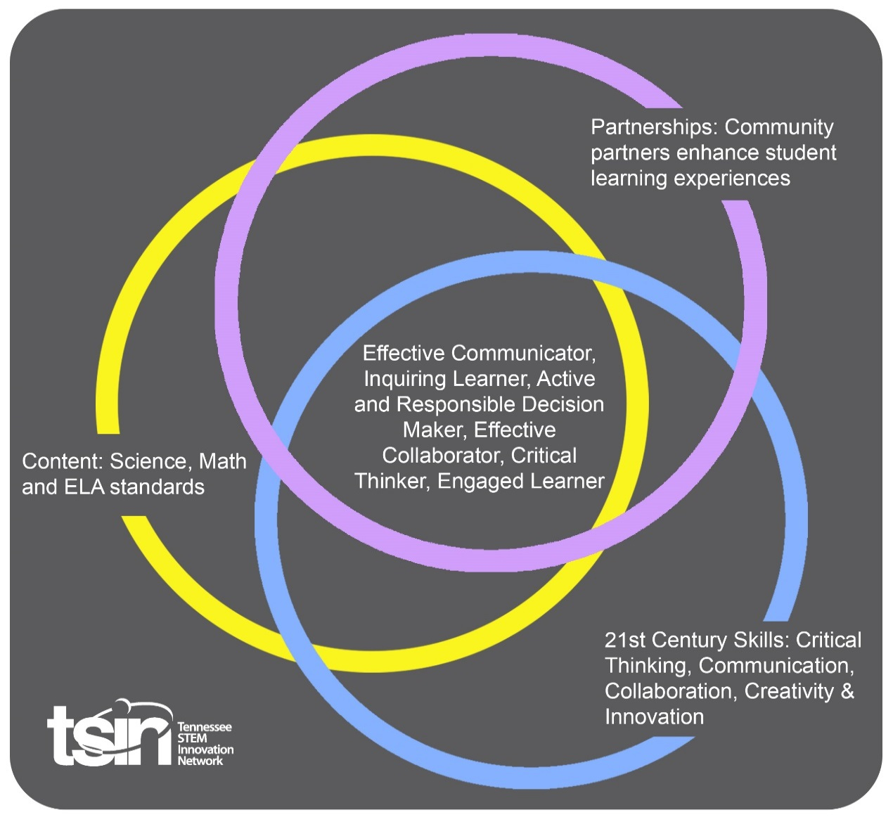

Created By: Molly Plyler | Topic: Amusement Park Ride | Grade Level or Subject: 6th Grade
Science Standards:
6.PS3: Energy 1) Analyze the properties and compare sources of kinetic, elastic potential, gravitational potential, electric potential, chemical, and thermal energy.
6.ESS3: Earth and Human Activity 1) Differentiate between renewable and nonrenewable resources by asking questions about their availability and sustainability.
Math Standards:
6.EE.B.6 Use variables to represent numbers and write expressions when solving a real-world or mathematical problem; understand that a variable can represent an unknown number, or, depending on the purpose at hand, any number in a specified set.
ELA Standards:
6.SL.PKI.5 Include multimedia components and visual displays in presentations to clarify information.
6.SL.PKI.6 Adapt speech to a variety of contexts and tasks, demonstrating command of formal English when indicated or appropriate.
Additional Standards (Social Studies, Art, Physical Education):
Digital Readiness (Computer Science): AIT.6 Collect, organize, analyze, and interpret data to identify solutions and/or make informed decisions.

PBL Summary: Write a few sentences describing this PBL unit.  This PBL unit will ask students to explore the concepts of physical science, math and tech as they design and construct an amusement park ride for a theme park. This unit will require students to create an amusement park ride (digital or physical) and determine if passenger safety has been appropriately addressed in the design.  In addition, students will examine and promote the natural resources surrounding their amusement park in their ride design.  Note: We have used Dollywood for this unit but teachers are welcome to adapt the activities to include the theme park of their choosing. |  | Driving/Multi-dimensional Question: Think of a relevant problem with multiple solutions that will drive student learning.  You have been hired to create a ride for the Dollywood theme park. The design of the ride needs to take into consideration and promote the natural resources surrounding Dollywood.  You must also take into consideration safety concerns. This includes determining the safe height and size of passengers for your ride.
Tennessee Academic Standards for Science Connection
Disciplinary Core Idea(s):  Motion and Stability: Forces and Interactions | Science & Engineering Practice(s):  Developing and Using Models |  | Cross Cutting Concept(s):  Patterns; Cause & Effect
21st Century Skills Addressed (check all that apply):

X Creativity X Collaboration X Critical Thinking X Communication

Culminating Event: What final student learning products will show student mastery of the content area standards?

Creation of a 3-D rendering (either digitally or physically) of your own amusement park ride. This rendering can just be the compartment that the passenger sits in.

Hook Event: Develop an introductory activity that will spark student interest and further questions.  Create-Pair-Share Activity  Students will use play-dough to create a model of their favorite amusement park ride. Then they will pair with a fellow classmate and share the reasons why this particular ride is their favorite. | Community Partners: List potential business or industry partners that could add to the learning experience for students. Include websites or contact info.  1. TCAT campuses and other local vocational schools familiar with 3D printing and/or fabrication  2. Local Energy Provider Representative  3. Highway Patrol Officer |  | What do you need from these partners (i.e. guest speaker, field trip, help facilitate an activity)?  1. Field Trip – so students have a better understanding of 3D printing, digital design and product fabrication, in addition to how these skills are marketable in the workplace  2. Guest speaker – to discuss the importance of renewable energy and how it is utilized in the community  3. Guest speaker – to discuss how vehicle and seat belt design impacts passenger safety

Daily Activities: What activities will students complete to answer the multi-dimensional/driving question (that reinforces content from the standards)?  Activity:  1. A Day at the Amusement Park  2. Safety First  3. Amusement Park Ride Design  4. Pitching Your Design to Investors  5. Optional Extension Activity: Field Trip to an Amusement Park  6. Optional Extension Activity: Ride Iteration | Resources/Materials Needed:  *** This unit and its activities will reference TN’s Dollywood theme park. Teachers can easily substitute another amusement park if so desired.  1. KWL Organizer for Dollywood  In the first column, students will write what they know about the Dollywood theme park and its surrounding natural resources. In the second column, students will write what they want to know about the Dollywood theme park and its surrounding natural resources. After students complete the “Virtual Tour of the Park” activity, they will complete the last column with what they learned about Dollywood and its surrounding natural resources. (hint: Remember to look for natural resources which could later be used in your amusement park ride design)  Virtual Tour of the Park  Students will take a virtual tour of Dollywood by examining the park’s website and videos.  Website Photo Gallery https://www.dollywood.com/themepark/Photo Gallery/Overview  Wildwood Grove https://www.dollywood.com/themepark/Rides /Wildwood-Grove  A Day with the Blue Family https://vimeo.com/345908978  2. Think - Pair - Share https://saferparks.org/  How amusement park rides are governed differs from state to state. Take a moment to explore the Saferparks website on your own and answer the following questions:  - What government agency(ies) works to regulate amusement park safety in your state?  - Examining the “Safety Tips,” what are 3 safety items you need to include in your ride design.  Once completed, turn to your shoulder partner and share your findings.  Tree Map Graphic Organizer for Ride Safety  Students will work in groups of 2-3 to research the rides at Dollywood. Their goal is to find patterns between the ride descriptions and the rider height safety requirements and document this on the attached tree map graphic organizer.  Students should pay special attention to each ride’s description, the “Rider Requirement Chart” PDF, “Loose Article Policy” PDF and the “Accessibility Guide” PDF to complete the attached tree map.  Dollywood Ride information can be found using the following link. https://www.dollywood.com/themepark/Rides  3. Energy in a Roller Coaster Interactive Graphic https://wljt.pbslearningmedia.org/resource/he w06.sci.phys.maf.rollercoaster/energy-in-a-roll er-coaster-ride/ - .W2sOK34h1Bw  Students will view the above graphic and answer the following questions: What is the relationship between the roller coaster design and potential / kinetic energy? How does velocity change based on potential / kinetic energy? (hint: Click on the “Step” button.)  Designing Your Amusement Park Ride  Students will work in groups of 2-3 to design and create a 3-D rendering (either digitally or physically) of their own amusement park ride.  This rendering could only include the compartment that the passenger sits in. Physical renderings may be created using maker tech, such as 3D printers, laser engravers or CNC routers, OR common craft / household items.  Keep in mind that you must take into consideration safety concerns. This includes determining the safe height and size of passengers for your ride.  Students should also be able to a nalyze the properties of energy and compare sources of energy during the ride experience.  In addition, your ride must take into consideration and promote the natural resources surrounding Dollywood. This can be done through the ride’s entertainment value, energy needs or ride appearance.  4. Investor Pitch Prep Guide  Your team will prepare a pitch to deliver to the “investors” (aka - your classmates). Your pitch should be less than 3 minutes and presented in a way that people want to invest in your idea.  Your pitch should include the following:  - Multimedia components and visual displays to clarify information  - A completed 3-D model of your ride  - Explanation for how you determined your ride’s passenger safety height and size requirements  - Clear explanation of the analysis of their ride’s energy properties and sources  - Clear explanation as to how your design incorporated and promoted the natural resources surrounding Dollywood  An investor pitch prep guide is attached for students to use as they prepare.  Prior to the team pitches, your teacher will hand each student $300 in monopoly money. Once all teams have presented their pitch, you will determine how much of your $300 you wish to invest in each group. You may give as much or as little to each team as you wish. Investments must be in whole dollar increments. You may NOT invest in your own team.  The team with the most investment dollars will win.  Prizes may range from displaying the winning ride model with a certificate or 1st place ribbon to small treats.  5. Now that students have completed their ride models, plan a field trip to Dollywood or another local amusement park. After experiencing the amusement park, what changes can be made to their ride design? Allow students time with their team to discuss and select a group spokesperson. The spokesperson will then have 1 minute to share their design changes with the class.  6. Now that you have pitched your ride design to investors and seen other teams’ designs, how will you iterate your team’s ride? How will your next iteration further address safety, usability, ride aesthetics and/or natural resource promotion issues? Students will create their new design by either printing it on a 3D printer OR building a physical prototype.
Technology Integration: How is technology embedded into this PBL unit?
Students will use digital productivity tools and the Internet for project research and their team investor pitch. Students also have the option of utilizing technology to create a digital 3-D model of their Dollywood ride and/or using maker tech, such as 3D printers, laser engravers or CNC routers, to create their 3-D renderings
Capstone Presentation: How will students present what they’ve learned publicly? This can be the culminating event if that event is presenting what has been learned publicly.

As a grade-level project, the winning team from each 6th grade classroom will have an opportunity to pitch their ride to a new set of investors. This can be students in another grade, parents or school personnel.
Using a Google form, the new set of investors may allocate funds electronically, in whole dollar increments, to the participating teams. Investors may spend up to $500, which may be divided among multiple teams.

Performance Based Rubric
Standards | Developing | On-Target | Mastery
Science

Math
ELA

Social Studies

Other Content Areas

