Birds of Prey
Project/Problem Based Learning
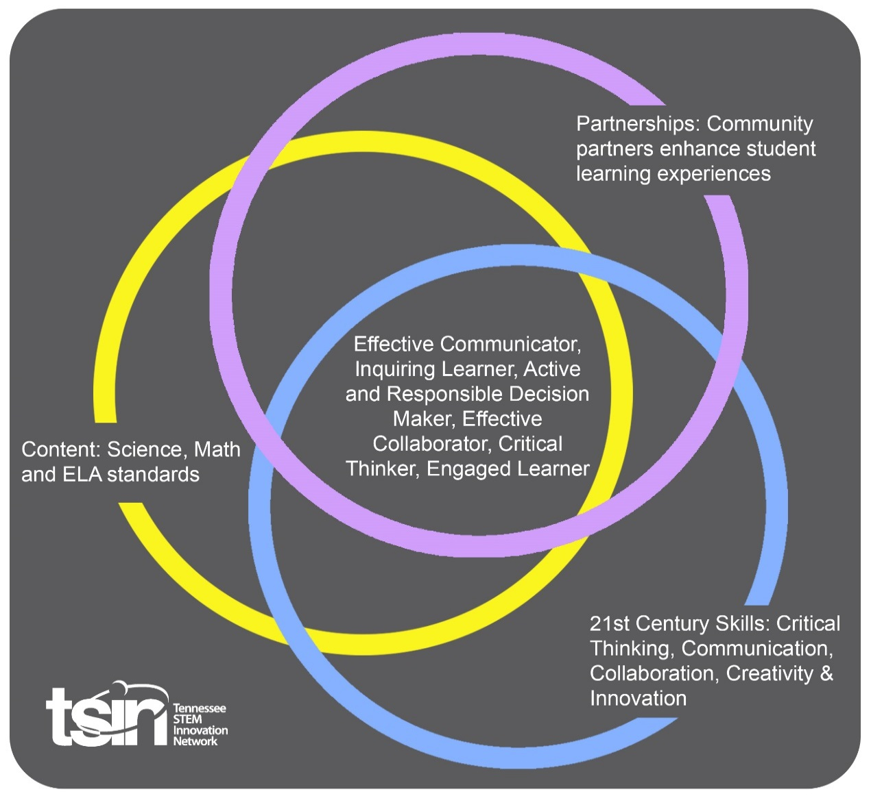

Created By:  Brittany Crouch and Emily Wong | Topic:  Birds of Prey |  | Grade Level or Subject:  3rd Grade - Science
Science Standards:
3.LS1.1 Analyze the internal and external structures that aquatic and land animals and plants have to support survival, growth, behavior, and reproduction.

PBL Summary:  Students will learn about the various types of birds of prey and their importance to our environment, food chains, and our nation. Students will have the opportunity to analyze the structures, behaviors, growth, and pure survival of birds of prey through various videos, internet research/observation, dissection, as well as classification. They will ultimately be given the opportunity to creatively communicate their findings and demonstrate the importance of our national bird through letter-writing. Students will address a person within our local and federal government to persuade an ever-renewing proclamation to declare June 20th American Eagle Day. |  | Driving/Multi-dimensional Question:  Construct an explanation discussing how the structure of birds of prey determine/support the survival, growth, behavior, and/or reproduction of their species. Are there other factors that can affect these outcomes? What can we do to insure birds of prey are successful in their natural environment?
Tennessee Academic Standards for Science Connection
Disciplinary Core Idea(s):  Life Sciences | Science & Engineering Practice(s):  Constructing explanations and designing solutions |  | Cross Cutting Concept(s):  Structure and Function
21st Century Skills Addressed (check all that apply):

X Creativity X Collaboration X Critical Thinking X Communication

Culminating Event:

After completing the daily activities, go to the American Eagle Foundation website (www.eagles.org) and click on “About Eagles” to learn more about our nation’s bird. Feel free to continue research as a whole group, or separate students into groups and have them research different aspects of the American Bald Eagle. Student can then present their information to the class. Here is an additional resource specific to Bald Eagles: Eagle Video.

Students will also research the different “Take Action” aspects on the site: American Eagle Day 2020 Cleanup, Hunt and Fish Lead Free, Protect from Wind Turbine Fatalities, Avian Friendly Power Lines, and Nest and Habitat Protection. Be sure to discuss each of these Take Action Steps as a class to insure that students understand each event.

Students will use the information researched about the Bald Eagle and the other action steps to participate in the American Eagle Day Project (part of the “Take Action” tab on eagles.org). Students will develop a letter to send to the Governor, the President, and/or someone in leadership at the House of Representatives/U.S. Senate. The letter will persuade these leaders to proclaim June 20th American Eagle Day. Students must use the information they have obtained to develop arguments as to why we need an American Eagle Day.

Hook Event:  Access eagles.org and click on the “Nest Cams”. Select which nest cam you would like to view. Allow students to view the nest cams. Discuss through accountable talk any observations they may see. Talk about some things that they might wonder. Record findings and what students may want to know more about. Reference this throughout the unit. | Community Partners:  - TVA Wildlife Conservation Department  - Local Zoo  - Local Animal Rehabilitation Center  - American Eagle Foundation  - 4H | What will we need from our Community Partners?  - Speak to students on ways TVA is helping conserve wildlife.  - Bring different birds of prey to classroom for up-close encounter.  - Speak to students about ways to protect birds they find, and what steps to take if they find a bird of prey that is injured.  - Birds of Prey Education programs—request a Birds of Prey Presentation. www.eagles.org  - Assist in providing resources as well as additional lessons regarding birds of prey in your state
Daily Activities:  Activity:  - Glenda and Grant/Isaiah and Ms. Jefferson (bald eagles): re-visit the nest cams from the hook activity daily, or as necessary. Allow students to keep a running journal of different behaviors and observations of the eagles. Feel free to allow students to discuss their findings.  - Food Chain Game/Lesson: Students will play a game (here) with cheerios and different sized cups to understand the energy flow within a food chain. Students will be able to relate this back to understanding the birds of prey and where they stand within a food chain and other aspects of life.  - Owl Pellet Dissection: View the Power Point Presentation, “Owls—Did you know?” Students will be divided into groups. Each group will be given an owl pellet and tweezers. Allow students to dissect the owl pellet, writing down any information that they find valuable. Use the Owl Pellet Resource Guide (free sample) as a guide/resource. *This is a free sample; however, if you wish to download the full resource guide there is a cost of $12.95 (on TPT).  - Birds of Prey Classification Activities: Pull each of these lessons to use as necessary: Wingbeats, Curvy Beaks, Wings: Shapes and Spans, Can you Pass the Parts? and Sharp Feet. Feel free to further use this site for quizzes and other information.  - Dollywood Workbook: Go to Dollywood.com. Download and introduce the workbook to students. Within the workbook the various birds of prey are introduced with a multitude of information about the bird and its species. Separate students into groups and have them read and further research the given bird of prey. Each group will have an opportunity to present the information from the workbook to the rest of the class. Students who are viewing each presentation should then begin to fill out the corresponding worksheet, listening for any information that may be of use to answering the given questions.  - Field Trip: Students will take a field trip to the Eagle Mountain Sanctuary and Wings of America Theater at Dollywood. Students will use information obtained during this trip to use in the culminating event. |  | Resources/Materials Needed:  - www.eagles.org  - Materials: Cheerios, cups (varied sizes)  - Materials: owl pellets, tweezers  Owl pellet resource guide (free sample—full cost $12.95)  Owls—Did you know? Power Point  - Lessons:  Wingbeats  Curvy Beaks  Wings: Shapes and Spans  Can You Pass the Parts?  Sharp Feet  - Materials: Dollywood workbook and worksheet
Capstone Presentation:
Students will have the ability to utilize all the information that they obtained throughout this unit to determine the importance of birds of prey to the natural world around us. Through these discoveries students will have the opportunity to voice their concerns and persuade others to come to the same understanding. Feel free to allow students to share their letters with the group.

Performance Based Rubric
Friendly Letter Writing Checklist
Persuasive Writing Rubric

