Browns Ferry Nuclear Reactor and the EPA
Project/Problem Based Learning Template
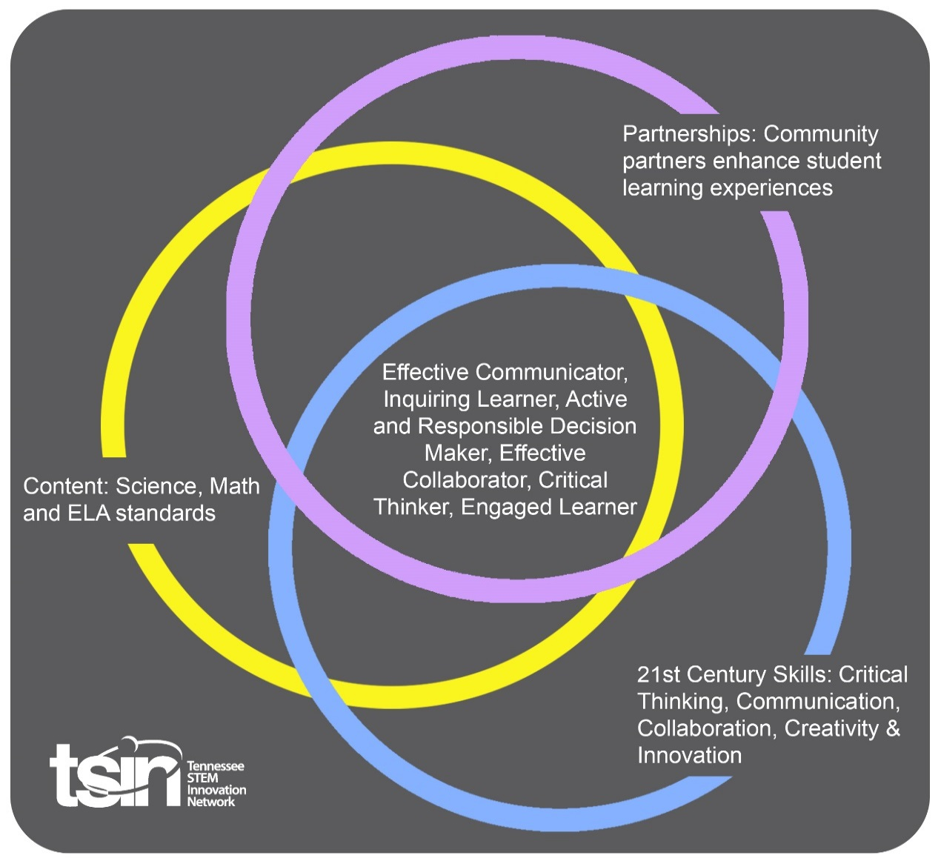

Created By: Kaitlin Asher and Lauren Cantrell | Topic: Browns Ferry Nuclear Reactor and the Environmental Protection Agency |  | Grade Level or Subject: High School Biology
Science Standards:
ES 1: Investigate and analyze the use of nonrenewable energy sources (e.g., fossil fuels, nuclear, natural gas) and renewable energy sources (e.g., solar, wind, hydroelectric, geothermal) and propose solutions for their impact on the environment.

Math Standards:

ELA Standards:
ELA 9.26 : Conduct short as well as more sustained research projects to answer a question (including a self-generated question) or solve a problem; narrow or broaden the inquiry when appropriate; synthesize multiple sources on the subject, demonstrating understanding of the subject under investigation. [W.9-10.7]

Additional Standards (Social Studies, Art, Physical Education):
L11.7: Explain strengths and weaknesses of the New Deal in managing problems of the Great Depression through relief, recovery, and reform programs, including the Tennessee Valley Authority (TVA), the Works Progress Administration (WPA), the Civilian Conservation Corps (CCC), and the Social Security Act.

PBL Summary: Write a few sentences describing this PBL unit.  This lesson will allow students to investigate the environmental issues that can arise surrounding a nuclear power plant. It will also discuss some of the history behind the Tennessee Valley Authority and how they created the Browns Ferry nuclear power plant. It will take a deeper look at the research conducted at Browns Ferry by the Environmental Protection Agency and the problems they discovered. The students will then have to solve a similar problem themselves. |  | Driving/Multi-dimensional Question: Think of a relevant problem with multiple solutions that will drive student learning.  How does the water released from a nuclear power plant affect the environment surrounding it?
Tennessee Academic Standards for Science Connection
Disciplinary Core Idea(s):  Human Impacts on Earth systems. | Science & Engineering Practice(s):  Analyzing and interpreting data. Constructing explanations and designing solutions. |  | Cross Cutting Concept(s):  Cause & Effect
21st Century Skills Addressed (check all that apply):

X Creativity X Collaboration X Critical Thinking X Communication

Culminating Event: What final student learning products will show student mastery of the content area standards?

The students will give a presentation at the end of the lesson. They will conduct research to provide a solution to help clean up algal blooms caused by nuclear power plants.

Hook Event: Develop an introductory activity that will spark student interest and further questions.  The students will begin the lesson with a formative assessment. This formative assessment is called twitter board. The students will use strips of paper to answer three separate questions. The students will be required to answer in 140 characters or less, just like Twitter.  - What do you think TVA does and why is it important?  - What does the Environmental Protection Agency do?  - How could these two organizations be linked together? | Community Partners: List potential business or industry partners that could add to the learning experience for students. Include websites or contact info.  - Environmental Protection Agency. https://www.epa.gov/students  - TVA – STEM. http://www.tvastem.com/ |  | What do you need from these partners (i.e. guest speaker, field trip, help facilitate an activity)?  - Multiple Resources  - Multiple Resources
Daily Activities: What activities will students complete to answer the multi-dimensional/driving question (that reinforces content from the standards)?  Activity:  - The first activity will be the formative assessment Twitter board. The students will be required to answer three questions on the topic of this PBL.  - The second activity will require the students to participate in a classroom discussion of the TVA and the EPA. There will be a PowerPoint associated with this discussion that will open up questions for the students. The students will learn the history of the TVA, how and why they built Browns Ferry, and the EPA’s involvement and research in the project.  - The students will then complete an algae lab activity. This will be a week long activity. The students will prepare their algae solution and then select an “environment” for their algae to live in over the next week. The students will observe and take notes on their algae every day to monitor its progress.  - Once the week is up there will be a classroom discussion about what they observed with their algae and how it compared to their hypothesis.  - The students will then create a presentation on water temperature and algae growth and how they could prevent it. The presentation will be required to contain:  – Explain the group’s hypothesis.  – Explain the results.  –Did the results match the hypothesis?  –How would they get rid of overgrowth of algae in the river?  –Research actual solutions to this problem.  –Correctly site all sources. |  |  | Resources/Materials Needed:  Lab Goggles  Safety Gloves  Plastic water bottles  Tap Water  Pond/Lake/River Water  Measuring Cup  Liquid Fertilizer
Technology Integration: How is technology embedded into this PBL unit?

The students will need the use of their computers in order to conduct research on ways to combat the overgrowth of algae. Students will need to think of ways to actually solve this problem and accurately source sites in the process.

Capstone Presentation: How will students present what they’ve learned publicly? This can be the culminating event if that event is presenting what has been learned publicly.

For the capstone presentation the students will work in small groups. There will be requirements to meet in the presentation and all students must participate equally. Each group will give a presentation explaining their group’s hypothesis, along with the results of their algae experiment data, and how they would solve the overgrowth of algae.

Performance Based Rubric
Standards | Developing | On-Target | Mastery
Science

Math
ELA

Social Studies

Other Content Areas

