What's My Yard Got to Do With It?
Chemistry of Nutrient Runoff
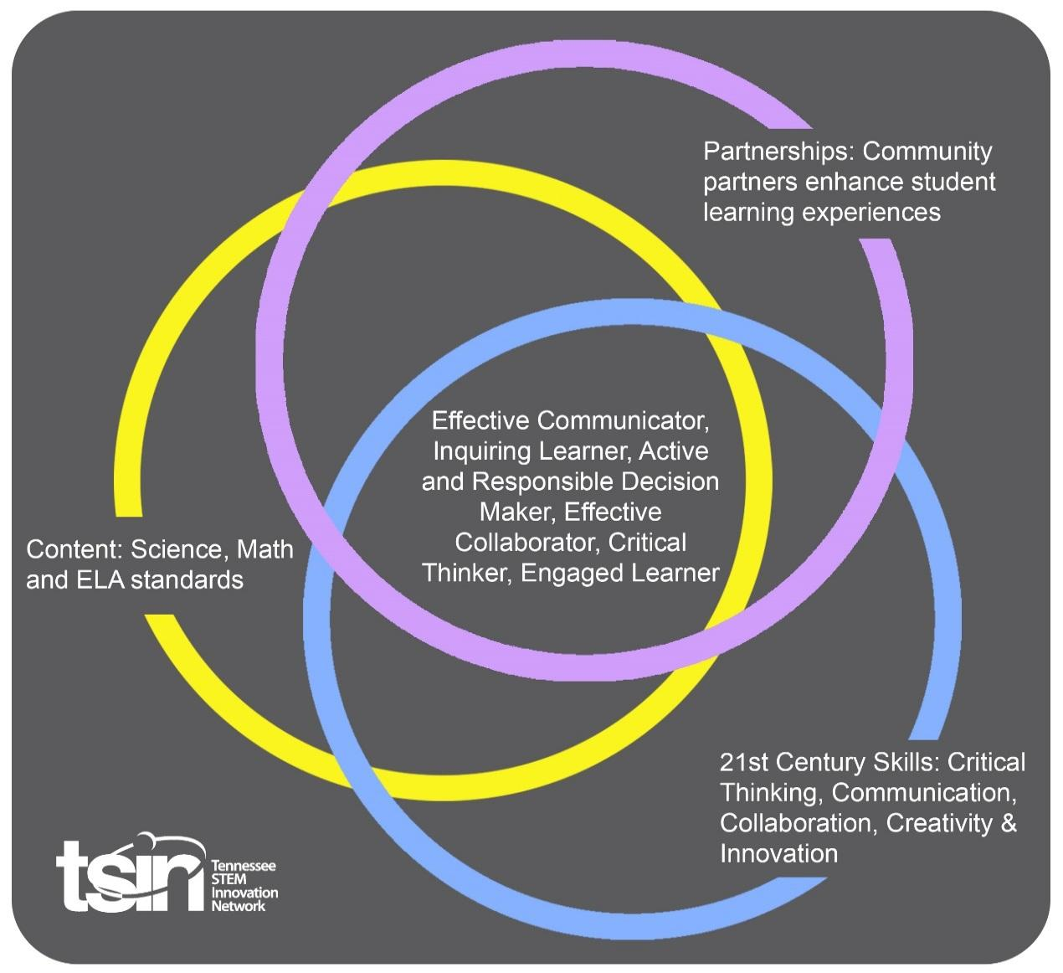

Created By: Sally Rodgers | Topic: Chemistry of Nutrient Runoff |  | Grade Level or Subject: Chemistry
Science Standards:
CHEM1.PS1: Matter and Its Interactions
7) Analyze solutions to identify solutes and solvents, quantitatively analyze concentrations (molarity, percent composition, and ppm)

Math Standards:
From the ACT standards A 601.Manipulate expressions and equations

ELA Standards:

Additional Standards (Social Studies, Art, Physical Education):

PBL Summary: Write a few sentences describing this PBL unit.  In this unit students will compete to grow the best yard (paint tray) of grass. Also students will investigate the side effects of nutrient runoff using nitrate, phosphate and dissolved oxygen testing kits. Students will also analyze samples in parts per million and parts per billion (ppm, ppb) |  | Driving/Multi-dimensional Question: Think of a relevant problem with multiple solutions that will drive student learning.  What does my yard/ garden have to do with the fish in the river?
Tennessee Academic Standards for Science Connection
Disciplinary Core Idea(s): soluets, solvents, ppm,ppb | Science & Engineering Practice(s): Developing and using models |  | Cross Cutting Concept(s):  Cause and effect
21st Century Skills Addressed (check all that apply):

Creativity X Collaboration X Critical Thinking X Communication X

Culminating Event: What final student learning products will show student mastery of the content area standards?

To begin the study students will grow grass seed or garden seed in a controlled environment collecting the runoff water and testing the phosphate and nitrate content of water. Students will defend or discredit the use of commercial fertilizers in the manner in which they used these additives to grow the best yard. Students will participate in a field day in collaboration with TVA, TDEC and the US Forestries division. After the field day with the experts, students will build a “public broadcast” to inform the public of the damage misplaced fertilizer can cause.

Hook Event: Develop an introductory activity that will spark student interest and further questions.  It’s a competition!  Who can grow the best _________?  grass/beans/corn | Community Partners: List potential business or industry partners that could add to the learning experience for students. Include websites or contact info.  1. TVA - O'Quinn, Terry Shannon  2. Shawn R. Puckett | Environmental Scientist, Division of Water Resources/Cookeville Environmental Field Office  3. USDA -Soil Conservation Technician-  Andrzej Kaslikowski  4. H and H Hardware |  | What do you need from these partners (i.e. guest speaker, field trip, help facilitate an activity)?  1. Conservation field day  2. Conservation field day  3. Soil testing and guest speaking  4. Supplies

Daily Activities: What activities will students complete to answer the multi-dimensional/driving question (that reinforces content from the standards)?  Activity:  1. Plant/ seed the paint tray for the competition- fertilize as wanted. Grow and collect water samples after 1 week. Record plant growth on a google sheet then share with the class and with all chemistry classes.  2. Test water samples for nitrates, and phosphates and record data as a group generated google sheet. Then share with the class and with all chemistry classes.  3. Send soil samples to Waypoint Analytical Lab for testing - Guest speaker USDA  4. Math day of parts per million/parts per billion video lesson at: https://www.sophia.org/tutorials/parts-per-million-calculations with quiz  5. Conservation field day  6. Broadcast day | Resources/Materials Needed:  paint trays  soil  seed  fertilizer - different grades  coffee grounds  epsom salt  bananas  ash  watering cans  Test kits(nitrates and phosphate)
Technology Integration: How is technology embedded into this PBL unit?
Students will use google drive and google docs/sheets to record the process they choose to fertilize their yard/garden as well as collect and document data of plant growth. Students will also use google docs to write a script for the announcement as well as the app screencastify to record their service announcement.

Students will use video lessons for parts per million with online exit ticket quiz.

Capstone Presentation: How will students present what they’ve learned publicly? This can be the culminating event if that event is presenting what has been learned publicly.

Students will make a “public broadcast” announcement citing actual data or events relating to the project to inform the public of how to be mindful of the effects of runoff nutrients as they seed their yards or plant their gardens. This video will be accompanied by a document scripting the announcement.
Performance Based Rubric
Standards | Developing | On-Target | Mastery
Science | Service announcement cites 1-2 sources of information or data as well as speaks of using of data from soil test to treat soil very specifically with household fertilizers and building boundaries between yard/garden to stream. References nutrients in ppm or ppb. | Service announcement cites 3-4 sources of information or data as well as speaks of using of data from soil test to treat soil very specifically with household fertilizers and building boundaries between yard/garden to stream. Properly speaks of nutrients in ppm or ppb. | Service announcement cites 5 sources of information or data as well as speaks of using of data from soil test to treat soil very specifically with household fertilizers and building boundaries between yard/garden to stream. Properly speaks of nutrients in ppm or ppb.
Math | Calculates ppm and ppb. | Calculates and explains ppm and ppb. | Calculates and explains ppm and ppb in reference to size of sample as well as variation of sources.
ELA | Properly cites 1-2 sources during the service announcement. | Properly cites 3-4 sources during the service announcement. | Properly cites 5 sources during the service announcement.
Social Studies

Other Content Areas

Thanks to http://rubistar.4teachers.org for the rubric templates.

Rubric for group work: https://drive.google.com/file/d/1vbziknng1XjmB1iAe2Ijsg9XOG0MGbvp/view?usp=sharing
Rubric for script:https://drive.google.com/file/d/1AZjCAbGy4a3kMrR3jCTa7S9ZFbuogzMh/view?usp=sharing
Rubric for announcement: https://drive.google.com/file/d/1uYQH8uJbFnIeZDJeFjCNfJmQ1efSMl5i/view?usp=sharing

Timeline of project: https://docs.google.com/document/d/1vuisrd2Gy0S6pp1TSiD0w89wBBvuMllEwuRGkaw2MHs/edit?usp=sharing

What to do during plant growth: https://docs.google.com/document/d/1zSlo1VOiUKPceHtl2nSDYchHKvTrP2lKqsJLSBfkYdU/edit?usp=sharing

