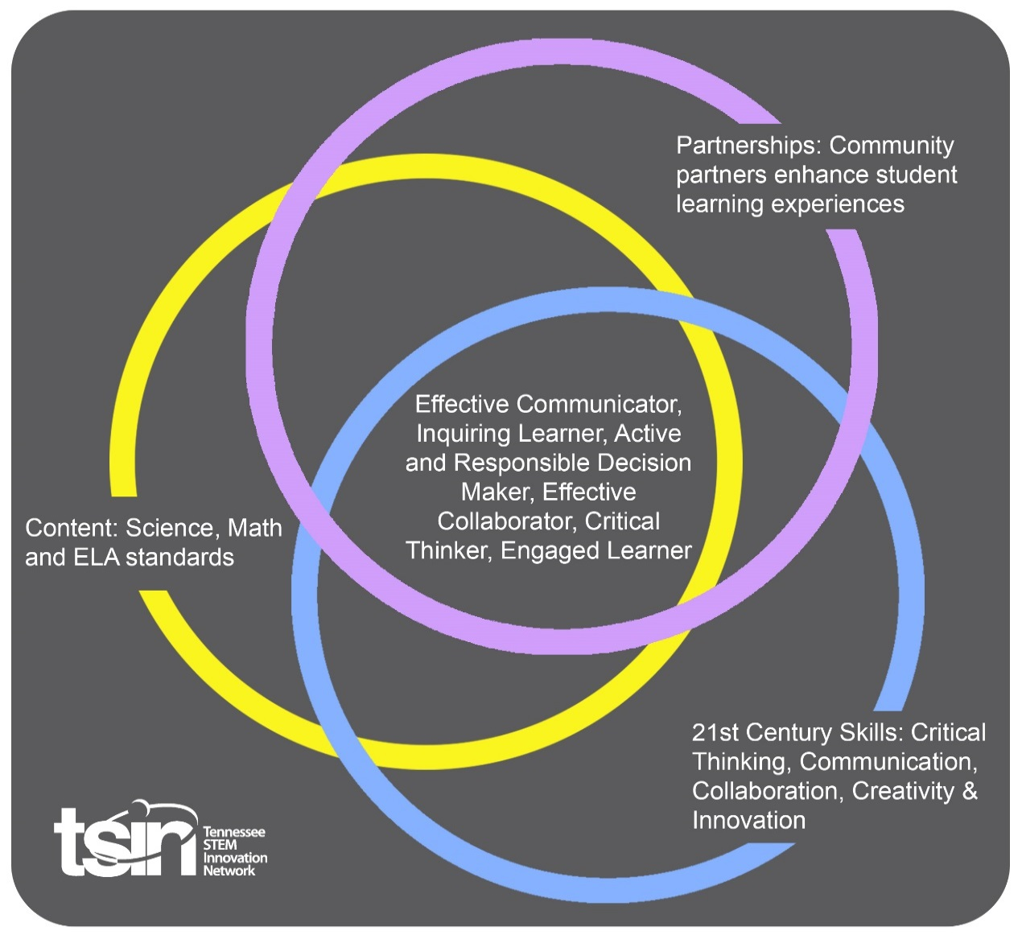
Physical Science PBL – Water Quality

Created By: Sandi Bigham | Topic: Water Quality | Grade Level or Subject: Environmental Science, 9 – 12
Science Standards:
EVSC.ESS2.5 Plan and carry out an investigation examining best management practices in water usage, agriculture, forestry, urban/suburban development, mining, or fishing and communicate findings.
EVSC.ESS2.5 Plan and carry out an investigation examining the chemical and physical properties of water and the impact of water on Earth’s topography. Analyze data and share findings.
EVSC.ETS2.2 Research and communicate information on an environmental science career. Analyze the role of society, engineering, technology, and science in that career.

Math Standards: A1,N.Q.A.1
Reason quantitatively and use units to solve problems. Use units as a way to understand problems and to guide the solution of multi-step problems; choose and interpret units consistently in formulas; choose and interpret the scale and the origin in graphs and data displays.

ELA Standards:
9 -10.SL.PK1.4. Present information, findings, and supporting evidence clearly, concisely, and logically, so that listeners can follow the line of reasoning; ensure the organization, development, substance, and style are appropriate to purpose, audience, and task.
11 – 12.SL.PK1.4.
Present information, findings, and supporting evidence, conveying a clear and distinct perspective so that listeners can follow the line of reasoning; address alternative or opposing perspectives; and organize and develop substance and style appropriate to task, purpose and audience.

Additional Standards (Social Studies, Art, Physical Education):

PBL Summary: Write a few sentences describing this PBL unit.  Students will gain an understanding of the importance of water quality for drinking and for biological functions. Students will investigate drinking water quality, geological makeup and its effect on water, and soil properties and the effect of soil quality on water quality. To culminate the activities, students will determine whether Reelfoot Lake is thriving or dying. |  | Driving/Multi-dimensional Question: Think of a relevant problem with multiple solutions that will drive student learning.  How does soil quality and geological features affect the quality of drinking water, ground water, and biological functions?
Tennessee Academic Standards for Science Connection
Disciplinary Core Idea(s):  Environmental Science | Science & Engineering Practice(s):  Obtaining, evaluating, and communicating information |  | Cross Cutting Concept(s):  Systems and system models, cause and effect, stability and change
21st Century Skills Addressed (check all that apply):

Creativity x Collaboration x Critical Thinking x Communication

Culminating Event: What final student learning products will show student mastery of the content area standards?

Reelfoot Lake Environmental Field Station Research Trip—The University of Tennessee at Martin Biology Department, Reelfoot Lake Environmental Field Station. Students (15 – 40 students at a time) will visit the watershed and two other sites around the lake. Water samples will be taken from each identified area and tested for dissolved oxygen and temperature, productivity, water chemistry, and soil analysis of the area. Additionally, students can observe vegetation and wildlife, and test water bugs from different sources to determine the effects of water quality. Students will collect and organize data, take photos, and then share their findings.

Hook Event: Develop an introductory activity that will spark student interest and further questions.  Bottled or Tap? Should clean water be a commodity, bought and sold?  - Introduce this idea through watching all or part of the movie Tapped (www.tappedthemovie.com), 76 min. that looks at the bottled water industry.  - Conduct an internet search of the Memphis Sand aquifer to understand how aquifers serve the people that live in the area.  - Debate the necessity of water bottled from aquifers and sold.  - (Not necessary, but you could handout the Optional water needs checklist for students to survey at home prior to this hook activity.) | Community Partners: List potential business or industry partners that could add to the learning experience for students. Include websites or contact info.  - Dr. Tom Blanchard, Director  Reelfoot Lake Environmental Field Station; Professor of Biology, UTM  731-881-7594  731-636-1654  tblanch@utm.edu  - USDA-NRSC (Natural Resource State Conservation Office)  Public Affairs Specialist  615-277-2533  - Obion County Soil Conservation District  Josh Richardson, DC  Union City, TN  731-885-6480 ext. 3 |  | What do you need from these partners (i.e. guest speaker, field trip, help facilitate an activity)?  - Tom Blanchard, contact to set up a trip to the Reelfoot Lake Field Station  Tom Blanchard, classroom visit—career possibilities in Biology  - The USDA-NRSC has a Soil Conservation District in every Tennessee county. There will be a contact able to discuss classroom visits, or even materials to share, in each county.  - Josh Richardson is the District Coordinator for the Obion County Soil Conservation District. He is willing to make classroom visits, and also has materials that can be copied or shared with schools in the Reelfoot area.

Daily Activities: What activities will students complete to answer the multi-dimensional/driving question (that reinforces content from the standards)?  Activity:  - Water Quality on Tap – Testing City Water vs. Well Water  - Students will determine and communicate method of testing well water vs. city water samples.  - Students will graph and compare results  - Schedule visitor from local public water department to discuss the Water Department Water Quality Report and data sheet sent to citizens, and what that information tells.  - Study of Land Resource Areas in the State, concentrating on counties in our region, but discussing other regional effects on water quality—Region (counties)  Mississippi Delta (Lake, Obion), Loess Region (Obion, Weakley, Henry), Coastal Plain (Henry to Tennessee River), Highland Rim (several middle TN counties), Central Basin (several middle TN counties, very middle), Cumberland Plateau & Mountains, Appalachian Ridges and Valleys, Smokey Mountains  Have students research the effects of underground geologic features on how water is filtered, filtering out pollutants, etc.  - Soil Quality Evaluation—Soil quality is an evaluation of how well soil does the things we need it to do, specifically how water quality is maintained or enhanced. Soil samples from regions discussed in the study of land resource area of Tennessee will be used to test for soil quality. Students will be able to determine for themselves what type of soil best filters water as it moves through the ground.  - Visitor, Career Opportunities in Environmental Biology  Students will research information on an environmental science career, including an analyzation of the role of society, engineering, technology, and science in that career. | Resources/Materials Needed:  Hook Event:  - Tapped (www.tappedthemovie.com)  - Optional Assignment- Water Needs Checklist (before the movie is watched.)  Activity One:  - Clean, dry containers for students to collect water  - Water Quality Test Strips: HACH brand  - pH  - nitrite and nitrate  - phosphate  - Software or paper to create graphs to share data  - Local Public Utility Board, City Water Quality Report (the one mailed to homeowners)  Activity Two:  - Tennessee Agricultural Experiment Station (TAES) and Unit Locations map or other Tennessee Land Resource areas map from a google search.  - Computers or tablets/phones to research, share information with each other  Activity Three:  - Soil Quality Evaluation handout  - Various soil samples  - Instructional diagram for determining soil texture by feel https://www.nrcs.usda.gov/wps/portal/nrcs/  detail/soils/edu/?cid=nrcs142p2_054311 ( (USDA Natural Resources Conservation Service)  Activity Four:  - Internet access
Technology Integration: How is technology embedded into this PBL unit?

TVA water quality information: https://www.tva.gov/Environment/Environmental-Stewardship/Water-Quality

Capstone Presentation: How will students present what they’ve learned publicly? This can be the culminating event if that event is presenting what has been learned publicly.

Students will organize data collected through testing and photos taken throughout the unit, including those taken during the Reelfoot Lake trip, and create a presentation to share their methods and results. Information and data shared can include any or all of the following results: location/map of Reelfoot Lake, dissolved oxygen and temperature, productivity (photosynthesis and respiration), conductivity, pH, water chemistry, zooplankton, vegetation, water quality and its effects on macro-invertebrates.

Performance Based Rubric
Standards | Developing | On-Target | Mastery
Science

Math
ELA

Social Studies

Other Content Areas

