Lesson 1: Solar Energy

PSCI.PS3: Energy
3) Design, build, and refine a device within design constraints that has a series of simple machines to transfer energy and/or do mechanical work. (solar oven and solar car)

Read about some forms of renewable energy, including Solar, that are being used in the Tennessee Valley https://www.tva.gov/Energy/Our-Power-System/Renewables

Activity 1: Solar Oven

Overview
A solar oven is designed and created. If a solar oven, use surface temperature probes from Vernier to collect and analyze data regarding the temperature increase. A qualitative lab would be students making s’mores from wrapping marshmallows, chocolate and graham crackers in saran wrap or waxed paper and placing it in the solar oven.

Materials:
- Marshmallows Graham crackers
- Chocolate Pizza Boxes
- Tape Foil
- Saran wrap or waxed paper Straws or Skewers
- Surface temperature probes (Vernier)

Pictorial Procedure: Solar Oven

While students are heating their solar ovens, you can have them heat a solar bag and watch it rise in the air.
Activity: Solar Bag (Steve Spangler)

Activity 2: Solar Car

Overview:
Students are to design and build a model car that runs entirely on solar power. Students begin this by conducting research on how a car operates, including conservation of energy and mechanical advantage. Students will construct a prototype vehicle using a standard set of materials and instructions. Students will design, construct and analyze their prototype and implement modifications to their design (e.g. sun angle, aerodynamics, traction, friction, rear-wheel drive) to improve performance.

Objective:
- Students will design, test, refine and evaluate a solar car against a certain criterion.
- Students need to explain how underlying science concepts of energy and energy transfer relate to the solar car’s design.
- Students will develop and implement improvements to their design for optimum performance.
Materials:
- Motors Solar cells
- Wheels, axles Cardboard
- Drinking straws
Procedure:
- Students will construct a prototype vehicle that meets or exceeds the performance standards of a modern internal combustion engine for fuel efficiency and speed using alternative energy sources like solar power.
- Students analyze the distance from the light source and the angle of the light source on the car’s performance.
- Students will interpret the law of conservation of energy.

Technology: Students can measure the speed of the car using a photogate or motion sensor or a digital video using marked track for scale and a video application with time display.

Lesson 2: Hydroelectric Energy

PSCI.PS3: Energy
3) Design, build, and refine a device within design constraints that has a series of simple machines to transfer energy and/or do mechanical work. (Wind turbine and hydroelectric dam)

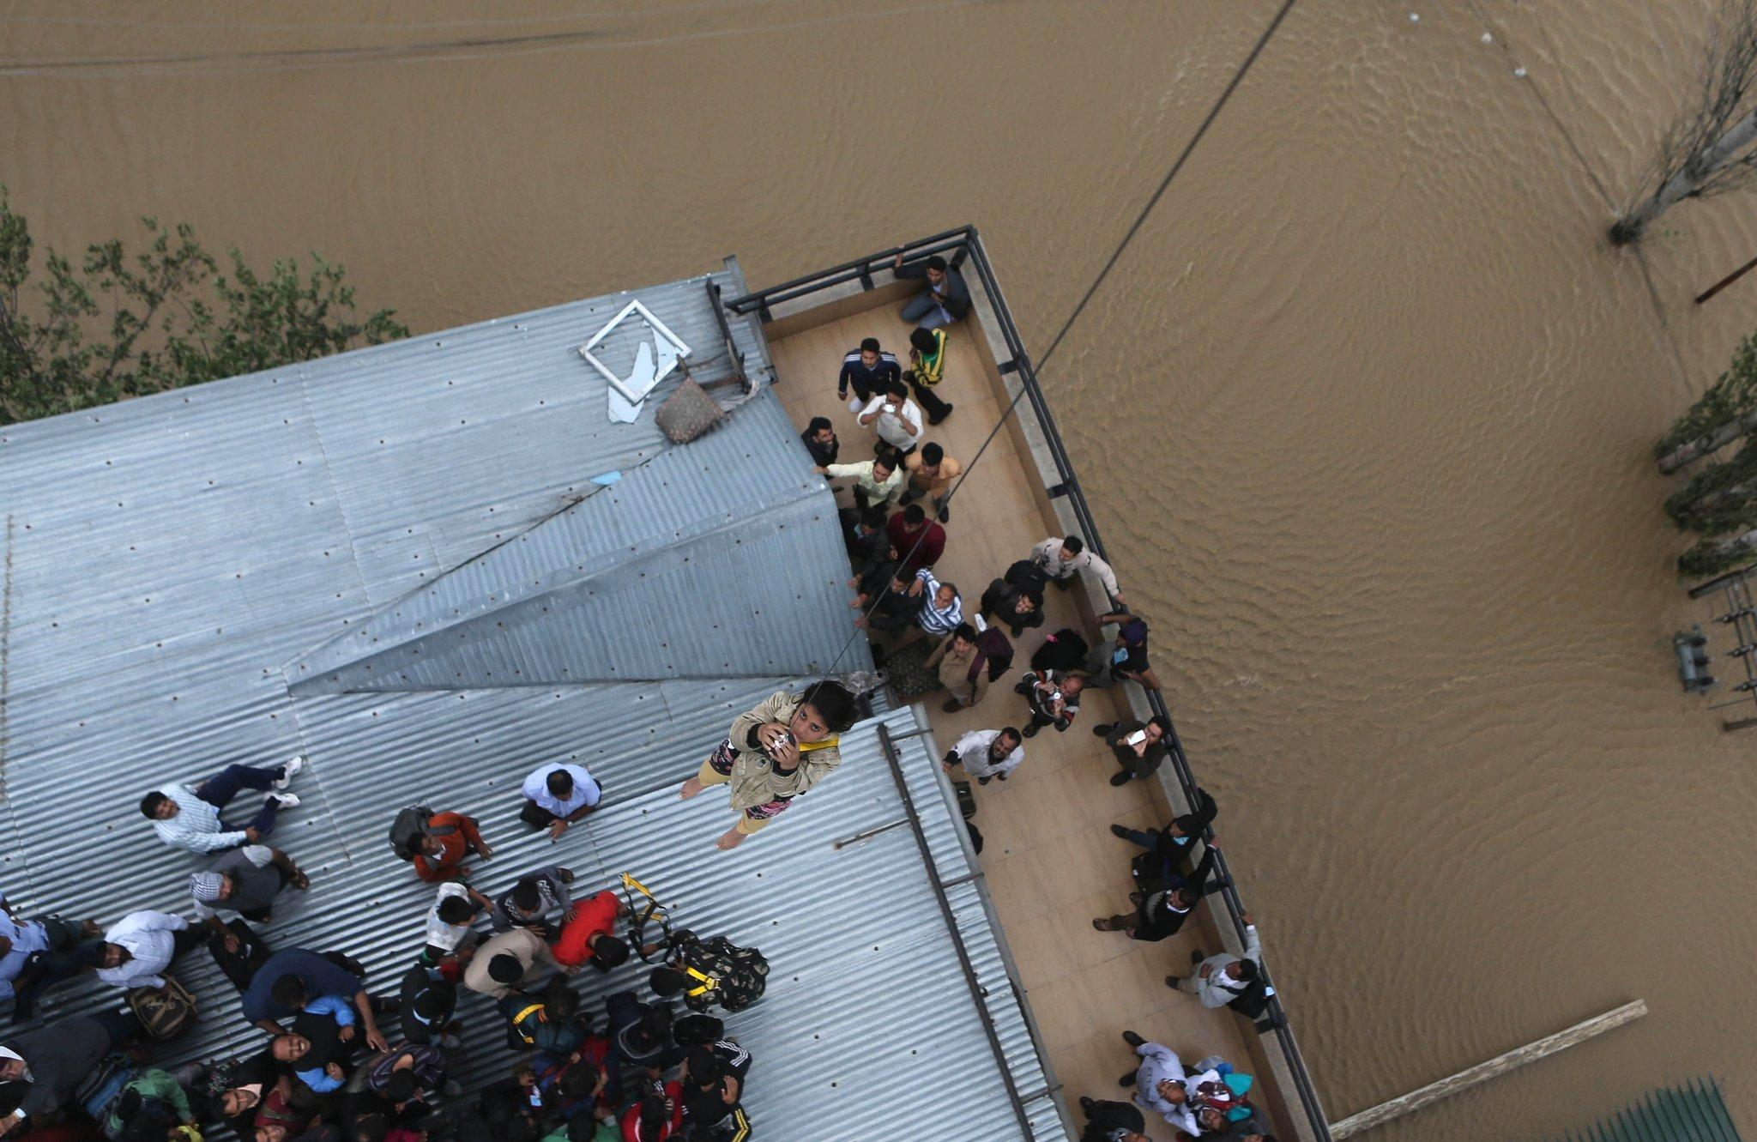

Picture analysis:
Observation: Study the picture quietly for a few minutes. Describe exactly what you see, including people, clothing, and other objects in the picture.

Inferences: Are there people in the picture? If so, what are they doing? What can you tell about the person or persons from looking at the picture? Is it a picture from today or long ago? How can you tell? What do you think the artist or photographer was trying to convey?
Based on what you observe, what can you infer about the picture?

Questions: What further questions does the picture raise in your mind? Where could you find answers to them? What are ways we can prevent events like this from occurring?

Activity: Building a hydroelectric dam
Overview: The Hoover Dam in the Unites States, the Aswan High Dam in Egypt, and the Three Gorges Dam in China are well- documented examples of dams in different regions of the world. Egyptians built the first dams around 2800 BC. Water use and control (water rights) is a topic for both science and politics. Students discover how emerging energies can change the way we develop and convert electric energy. Students observe a hand generator that converts mechanical energy into electrical energy. Student groups then design their own water wheel and compete with other groups to implement the most effective design.
Objectives:
- Students will design a water wheel that can effectively lift a paper clip using water power. This water wheel serves as a model of a hydroelectric power generator with the lifting paper clip representing the production of electric power.
- Students will understand the benefits of hydroelectric power to society and how the generation of hydroelectric power impacts the environment.
Materials:
- Hand generator Bulb holder
- Plastic tanks Funnels
- 6-inch length tubing tube clamps
- foam cups plastic lids
- small spoons medicine cups
- string (200 feet) pipets
- adhesive tape Parafilm
- Straws Paper clips
Procedure:
- Teacher will demonstrate how a hand-held generator works and observe the lighting of the bulb from the mechanical energy generated.
- Students will determine how many bulbs can be lit with the hand generator.
- From the materials given, students will have to design and construct a water wheel. This is comparable to a wind turbine.
- Students will have to determine what to use for axle and blades so the water wheel turns smoothly and consistently as the water flows over it.
- Test your prototype and make adjustment to your design if necessary. Video tape your prototype to see what adjustment you need to make.
Materials can be obtained from Carolina Biological- Building a dam kit
Extension: Students can research the environmental impacts that a hydroelectric plant has on wildlife. Have students come up with ways they can minimize the impact by determining ways they can protect the wildlife.
Students can also explore global climate change and explore and report out on glaciers melting, increased storms and heat waves, rising sea levels, habit destruction, land lost in Pacific islands and coastal areas and ways scientists are trying to mitigate effects of greenhouse gases.
Math: Students can calculate the rate at which the wheels lift the paper clip and figure out the rate units (e.g. cm lifted per ml of water or cm lifted per second).
Technology: Students can play build a dam and test constraints using a computer application.
Lesson 3: Wind Energy
PSCI.PS3: Energy
3) Design, build, and refine a device within design constraints that has a series of simple machines to transfer energy and/or do mechanical work.

TVA renewable energy (research source)

Objectives: Students will construct and test a prototype of a vertical axis wind turbine. Student will explore ways to modify and improve their design to meet the criterion of converting wind power into mechanical power that produces the most rotations minute.

Materials:
- Fan timer
- wind turbine assembly 4 foam airfoil blades
- 4 round wooden dowels paperclip
- snap swivel coil
- eye screw 4 rubber bands
Procedure:
- Twist the eye screw into the hole at the top end of the square dowel.
- Loop the paperclip through the eye screw.
- Attach the snap swivel to the paper clip.
- Tie the cord to the opposite end of the snap swivel.
- Insert a round dowel into one of the four holes in the square dowel. Position the round dowel so that half of its length extends from either side of the square
- Repeat this step until you have inserted all four round dowels in the square dowel.
- Slip a rubber band on to the ends of each pair of round dowels to keep them secure.
- Slide the rubber bands a little farther onto the pair of dowels, and then place the airfoil blades, flat side facing inwards, between the tips of the round dowels. Use the half circle indentations on the ends of the blades as a guide.
- Test the assembled wind turbine with a fan. Turn fan to highest speed setting. Hold the turbine by the cord in front of the fan. Count how many rotations the turbine makes in 15 seconds.
- Multiply the number of rotations by 4 to determine the number of rotations the turbine makes in 1 minute.
Modifications students can make to design after testing
- Altering the direction of wind turbine blades
- Adding or removing blades
- Altering the shape and size of the blades
- Using different materials to construct the wind turbine blades
- Moving the rubber bands away from the blades so they do not interfere with the airfoil shape
- Students can compare a pinwheel design to their vertical axis design wind turbine

Math
Students will measure the speed of their wind turbines using the velocity formula, measuring the distance that the wind turbine travels in one rotation (by measuring the circumference) and converting the rotations per minute to time it takes for the wind turbine to complete one rotation.

Note for teachers: Wind turbine are made of four basic components.
- Blades-the wind makes the blades spin.
- Rotor-as the blades spin, they turn the rotor.
- Shaft-the spinning rotor moves the shaft up and down.
- Generator- the moving shaft turns the generator, which creates the power.
A toy model wind turbine can be purchased from Hobby Lobby.

Resources: The American Wind Energy Association
U.S. Department of Energy. Wind Energy Basics

Lesson 4: Nuclear Energy

PSCI.PS3: Energy
14) Develop models to illustrate the changes in the composition of the nucleus of the atom and the energy released during the processes of fission, fusion, and radioactive decay.
15) Communicate scientific and technical information about nuclear energy and radioactive isotopes with respect to their impact on society.

Objective: Students will research a nuclear power plant and argue for the using nuclear energy as an alternative fuel. Students will weigh the pros and cons of the environmental impact and dangers vs the cost benefits.

Video: Atomic bomb
Ask students why a nuclear bomb is so powerful in terms of energy? Why does it form a mushroom shape?

Video: https://www.pbs.org/video/good-stuff-power-nuclear/

Activity:
Students will research and argue for/against the building of a nuclear power plant in their city.
Students have to know about the advantages of nuclear energy, NIMBY (Not In My Back Yard), nuclear meltdowns, fusion and fission. Students will illustrate through drawings the difference between nuclear fusion and nuclear fission. Students will, through computational analysis, determine the difference between fission, fusion and radioactive decay of isotopes. What happens to the radioactive waste and why is it a problem? How exactly did the meltdown at Chernobyl and Fukushima Daiichi happen?

Lesson 5: Benefits of Electricity & Careers

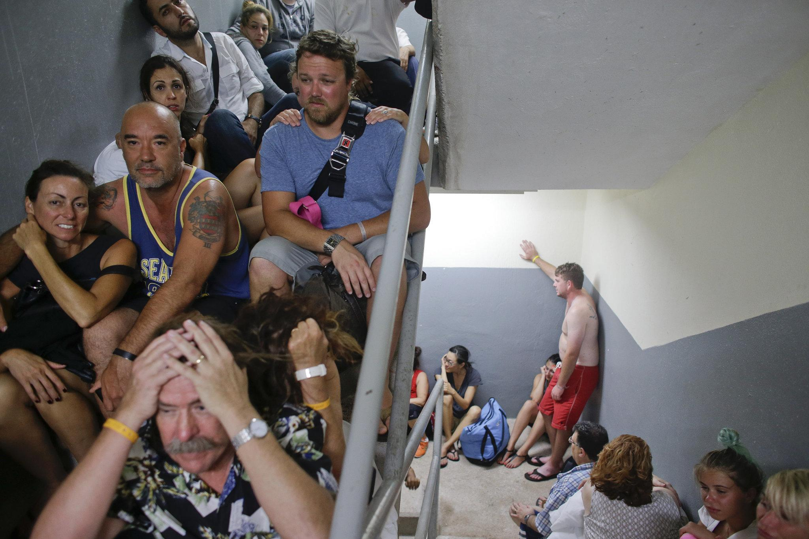
How would their life change if there was no electricity as in an emergency situation?

Observation: Study the picture quietly for a few minutes. Describe exactly what you see, including people, clothing, and other objects in the picture.

Inferences: Are there people in the picture? If so, what are they doing? What can you tell about the person or persons from looking at the picture? Is it a picture from today or long ago? How can you tell? What do you think the artist or photographer was trying to convey?
Based on what you observe, what can you infer about the picture?

Questions: What further questions does the picture raise in your mind? Where could you find answers to them?

Extension (Social Studies)
Research the Appalachian area and look at how citizens lived before the 1930’s, create a timeline of the major changes and imagine you are a citizen living through these changes. Write an article in the newspaper of the changes you have seen and the impact it has made in the local citizens’ lives. How has TVA or the damming of rivers improved the lives of people in Appalachian Mountains?

Resources: Out of the darkness

Future of Energy: What is the current research on alternative energy? How do natural resources of a region relate to a country’s wealth and stability? Mining and overuse of natural resources can lead to instability of governmental and economic systems. Discuss the current and historical importance of table salt as a commodity, ancient currency and as a preservative. Discuss fossil fuel and coal or even plutonium.

Careers: Have students research all the different careers they can have connected to electrical energy.

https://www.tva.gov/Our-TVA-Story

Culminating event:
Now that students have explored energy in the form of electricity, students need to propose a solution to Japan and discuss the advantages and disadvantages of each alternative energy source. Students can use the Tennessee Valley Authority as a source by looking at how we use energy by comparing how much fossil fuels vs alternative energy we use by graphing the data. Students will compare Japan’s usage to the TVA and determine how they can better serve their citizens by providing a clean, safe and efficient energy source.

