Lesson 1: What is energy?

PSCI.PS3: Energy
1) Identify and give examples of the various forms of energy (kinetic, gravitational potential, elastic potential) and solve mathematical problems regarding the work-energy theorem and power.
5) Investigate the relationships among kinetic, potential, and total energy within a closed system (the law of conservation of energy)

Objective: The student will identify and calculate different types of energy and their transformations from one form to another in a system.

Activity 1: Picture analysis - picture of a person in candlelight, without electricity.

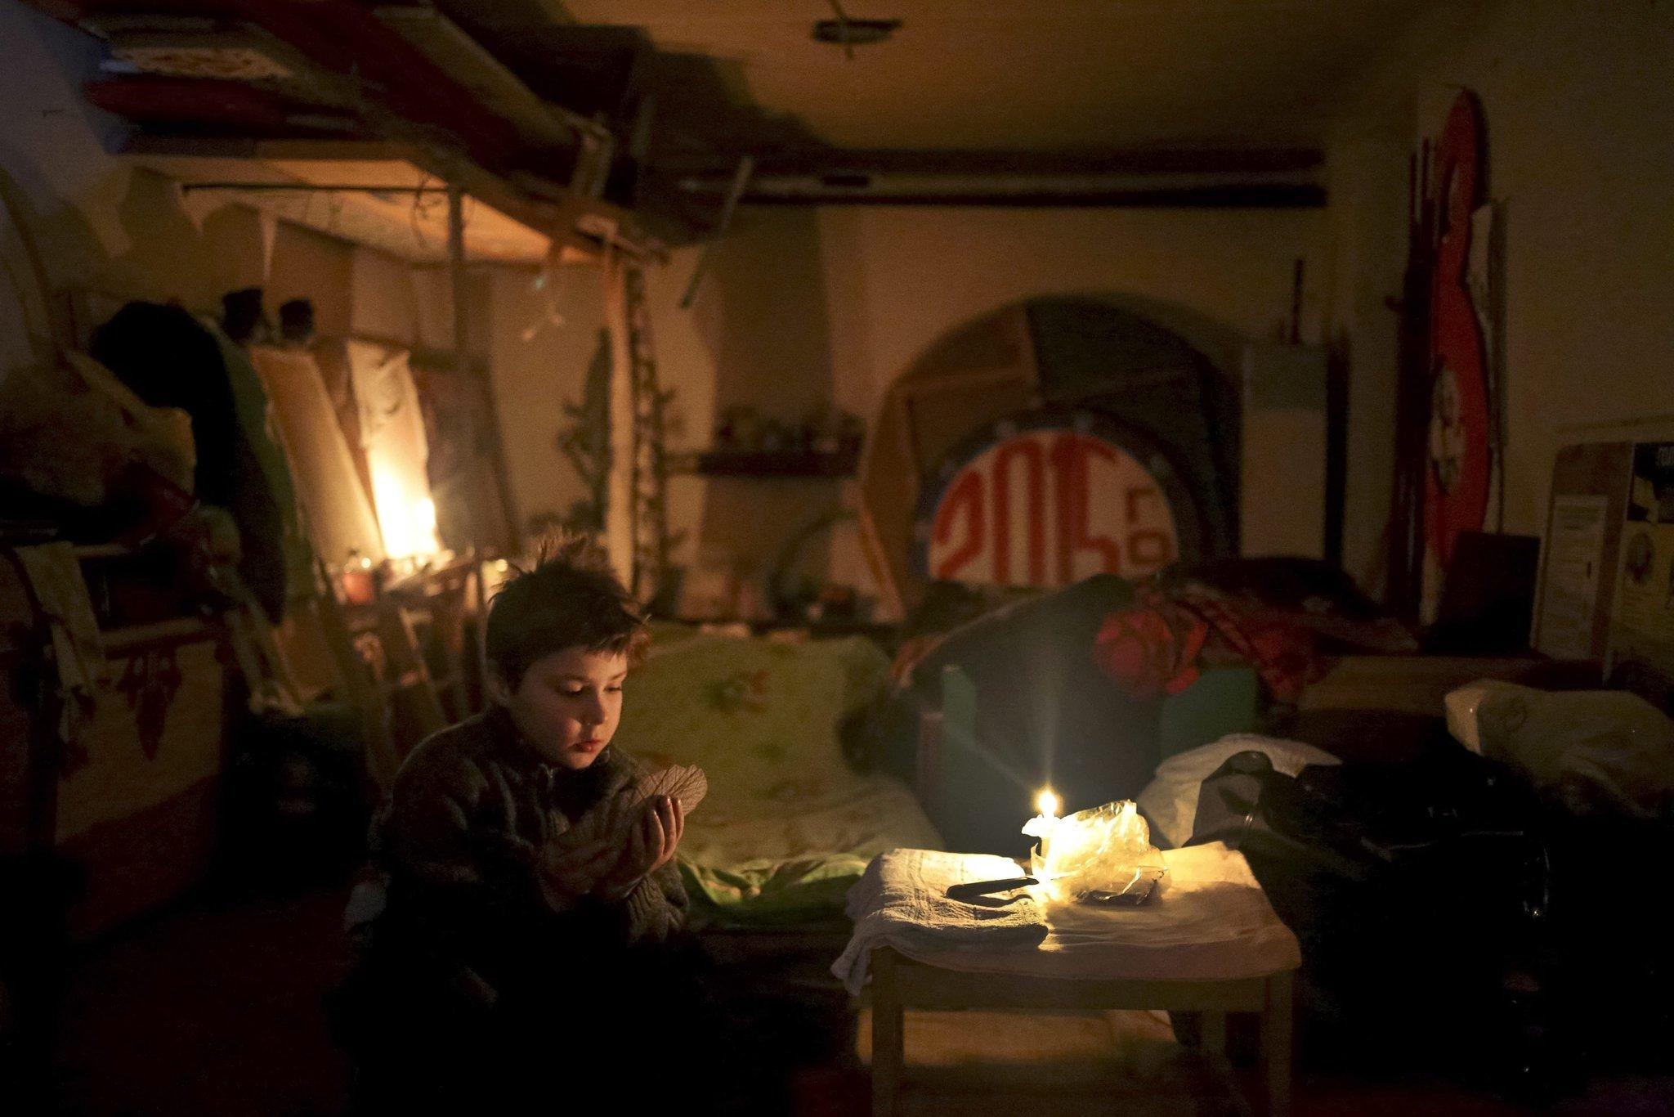

Observation: Study the picture quietly for a few minutes. Describe exactly what you see, including people, clothing, and other objects in the picture.

Inferences: Are there people in the picture? If so, what are they doing? What can you tell about the person or persons from looking at the picture? Is it a picture from today or long ago? How can you tell? What do you think the artist or photographer was trying to convey? Based on what you observe, what can you infer about the picture?

Questions: What further questions does the picture raise in your mind? Where could you find answers to them?

Activity 2: Student will explore energy at different stations and discuss the energy change from one form to another. Discuss the law of conservation of energy.

Show the Video: What is energy?

PowerPoint: Energy Stations (see attached)

Assessment: From these activities, students will derive a definition of energy. Students will also distinguish between potential and kinetic energy.

Lesson 2: Laws of conservation of matter and energy

PSCI.PS3: Energy
5) Investigate the relationships among kinetic, potential, and total energy within a closed system (the law of conservation of energy)

Turn lights off and have student light a candle. Ask them what they observe (due to fire safety codes, if you cannot light a candle show a video of candle burning). Students write down all observations on a whiteboard or piece of paper. Discuss: Where does the energy come from for the candle to burn? What is burning? What is the smoke? Discuss the transformation of energy from chemical to light and heat, etc. Explore all students’ answers and record.

Video: Candle burning

If you are able to light candles, complete the Candle Observation fill in the blank sheet (attached). The teacher will print and cut apart the word bank. Give one word to each student. With their one word and fill in the blank sheet in their hands, students walk around the room and “give one, get one” answer to the fill in the blank sheet.

Extension: (Art) Students can make their own candle
Activity: Make a soy candle of your own.
Video: Making a soy candle

Assessment: Students will derive the laws of conservation of energy and matter.

Lesson 3: Chemical Energy

PSCI.PS3: Energy
2) Plan and conduct an investigation to provide evidence that thermal energy will move as heat between objects of two different temperatures, resulting in a more uniform energy distribution (temperature) among the objects. (MRE, Instant Light and Hot and Cold Packs)

Have students brainstorm various chemical or physical changes that release or absorb heat.

Objective: Student will conduct an investigation and analyze data to prove that the energy transfer between different objects results in a uniform temperature. Students will describe the energy transfer both quantitatively and conceptually.

Activity 1: Students will create a cold pack.

Instant cold and hot packs

Overview: Exothermic reactions yield energy which is in the form of heat, but sometimes it also yields light. Chemiluminescent reactions yield light energy with little or no heat. Certain organisms are capable of producing light such as mushrooms, bacteria, earthworms, millipedes, etc. Each of these contain a substance that is oxidized in one way or another. During WWII, the Japanese military used the dry extract from the bioluminescence sea firefly to read maps at night and to tag soldiers to follow in the dark jungles. What are some other ways we use chemiluminescence?

Activity 2: Demo …Instant Light (Materials from Flinn)
Activity: https://www.flinnsci.com/api/library/Download/1f29f36990a3446a80153917dc185ada

Materials:
Luminol, 0.2 g Beakers, 400-mL, 2–3
Potassium ferricyanide, K3Fe(CN)6, 4 g Magnetic stirrer and stir bar
Clorox 2,® powder form, 64 g or Instant Light Kit Distilled or deionized water, 400 ml

Procedure
1. Fill a beaker with distilled or deionized water, and place the beaker on a magnetic stirrer. The size of the beaker and amount of water is up to you.
2. Turn off the lights in your classroom.
3. Add some Instant Light crystals to the water, about two teaspoons for every 200-ml water works well.
4. The blue chemiluminescent glow will begin instantly and last for several minutes.

Extension Activity:
How did we move from candles to gas light to electricity? A case study of Thomas Edison and Tesla…how did these two revolutionize electricity? Students can watch American Experience:Tesla (53 minutes) on Netflix or research the two scientists. Students are comparing and contrasting the two scientists and only looking for facts. Divide students to answer questions and have them report out as a class. Discuss the difference between the two AC vs DC.

Video: Difference between AC and DC
Lesson 4: Thermochemistry

PSCI.PS3: Energy
9) Demonstrate the impact of the starting amounts of reacting substances upon the energy released.

Objectives:
- Students will write thermochemical equations for endothermic and exothermic reactions.
- Students will calculate the heat of a solution between two salts and classify their dissolution as exothermic or endothermic.
Overview: Students investigate the thermodynamics of physical and chemical changes that absorb and release heat energy. Using a calorimeter containing a known amount of water, student groups measure the change in temperature of water caused by dissolving two chemical compounds. Students will, through computational analysis of the specific heat, determine whether the reaction is exothermic or endothermic.

Activity 1: It’s Not the Heat, It’s Thermochemistry

Materials:
Temperature probes Graduated cylinder
250 ml beakers 400 ml beakers
Balance (sensitivity to nearest 0.1g) Chemical scoops
Weighing paper Calcium chloride
Ammonium Chloride 8 oz. foam cups

Materials obtained from Carolina Biological It's not the heat, it's thermochemistry lab

Procedure:
- Students will place one foam cup inside another, inside a 400-ml beaker. This is your calorimeter.
- Measure 100ml of water with a graduated cylinder and pour into calorimeter. (Remember 1g = 1ml water)
- Place temperature probe in water. Add 5.0g of Calcium Chloride and stir. Record temperature value when stable.
- Determine the change in temperature. Calculate the heat gained or lost using the specific heat equation. Q = mc∆T
- Students will weigh 5g of ammonium chloride and determine the specific heat for this as well.
- Write out the equation and determine whether each reaction is exothermic or endothermic

Activity 2: Meals Ready to Eat

Real world Connection: Not all energy is in the form of light, but heat. Students will explore the chemistry behind flameless ration heater (FRH) which is used to heat meals ready to eat (MREs) which is used by the Army. Civilians use MREs for camping, disaster relief and general emergency preparedness.

Materials obtained from Carolina Biological Hot Demonstrations with Flameless Ration Heaters

Video: Flameless Ration Heater

Objective: Students predict the reactions and products of the reaction and write a balanced exothermic chemical equation for the reaction.

Materials:
3-pocket heater pad (contains Magnesium and Iron) flameless ratio heater in bags
salt packet empty heater bag

Procedure
- Add the remainder of saltwater from the open packet to the interior of the bag and quickly fold the open end over to the dotted line on top of the bag. Secure it with the tape provided.
- Allow the bag to lay horizontal as the FRH heats up in a few minutes, the bag will inflate from the steam and hydrogen gas produced, and visible plumes of steam will be emitted from the bag.
- Have students note their observations and conclusions
- Write a balanced equation for the reaction including the state of matter of the reactants and products.
Be sure to include heat in the reaction.
Mg_{(s)} + 2H₂O → Mg(OH)_{2 (aq)} + H_{2(g)} + heat

Video: How a MRE works

Lesson 5: Electricity and energy storage

PSCI.PS3: Energy
7) Demonstrate Ohm's Law through the design and construction of simple series and parallel circuits.

Objectives: Students will design, build and refine a potato battery to produce as much voltage as possible.

Activity: Battery Dilemma - Students construct and test a battery and create a series circuit that will light up an LED bulb.

Overview: Students will learn how batteries use chemical reactions to generate electric current. They will investigate how batteries may be made of one or more voltaic cells by examining a disassembled 9-V battery. Design teams are guided to build and test a battery prototype using a potato and pairs of dissimilar metal electrodes, determining which combinations of metals produces the highest voltage. Students will engineer ways to increase the voltage of their battery. Students will reflect on their design and think of materials they could use besides potatoes.

Materials: (for each team)
9V battery (one for Teacher demo only) Red wires with alligator clips
Black wires with alligator clips Copper metal strip
Zinc metal strip Magnesium ribbon
1.7 V red LEDs trays
Potatoes sandpaper
voltmeter
Materials can be purchased: Carolina Biological “Battery Dilemma” https://www.carolina.com/alternative-energies/carolina-stem-challenge-potato-battery-dilemma-kit/180958.pr

Procedure
- Teacher will disassemble a 9 V battery to show students what it is composed of. Use a document camera if possible.
- Remind students that batteries can be single or multiple cells. Allow students to connect a closed circuit using the battery to determine the voltage.
- Create a circuit using the potato with dissimilar metal strips (Zinc, copper or Magnesium) to light an LED. Determine the voltage, anode and cathode.
- Continue testing all combinations of the three metals as electrodes.
- Students can connect several batteries in series and parallel and determine the voltage.
Extension: Students can research how batteries were made and construct a coin battery by placing salt water bloated paper towels between alternating dimes and pennies. Tape together and connect to an LED.
Math Activity: Construct a Series vs Parallel circuit. Calculate the Voltage and Amperes.
Assessment: Calculate Ohms Law V-IR or R=V/I Students will construct a series circuit, placed known resistance and calculate the amperes and voltage at certain points in the circuit. Determine through experimentation if the computation is correct.

Video: “Search for the Super Battery” NOVA pbs.org
Lesson 6: Electromagnets

PSCI.PS2: Motion and Stability: Forces and Interactions
7) Plan and conduct an investigation to provide evidence that an electric current can produce a magnetic field.

Activity: Design a simple electromagnet Simple motors

Overview: Discuss how moving magnets through a magnetic field source induces a small, measureable current. In addition, looping a current-carrying conductor (nail wrapped in wire) energizes and strengthens the magnetic field. As the number of wire loops and the amount of electric current increases, the strength of the electromagnet increases. Therefore, electricity and magnetism are inextricably connected.
Ask students: What do you think the following have in common: super-fast levitating train in Japan, loudspeakers, door bells and electric cars?

Objective: Students will construct an electromagnet given simple household materials.

Materials:
Iron nail Insulated wire
Wire strippers or scissors Battery Holder
Alligator clips Magnetic items
6 V lantern Battery or several D batteries connected in series

Procedure
- Wrap insulating wire in a tight coil around the length of the large iron nail so that there are at least several layers. Leave a few inches of loose wire on either end. Strip the insulation off of the loose ends using wire strippers or scissors.
- Using the alligator clips, attach the ends of the wire to separate terminals (positive and negative) of a 6-volt lantern battery.
- Using your electromagnet, pick up as many items as possible. Experiment with various battery configurations to make the electromagnet stronger. Make sure to disconnect when not in use as it will overheat or drain the battery.
Extension
Math: Students can build a simple electromagnetic train that can move efficiently along the track using bare copper coil, battery and Neodymium disc magnets.
Students can make a circular loop and determine the centripetal acceleration of the train by determining the time it takes for the train to make one revolution.
Measure the radius ® of the circular loop and determine the circumference.$2μR$
Calculate the velocity (v) and plug into the centripetal acceleration (a_{c}) equation.
V=$2μR/T$ a_{c}=v

Technology: Students can construct a timeline of improvements of design on major appliances such as a stove, refrigerator, or phone. Predict what a future appliance might look like based on your research. This can be a homework assignment.

