Find Your Passion, Find Your Profession
Project/Problem Based Learning
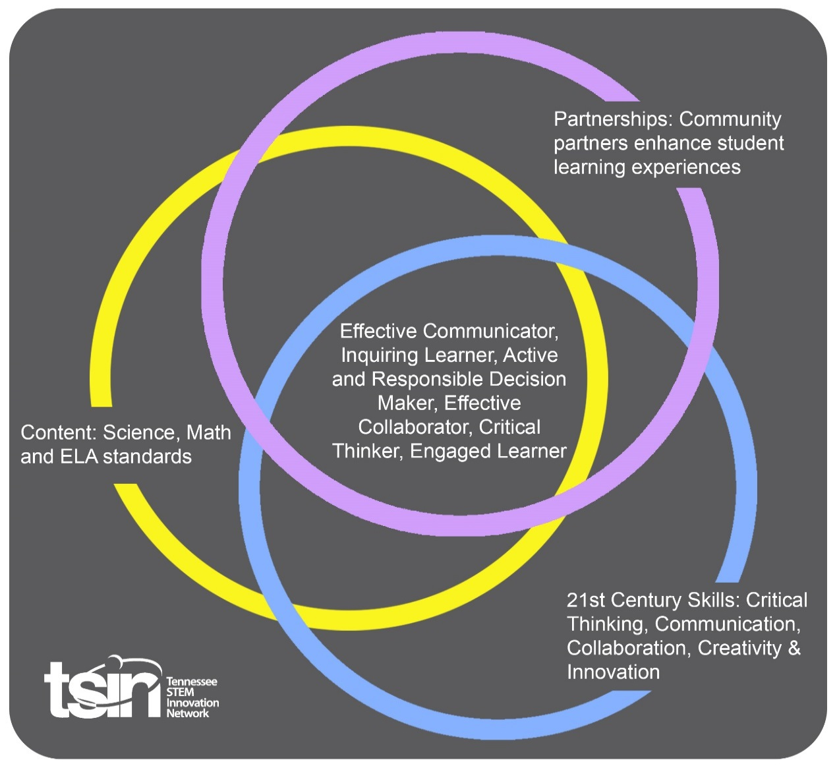

Created By: Kaitlin Asher and Lauren Cantrell | Topic: Find Your Passion, Find Your Profession – TVA and EPA |  | Grade Level or Subject: Biology and Environmental Science - High School
Science Standards:
ES 1: Investigate and analyze the use of nonrenewable energy sources (e.g., fossil fuels, nuclear, natural gas) and renewable energy sources (e.g., solar, wind, hydroelectric, geothermal) and propose solutions for their impact on the environment.

Math Standards:

ELA Standards:
ELA 9.26 : Conduct short as well as more sustained research projects to answer a question (including a self-generated question) or solve a problem; narrow or broaden the inquiry when appropriate; synthesize multiple sources on the subject, demonstrating understanding of the subject under investigation. [W.9-10.7]

Additional Standards (Social Studies, Art, Physical Education):
L11.7: Explain strengths and weaknesses of the New Deal in managing problems of the Great Depression through relief, recovery, and reform programs, including the Tennessee Valley Authority (TVA), the Works Progress Administration (WPA), the Civilian Conservation Corps (CCC), and the Social Security Act.

PBL Summary: Write a few sentences describing this PBL unit.  This PBL will explain the different career options for the TVA and the EPA. Students will be able to take a deeper look into each career choice and see how they solve real life problems for the good of the community. |  | Driving/Multi-dimensional Question: Think of a relevant problem with multiple solutions that will drive student learning.  What careers are available at the TVA and the EPA and what exactly do they do?
Tennessee Academic Standards for Science Connection
Disciplinary Core Idea(s):  Human Impacts on Earth systems. | Science & Engineering Practice(s):  Asking questions and defining problems. |  | Cross Cutting Concept(s):  Systems & system models.
21st Century Skills Addressed (check all that apply):

X Creativity X Collaboration X Critical Thinking X Communication

Culminating Event: What final student learning products will show student mastery of the content area standards?

The students will select a problem from their scenarios and complete research to determine which jobs could solve these problems and how exactly they would do it.

Hook Event: Develop an introductory activity that will spark student interest and further questions.  This PBL will start with a formative assessment in the form of the snowball game. Students will answer the question: What jobs do you think people have at TVA and the EPA? The students will write down one answer on a piece of paper. They will then throw that paper across the room to a new student. The next student will write their answer down and repeat. The class will continue this activity until each student has answered three times. This will lead to an interactive discussion to lead into the lesson. | Community Partners: List potential business or industry partners that could add to the learning experience for students. Include websites or contact info.  - Environmental Protection Agency. https://www.epa.gov/students  - http://www.tvastem.com/stem-careers |  | What do you need from these partners (i.e. guest speaker, field trip, help facilitate an activity)?  - Multiple Resources  - Learn about jobs that correspond with this lesson.
Daily Activities: What activities will students complete to answer the multi-dimensional/driving question (that reinforces content from the standards)?  Activity:  - The first activity will be a formative assessment with the snowball game. The students will be required to answer one question. What jobs do you think people have at TVA and the EPA?  - The teacher will then lead an interactive discussion about the jobs available at TVA and EPA along with a PowerPoint further explaining these careers.  - This discussion will lead the students into the jigsaw activity. The students will be numbered off and each number will be associated with a specific career (2-3) students per career. The students will break into groups with other students who received that same career. The students will have 20 minutes to research their careers.  - The students will then be split into new groups. The new groups will contain one student from each career field. This group will be given an envelope of scenarios. Each scenario will present a problem. The students must determine which careers will be used to solve each problem and how exactly they would solve it.  - Once the groups have solved each scenario, they must select one to conduct a presentation on. Each group will use PowerPoint or Prezi to answer the questions for the presentation.  - Explain the problem.  - How will each career contribute to helping solve this problem?  - What is the overall solution? |  |  | Resources/Materials Needed:  Envelope of Scenarios  Computers
Technology Integration: How is technology embedded into this PBL unit?

The students will use computers in order to complete research on each career type. They will also use their computers to complete a presentation to present the findings to their different scenarios.

Capstone Presentation: How will students present what they’ve learned publicly? This can be the culminating event if that event is presenting what has been learned publicly.

For a summative assessment. The students will conduct a presentation using PowerPoint or Prezi. They are required to answer the three questions listed above during their presentation. Each student in the group is responsible for talking about how their career would help resolve the issues.

Performance Based Rubric
Standards | Developing | On-Target | Mastery
Science

Math
ELA

Social Studies

Other Content Areas

