Project Based Learning Activity
Dale Hollow National Fish Hatchery
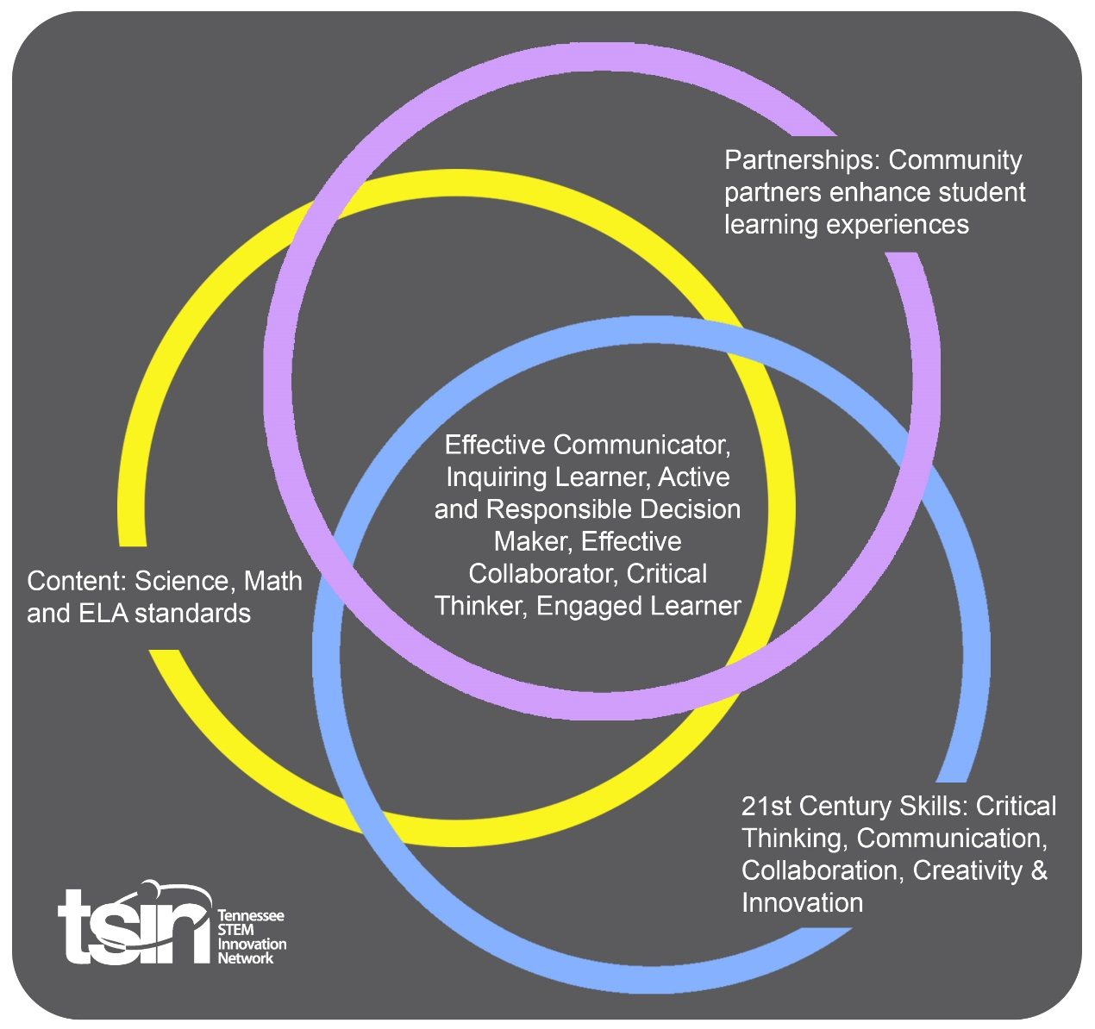

Students groups will be provided with a real problem faced by the Dale Hollow National Fish Hatchery.
Problems will relate to the conversion of energy in fish food to the development of 9” trout. Students will then present solutions to the staff of the hatchery by video. The staff of the hatchery will then visit our school and discuss solutions with the student groups.
Example Questions
- Funding for the hatchery is in question. How will your team rally support?
- The demand for trout in July is far above what was expected. How will your team react?
- A parasite has eliminated all the trout expected to be released in June? How will your team react?

PBL Summary and Culminating Event

21st Century Skills

☒ Critical Thinking ☒ Communication Skills
☒ Collaboration (Team Building) ☒ Creativity & Innovation

The Dale Hollow National Fish Hatchery must maximize the growth of rainbow trout to meet the growing demand for catchable trout by fishermen. How much feed and at what temperature should the trout be raised to meet the delivery dates provided by the TWRA?
Driving Question

Partners
Local Business or Industry Partner | How will these partners add to the learning experience? | Contact Person, Phone, and Email Address
Dale Hollow National Fish Hatchery | The Dale Hollow National Fish Hatchery provides technical assistance and real world application to the project. | Dale Hollow Hatchery
Friends of Dale Hollow National Fish Hatchery | On site management of our cold-water tanks in the Upper Cumberland area. | Paul Boyce  pawboyce@twlakes.net
Trout Unlimited | Trout in the Classroom – Program dedicated to providing resources for classroom teachers across the country. | Tennessee Trout Unlimited Link

Scaffolding Activities
Activities | Resources and Materials
The Following Activities Will Prepare Students for the Culminating Event. | List the resources (community partners, spaces, etc.) and materials (items for activities).
- Introduction to the Fish Hatchery  - Purpose  - Funding  - Careers | https://www.youtube.com/watch?v=nUhB6cldacM  - List of Hatcheries in TN Information Sheet
- Hatching Trout Eggs in a classroom tank. | http://www.troutintheclassroom.org/
- 2 Liter Bottle Ecosystems  - Nutrient Cycles  - Balance in Ecosystem | https://www.learner.org/courses/essential/life/bottlebio/  http://www2.nau.edu/lrm22/lessons/bottle_biology/
- How much food do the trout need? A complex problem using mathematics. | - Background Information Sheet  - Lesson Worksheet
*https://www.teachengineering.org/k12engineering/designprocess

- Students complete in order the activities above.
- Students are divided into teams
- Each team of students is provided with a real problem being faced in the production of 9” trout at our local hatchery.
  - Trout are to be released in December. As of October 1, they are currently 7.13”. What feeding protocol does your team recommend?
  - Trout are to be released in March. As of December 1, they are already 8.5”. What feeding protocol does your team recommend?
  - What can be done to increase the number of trout released in July?
  - Funding for the hatchery is in danger. How could your team rally support?
Multi-dimensional Question

Teams of students will create a video presentations, including Google Slides, stating their recommended solution to the problem they were given. The hatchery staff will review the videos and join us for a debrief at our school.
Work with the nearest hatchery to develop problems for your student teams or use some of the ones in this plan.

Capstone Presentation (formative or summative assessment)
Calendar Overview
Subject Areas | Early September  “Meet the Fish Hatchery” | Early September  “Hatching Trout Eggs in Our Classroom” | Late September  “2 Liter Bottle Ecosystems” | Early October  “How much food do trout need” | Early October  Student groups assigned their problem to solve.
Science
Math
ELA
Social Studies
Other
Subject Areas | Mid October  Capstone Presentations Due | Late October  Capstone Hatchery Staff on Campus for Review
Science
Math
ELA
Social Studies
Other

Performance Based Rubric
Standards | Developing | On-Target | Mastery
Science | The idea that energy is conserved and energy conversion between trophic levels is demonstrated when questioned directly. | The idea that energy is conserved and energy conversion between trophic levels is demonstrated as a team of students lead a discussion of their given problem at the hatchery. | The team of students drives home the importance of energy conservation as they use mathematics to demonstrate the conversion of food to body mass in trout.
Math | Basic math skills are used when prompted. | Students use mathematics to solve problems when given specific situations relating to our fish hatcheries. | Students determine which math skills are needed to solve issues that come up in our fish hatcheries.
ELA | Students use a variety of marginal sources as they explain their team’s problem. | Students use some good online sources as evidence but lack the types of sources used today in the fish production science in their explanation. | Students use technical writing relevant to the scientific field of fish production in their explanation.
Social Studies | Hydroelectric power is not mentioned in the explanation. | Student teams hint at the community impact of hydroelectric power production in the explanation | Students consider the deep community impact of hydroelectric power production in explanation
Other

