How Much Feed Do the Trout Need?
A Mathematics lesson

How Much Food Do the Trout Need
Introduction
The new Science standards in Tennessee take a more focused approach when it comes to Mathematics. Teachers who attended Science training in the summer of 2018 were given an example of a Math lesson that focused on sampling techniques. Students are encouraged to use Science and Engineering practices such as Mathematics to solidify content.
“How Much Food Do the Trout Need” is a lesson that uses the Science and Engineering practice of Mathematics to drive home the concept of energy transfer between trophic levels. Students will appreciate by the end of the lesson that one pound of trout food does not equal one pound of weight gained by the trout.
There are several fish hatcheries across the state. Each of those hatcheries have their own systems for growing the fish they stock. Please contact the hatchery nearest you and spend some time learning about their system. Adapt this lesson whenever possible to the situations relevant to the nearest hatchery to your school.
Math can be intimidating to every level of student. Modify whenever needed by breaking the lesson into smaller chunks. Some teachers will choose to focus only on one step of the process.
This lesson should provide students with the confidence to attack the issues to be presented in the culminating event.
This lesson is one suggestion of how to incorporate Mathematics relevant to a career available in Science near most students. Look for other scientists working in your area and have a conversation about their use of mathematics in day to day operations. Make your incorporation of mathematics relevant to your students and please share your lessons with as many people as possible.

How Much Food do the Trout Need? Part 1
How many trout need to be stocked and where?
Fish hatcheries are tasked by the Tennessee Wildlife Resources Agency with stocking our tailwaters and streams with trout. Each hatchery should have a stocking sheet that details when, where and how many trout will be stocked. This stocking sheet is used to determine how fast or slow the trout need to grow. The fish that are stocked are generally at or around nine inches in length.

This is the stocking sheet for Dale Hollow National Fish Hatchery
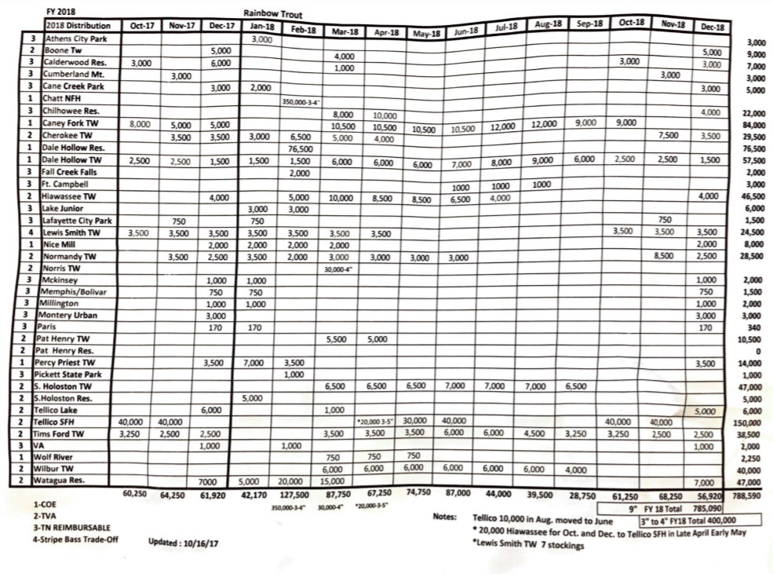
Classroom suggestions
- Ask students if they notice a pattern. What time of year are more fish stocked? Why?
- Project the stocking sheet and have a pair of students take turns racing to find information on the table.
- Ask what would happen if less or more fish are stocked at a given location.

How Much Food Do the Trout Need Part 2
- Finding the Current Length of the Trout
Hatchery managers need to know how long the trout they currently have are. A mathematical formula can let the manager know this length without actually measuring the length of thousands of fish.
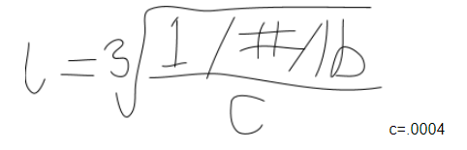

Step 1 – Find out how many trout it takes to make up 1 lb. Example = 25 fish per pound
Step 2 – replace C in the formula with .0004 every time (it is a constant)
Step 3 – Plug it in 1 divided by 25 divided by .0004 then hit the cubed root button = 4.64 in
. 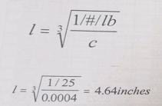
Students should then be given sample data and encouraged to find the length of the trout.
Examples = 12 fish/lb. 40 fish/lb. 60 fish/lb.
Classroom Suggestions
- Why might it be important to know the length of trout?
  - Length of fish must be known to calculate how much they need to grow before they are released at the stocking date.
- Share class time with a math teacher as this formula might be intimidating to your students.
- Secure scientific calculators or a website to use ahead of time as the cubed root function is not particularly common.
How Much Food Do the Trout Need? Part 3
How much do the trout need to grow each day/month to reach nine inches by the stocking date?
Step 1 – Find current length
Example = 6.72”
Step 2 – Subtract current length from 9 inches
Example = 9”- 6.72” = 2.28” growth needed before stocking
Step 3 – Use the stocking sheet to see what month the fish will be stocked
Example = September 1 stocking date
Step 4 – Use the Julian Calendar to determine the number of days until stocking
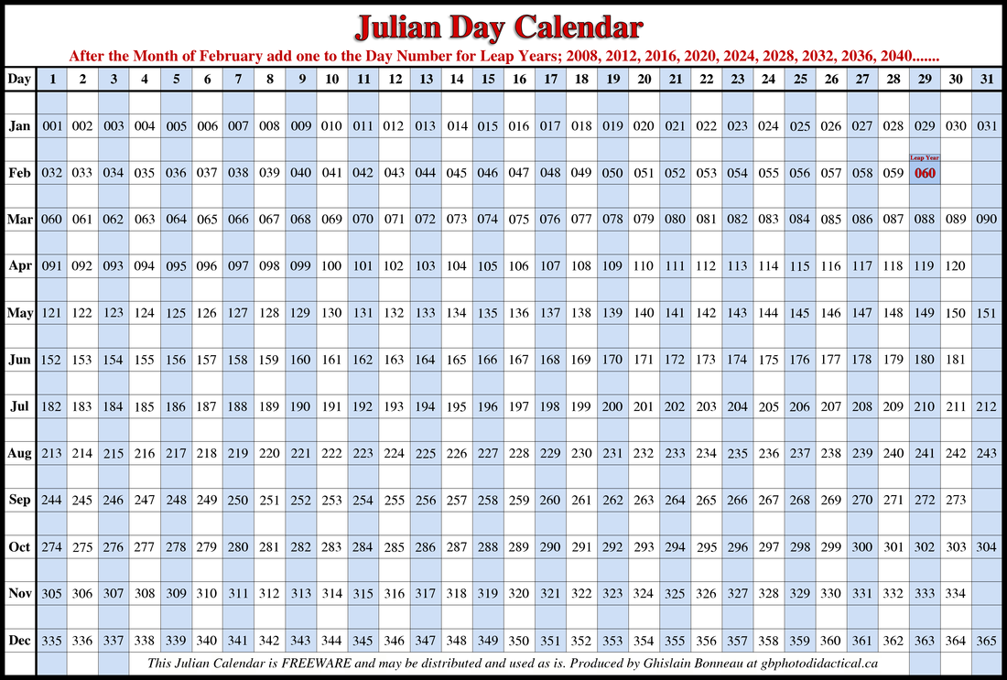

September 1 = 244 days Minus June 1 = 152 days
244 – 152 = 92 days until stocking date
Step 5 – Divide the growth needed by the number of days until stocking
Example 2.28” divided by 92 days = .024” per day
Step 6 – Multiply the daily growth by 30 days
Example .024” x 30 days = 0.72” Monthly Growth Rate

The ideal monthly growth rate is about half an inch or .55”. The fish in the example above must grow fast to meet the goal for stocking. This means the fish in the example are behind in size. When fish are forced to grow fast many problems such as stress and wasted food can occur.
Students should practice different scenarios. Give your students different stocking dates and starting lengths and let them tell you if the fish are ahead or behind schedule.

Part 4 on next page….

How Much Food Do the Trout Need Part 4
How much feed should be given to the raceway of trout for them to grow to stocking size at the right time?
Step 1 – Students need to understand that it takes on average 1.5# of feed to grow 1lb of trout
Step 2 - Figuring the % Body Weight
1.5 x 3 x Daily Change Length x 100
%Body Weight = current length

Example 1.5 x 3 x .024” x 100
%Body Weight = 6.72” = 1.60% Body Weight

Step 3 – Use hatchery data to look up the pounds in the raceway you are figuring.
** I encourage you to work with a nearby hatchery to get relevant data. **
A teacher can choose to create data to give the students and the project will work just fine.
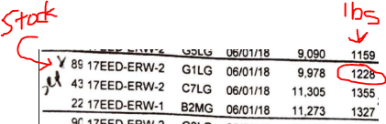
Lbs. in the raceway(%BW/100) = lbs. of food per day
Example
1228lbs. (1.60%BW/100)
1228lbs. (.016) = 19.648 or 19lbs of food per day in this raceway
Classroom Suggestions
- Do not be concerned if you cannot get current hatchery data on raceway weights. Use this number as a guide for fish that are behind schedule and adjust it to suit your scenario.
- Students who do not consider themselves “good” at math will be encouraged as they work through a meaningful real world math problem.

