My Aquatic Animal
Project/Problem Based Learning
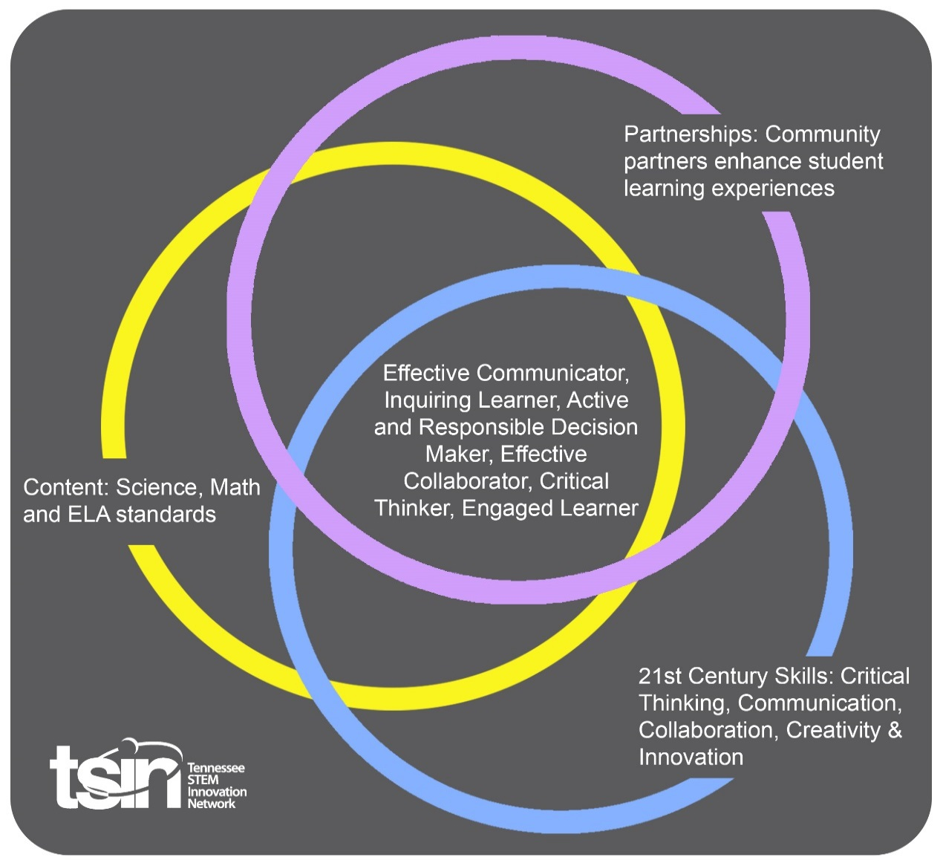

Created By:  Sally Rodgers | Topic: My Aquatic Animal - Water flow, temperature and dissolved oxygen |  | Grade Level or Subject: Physical Science/ Chemistry
Science Standards: Next Generation Standard
HS-PS1-5. Apply scientific principles and evidence to provide an explanation about the effects of changing the temperature or concentration of the reacting particles on the rate at which a reaction occurs.
Math Standards: Tennessee Standard
A. Make inferences and justify conclusions from sample surveys, experiments, and observational studies.

ELA Standards: Tennessee Standard
11-12.SL.CC.2 Integrate multiple sources of information presented in diverse media formats in order to make informed decisions and solve problems; evaluate the credibility and accuracy of each source and note any discrepancies among the data.

Additional Standards (Social Studies, Art, Physical Education):

PBL Summary: Write a few sentences describing this PBL unit.  Students will collect data and research the life sustaining requirements for respiration and digestive reactions of aquatic life. Students will be supported in collection of data by several organizations. Students will present the findings in written and presentation formats. |  | Driving/Multi-dimensional Question: Think of a relevant problem with multiple solutions that will drive student learning.  Given a specified stream or aquatic environment will aquatic animals survive, maintain, or thrive?
Tennessee Academic Standards for Science Connection
Disciplinary Core Idea(s):  Physical Science; Chemistry | Science & Engineering Practice(s):  Conducting Investigations  Analyzing and Interpreting Data |  | Cross Cutting Concept(s):  Stability and Change
21st Century Skills Addressed (check all that apply):

X Creativity X Collaboration X Critical Thinking X Communication

Culminating Event: What final student learning products will show student mastery of the content area standards?

Students will present the data findings as applied to the suitability and sustainability of three aquatic animals for a specified aquatic system. The data and defense will be presented through a google slide and in a research paper.

Hook Event: Develop an introductory activity that will spark student interest and further questions.  In groups of 4 students will visit the specified area (field trip/ virtual field trip). With the help of a local environment and conservation office, present students with options of aquatic animals so they can pick their favorite. | Community Partners: List potential business or industry partners that could add to the learning experience for students. Include websites or contact info.  - Tennessee Department of Environment & Conservation TDEC  - TVA- water quality support- Lana Bean  - U.S. Army Corps of Engineers  - TTU – Exercise Science Christy Killman  - TTU – Director of Water Center Jeff Schaeffer  TTU –Tania Datta Associate Professor Department of Civil and Environmental Engineering Center for the Management, Utilization & Protection of Water Resources  - TTU – Lending Library equipment |  | What do you need from these partners (i.e. guest speaker, field trip, help facilitate an activity)?  - TDEC stream study and samples of aquatic animals  - TVA recorded data and information on aquatic animals  - Permission to use the land and canoes  - Safety in canoes and volunteers to ensure safety and Vernier Sensor loan through the TTU Lending Library at the STEM center
Daily Activities: What activities will students complete to answer the multi-dimensional/driving question (that reinforces content from the standards)?  Activity:  - Introduction into respiration and digestion reactions of aquatic animals.  - Visit the chosen aquatic habitat site with TDEC. Students will choose three aquatic animals and research the water temperature, flow rate and dissolved oxygen needed for this animal not only to survive but thrive.  - Use Vernier dissolved oxygen sensors, flow sensors and thermometers to record data in the chosen area. TTU’s exercise science instructor and team will teach kayak /canoe safety and monitor for safety while students are in the water. TTU’s Director of the Water Center will teach students how to properly take data.  - Students will analyze the collected data. The data will be used in determining if the aquatic animals will survive based on the nutritional needs of the reactions.  - Students will write a report citing evidence comparing the data collected to sources from TVA, U.S. Army Corps of Engineers, and TTU water Center. |  |  | Resources/Materials Needed:  Vernier sensors:  - Dissolved Oxygen sensor  - Water flow rate sensor  Thermometers  Computers for data recording and Google slides presentation  Google docs
Technology Integration: How is technology embedded into this PBL unit?

Students will use Vernier probes for water flow rate and dissolved oxygen. Students will use Google to collect and share data. Students will also write a paper of the findings and build a presentation on Google.

Capstone Presentation: How will students present what they’ve learned publicly? This can be the culminating event if that event is presenting what has been learned publicly.

Students will present the findings to their peers. The organizations, university and agencies who assisted the students will be invited to attend.

Performance Based Rubric
Standards | Developing | On-Target | Mastery
Science

Math
ELA

Social Studies

Other Content Areas

