Protecting Our Bats
Project/Problem Based Learning Lesson

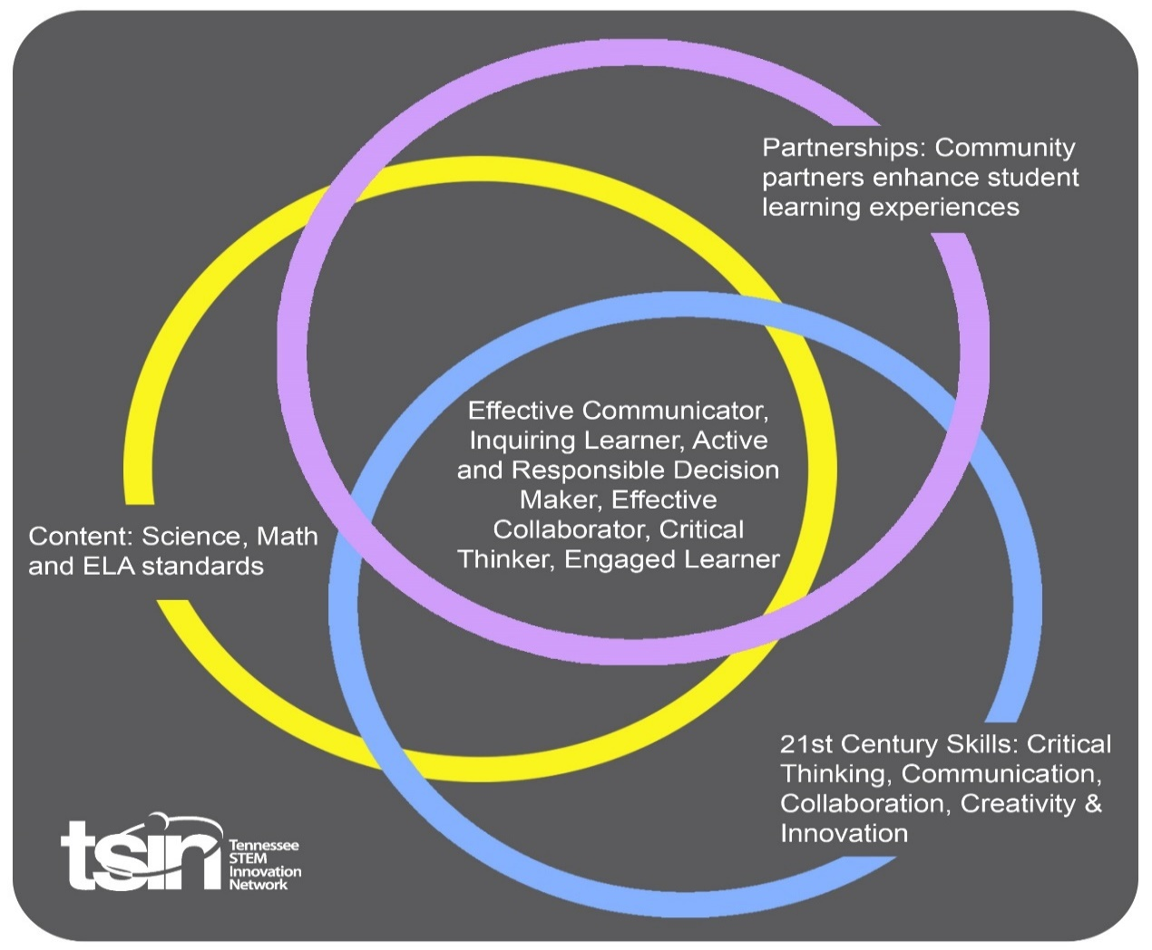

Created By: Allison Ledford | Topic: Bats |  | Grade Level or Subject: 2nd grade
Science Standards:
2.LS2: Ecosystems: Interactions, Energy, and Dynamics
2) Predict what happens to animals when the environment changes (temperature, cutting down trees, wildfires, pollution, salinity, drought, land preservation).

Math Standards:
2.MD.D.10 Draw a pictograph and a bar graph (with intervals of one) to represent a data set with up to four categories. Solve addition and subtraction problems related to the data in a graph.
ELA Standards:
RI 2.1 Ask and answer such questions as who, what, where, when, why, and how to demonstrate understanding of key details in a text.
Writing:
2W.TTP.2 Write informative/explanatory texts to examine and convey complex ideas and information clearly and accurately through the effective selection, organization, and analysis of content.
Write informative/explanatory texts.
- Introduce a topic.
- Use facts and definitions to provide information.
- Provide a sense of closure.
PBL Summary: Write a few sentences describing this PBL unit.  In this PBL, students will assume the responsibilities of a zoologist for the TVA. As zoologists they will decide if bats are our friends or foe. Finally, they will research the impact humans have on bats. By the end of the unit students should be able to explain what humans can do to lessen their impact on bat habitats. |  | Driving/Multi-dimensional Question: Think of a relevant problem with multiple solutions that will drive student learning.  How can we as zoologists assist in removing bats from the endangered species list? What can we as humans do to help?
Tennessee Academic Standards for Science Connection
Disciplinary Core Idea(s): 2.LS2: Ecosystems: Interactions, Energy, and Dynamics | Science & Engineering Practice(s):  -Asking questions and defining problems  -Analyzing and Interpreting Data  -Engaging in Argument from Data |  | Cross Cutting Concept(s):  Patterns  Cause and Effect
21st Century Skills Addressed (check all that apply):

X Creativity X Collaboration X Critical Thinking X Communication

Culminating Event: What final student learning products will show student mastery of the content area standards?

Students will be able to write a paragraph using their research that states their opinion about bats. Students should be able to use their research to justify their opinion and support their answer.

Hook Event: Develop an introductory activity that will spark student interest and further questions.  Students will watch the video from TVA to meet a terrestrial zoologist, Liz Hamrick.  https://www.tva.gov/Our-TVA-Story/Liz-Hamrick  After students watch the video the teacher will share education requirements, average salary and job requirements of a zoologist.  https://www.salary.com/research/salary/benchmark/zoologist-salary  Finally, the teacher will announce to students that this week they will become Zoologists. They will assume some of the responsibilities of a real zoologist including researching bats. | Community Partners: List potential business or industry partners that could add to the learning experience for students.  - TVA Employee, Elizabeth Hamrick or other zoologist  - TWRA Wildlife Specialist  - Cumberland Caverns or other local cave  - Lowe’s or another local business | What do you need from these partners (i.e. guest speaker, field trip, help facilitate an activity)?  - Guest speaker, video of job, exposure to career  - Watch video for guest speaker  https://www.youtube.com/watch?v=11JAqV7FhIQ  3. Field trip  4. Help students build bat boxes

Daily Activities: What activities will students complete to answer the multi-dimensional/driving question (that reinforces content from the standards)?  Students will work in small groups or partner groups daily to answer the guiding questions in their Zoologist scientific notebook. The teacher will gather the approved website or book in advance, to help students with research. Each day they will take note of observations and findings. They should be able to explain what they found at the end of each class period. Groups can be levelled so that teacher can assist specific groups in research.  It is also important that the teacher have a reflection or closure at the end of each day’s research to ensure students have gathered the appropriate material to be able to justify their reasoning for their capstone presentation.  Activity:  - Are bats our friends or foe?  Sometime during the day before you begin your lesson you will want students to take a poll about their opinion of bats. You could create a T chart that said something like “helpful or harmful” or do you like bats yes or no?  Once students have finished their T chart, students can document this data into bar graphs and pictographs. You will poll students again at the end of the unit. Students will be able to analyze if and how their data has changed.  Higher groups will be able to answer this in complete sentences after research. Lower groups can answer in a graphic organizer “Bats have, Bats can, Bats are…”  Concluding this lesson, you could include this Educational Ted talk about whether bats are friends or foe.  https://ed.ted.com/lessons/i-m-batman-amy-wray#review  - What is white nose syndrome? How is white nose syndrome affecting bats?  The teacher will provide the website www.whitenosesyndrome.org for students to research white nose syndrome.  A great way to introduce this topic would be to simulate contamination. There are so many great contamination simulation activities including black light “germs,” so students will be able to understand how easily contamination occurs and what they can do to help prevent spread.  At the conclusion of the lesson the teacher can visit www.whitenosesyndrome.org/spreadmap to show students interactively how quickly this spread has occurred.  - Final research day: How are humans impacting bats? What can humans do to help?  https://www.whitenosesyndrome.org/static-page/how-you-can-help  https://defenders.org/blog/2016/10/go-batty  There are many things that humans do to impact bats. After research students should be able to identify how white-nose syndrome affects bats and how humans, without knowing it, are helping to spread white-nose syndrome. Some other things humans can do to minimize impact on bats include limiting the use of pesticides, protecting natural water sources such as streams or wetlands, and providing bats with a safe habitat. At the end of this PBL teachers will have an optional extension to help students provide bats with a safe habitat.  - Reflect, write, edit, work on presentations. Today is the chance to reflect on all of the guiding questions, help put student thinking into graphic organizers and begin to develop opinion statements. The teacher can model what an exemplary writing piece should look like, and how to take research and plug it into writing. Work can be differentiated, and the teacher can work with small groups who need more guidance. Next, students should have an opportunity to peer edit. Finally, students can begin preparing their final presentation whether they choose a Screencastify or poster presentation.  - Capstone presentation. Show students how to present a poster, or how to act if their video is being presented. Remind them of positive manners to show when speaking and listening. If you would like to invite another class, or another grade to hear select presentations that would be an interesting way to educate others. Alternatively, you could invite any guest speakers on this day so the adults can hear the information students have gathered and what students suggest they can do going forward.  Once students have finished presenting and hearing others present, they can take the same poll they took originally. Students will have an opportunity to make a new pictograph and bar graph and be able to analyze before and after data. Ideally, if students felt negatively about bats at the beginning of the unit, after their research and presentations, their opinion might become more positive of bats and they will be able to identify that trend in the data.  - Optional extension: Students use the engineering design steps to build a bat box. (This would be a great opportunity to get Lowe’s or any local business involved by donating or precutting wood. If they wanted to come in and help students build the box that would be excellent.) Students should not only learn to build a habitat, but also need to know where to place it. Some things to keep in mind would be sun exposure, where or how to mount, and near what vegetation or natural source of water the habitat would be placed. It might even be a unique experience to place one near the school with your Principal’s permission, if your school is in a rural or wooded area. | Resources/Materials Needed:  Empty bar graph  Empty pictograph  Small journal or notebook for Zoologist notes (see attached for a free printable)  Technology  Bats by Gail Gibbons  Caves and Caverns by Gail Gibbons  Additional resources:  Liz Hamrick STEM Hero poster- this could be displayed in the classroom for the unit, and in the hallway with finished work when the unit has been completed  https://www.facebook.com/TVA/photos/a.390527717690/10156123172302691/?type=3&theater  Spring Migration of the Indiana Bat video:  https://www.youtube.com/watch?v=wD9Cs7vRWbQ&t=30s  Other fiction literature studies that could be done during this time:  Stellaluna by Janell Cannon  Nightsong by Ari Berk
Technology Integration: How is technology embedded into this PBL unit?

Students will use technology for their research including websites like kiddle.co, Screencastify, and other links provided in the PBL.

Capstone Presentation: How will students present what they’ve learned publicly? This can be the culminating event if that event is presenting what has been learned publicly.

Students will gather data in their scientific notebook throughout the week. At the end of the week they will be asked to write persuasively about bats. Students should be able to use their research to justify their opinion. Finally, students can choose to present this video via Screencastify video, or poster presentation.

Performance Based Rubric
Standards | Developing | On-Target | Mastery
Science  Predict what happens to animals when the environment changes (temperature, cutting down trees, wildfires, pollution, salinity, drought, land preservation). | With help, students will be able to explain what has happened to bats through their environment changing. | After research, with prompting, students will be able to explain what has happened to bats through their environment changing. | After research, students will be able to independently explain what has happened to bats through their environment changing.
Math:  2.MD.D.10 Draw a pictograph and a bar graph (with intervals of one) to represent a data set with up to four categories. Solve addition and subtraction problems related to the data in a graph | Students will be able to draw a pictograph and a bar graph with intervals of one to represent a data set with up to four categories, with little assistance. Students will solve addition and subtraction problems related to the data with 80% or below accuracy. | Students will be able to draw a pictograph and a bar graph with intervals of one to represent a data set with up to four categories, with little assistance. Students will solve addition and subtraction problems related to the data with 80% or higher accuracy. | Students will be able to independently draw a pictograph and a bar graph with intervals of one to represent a data set with up to four categories. Students will solve addition and subtraction problems related to the data with 90% or higher accuracy.
ELA  Ask and answer such questions as who, what, where, when, why, and how to demonstrate understanding of key details in a text. | The teacher will segment the text into smaller pieces and guide students through questions in order to find appropriate answers to each day’s research question. The teacher could also record herself reading the article in advance. | Students will be able to research with limited help or assistance from the teacher. | Students will be able to do research independently with little help or assistance and pull reasonable answers for each day of research.
Writing:

See state level wholistic writing rubric

