**The Energy Behind Roller Coasters**

**A Project/Problem Based Learning Lesson**

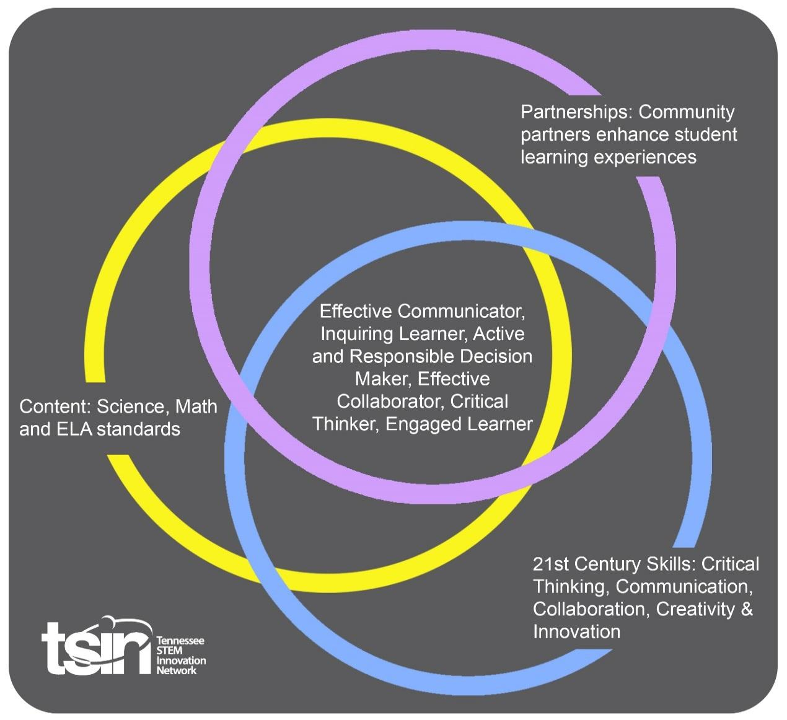

|  |  |  |  |
| --- | --- | --- | --- |
| **Created By: Teresa Celusta** | **Topic: The Energy Behind Roller Coasters** | | **Grade Level or Subject: Physics** |
| **Science Standards:**  **NGSS:**  **HS-PS3-3. Design, build, and refine a device that works within given constraints to convert one form of energy into another form of energy.**  **HS-PS3-1. Create a computational model to calculate the change in the energy of one component in a system when the change in energy of the other component(s) and energy flows in and out of the system are known.**  PHYS.PS2.1 Investigate and evaluate the graphical and mathematical relationship (using either manual graphing or computers) of one-dimensional kinematic parameters (distance, displacement, speed, velocity, acceleration) with respect to an object's position, direction of motion, and time.  PHYS.PS2.2 Algebraically solve problems involving constant velocity and constant acceleration in one-dimension.  PHYS.PS3.3 Use the principle of energy conservation and mathematical representations to quantify the change in energy of one component of a system when the energy that flows in and out of the system and the change in energy of the other components is known.  PHYS.PS3.1 Identify and calculate different types of energy and their transformations (thermal, kinetic, potential, including magnetic and electrical potential energies) from one form to another in a system. | | | |
| **Math Standards:**  MP.2 Reason abstractly and quantitatively. (HS -PS3-1),(HS-PS3-2),(HS-PS3-3),(HS-PS3-4),(HS-PS3-5)  MP.4 Model with mathematics. (HS -PS3-1),(HS-PS3-2),(HS-PS3-3),(HS-PS3-4),(HS-PS3-5)  HSN-Q.A .1 Use units as a way to understand problems and to guide the solution of multi-step problems; choose and interpret units consistently in formulas; choose and interpret the scale and the origin in graphs and data display s. (HS-PS3-1),(HS-PS3-3)  HSN-Q.A .2 Define appropriate quantities for the purpose of descriptive modeling. (HS-PS3-1),(HS-PS3-3) | | | |
| **ELA Standards:**  WHST .9-12.7 Conduct short as well as more sustained research projects to answer a question (including a self-generated question) or solve a problem; narrow or broaden the inquiry when appropriate; synthesize multiple sources on the subject, demonstrating an understanding of the subject under investigation. (HS-PS3-3),(HSPS3-4),(HS-PS3-5) | | | |
| **Additional Standards (Social Studies, Art, Physical Education):**  EVSC.ETS2 Links among engineering, technology, science and society. | | | |
| **PBL Summary:** Write a few sentences describing this PBL unit.  The concept of energy transfer in and out of systems can be predicted qualitatively and quantitatively. Students should be able to understand the conservation of energy, how energy is stored and transferred, the relationship between forces and how they are related to energy and how it is used in the making of rollercoasters. This lesson incorporates evaluations of energy transfers and conservation using online simulations. Then students will use what they have learned to build and test a prototype. Students will conduct investigations and analyze data to evaluate their model and compare it to those of their peers. | | **Driving/Multi-dimensional Question:** Think of a relevant problem with multiple solutions that will drive student learning.  How do roller coasters work, and how are forces and energy transfer involved?  Students will explore the science of roller coasters. How is the law of conservation of energy used for enjoyment in theme parks, while keeping the thrill seekers safe? | |
| **Tennessee Academic Standards for Science Connection** | | | |
| Disciplinary Core Idea(s):   * Definitions of energy * Conservation of energy and energy transfer * Relationship between energy and forces | Science & Engineering Practice(s):   * Developing and using models. * Planning and Carrying out Controlled Investigations * Analyzing and interpreting data. * Obtaining, evaluating, and communicating information. | | Cross Cutting Concept(s):   * Cause and effect * Systems and system models * Energy and Matter |
| **21st Century Skills Addressed (check all that apply):**   Creativity  Collaboration  Critical Thinking  Communication | | | |
| **Culminating Event:** What final student learning products will show student mastery of the content area standards?  Students will design, build and test a roller coaster design of their choosing, factoring in safety of the riders (marbles, steel ball bearings, plastic balls). Students will decide the parameters to be tested through class consensus before testing begins. Students will test their own design and one other group’s from the class. Class data will be recorded and analyzed. Each group will design a multimedia presentation to share with the class, to include a brief discussion of a roller coaster engineering career. | | | |
| **Hook Event:** Develop an introductory activity that will spark student interest and further questions.  Roller Coaster Ride - Watch the video of Dollywood’s Wild Eagle Ride:  <https://youtu.be/MWG8l9qj3Qo>  Beginning Questions:   * What factors make a roller coaster ride so exciting? * Where does the energy for making the roller coaster “go” come from? | **Community Partners:** List potential business or industry partners that could add to the learning experience for students. Include websites or contact info.  1.Dollywood Theme Park  2700 Dollywood Parks Blvd.  Pigeon Forge, TN 37863  1-800-365-5996  2.Tennessee Valley Authority  400 West Summit Hill Drive  Knoxville, TN 37902  865-632-2101  [tvainfo@tva.com](mailto:tvainfo@tva.com) | | What do you need from these partners (i.e. guest speakers, field trips, help facilitate an activity)?  1. Field trip or roller coaster engineer guest speaker  2. Guest speaker on energy and how it is changed in form and conserved. |
| **Daily Activities:** What activities will students complete to answer the multi-dimensional/driving question (that reinforces content from the standards)?  **Activity:**   1. Roller Coaster Ride  * Watch the video of Dollywood’s Wild Eagle Ride:   <https://youtu.be/MWG8l9qj3Qo>   * Using prior knowledge of kinematics, students will use the Dollywood Wild Eagle Fact Sheet to answer student questions. The answers will be reviewed as a class.   <https://www.dollywood.com/Groups/Education/Resources>   * Science in the park workbook (p. 12-14). * Extra review problems if needed (can be homework):   <https://www.real-world-physics-problems.com/roller-coaster-physics.html>   * Use the TVA- Exploring Energy for a station investigation using slides:5-10 & 12.   <https://www.tvastem.com/pbl/alternative-energy/>  (scroll to the bottom for Energy Stations power- point)   * Nearpod PhET lab   <https://share.nearpod.com/NkapjQ2wFY>  -Students will use the PhET simulation to explore the relationship between Kinetic and Potential energy for a skate park, create energy diagrams, and study how energy relates to a carnival slide.   * Review Newton’s Laws of Motion by viewing and discussing the Emaze:   <https://www.emaze.com/@ALOFZOZL>   * Review the forces and laws of energy in a roller coaster ride   <https://edpuzzle.com/media/5ce53a0e7ac7064106ac33cf>   * Students investigate energy in a roller coaster ride with the PBS website:<https://tn.pbslearningmedia.org/resource/hew06.sci.phys.maf.rollercoaster/energy-in-a-roller-coaster-ride/> * Design a virtual roller coaster and complete a safety inspections follow-up:   <https://www.learner.org/interactives/parkphysics/coaster/>   1. A Tale of Friction Lesson:   <https://www.teachengineering.org/lessons/view/ind-1996-friction-force-along-curved-path-ap-calculus>   * Use the power point presentation: [ind-1996-friction-force-presentation.pptx](http://ind-1996-friction-force-presentation.pptx) * Reviews: * <https://www.sophia.org/playlists/rotational-dynamics-ii-angular-velocity-inertia-an> * <https://www.sophia.org/search?utf8=%E2%9C%93&q=rotational+motion+I&qs=1>   4. Design a roller coaster:  <https://www.teachengineering.org/activities/view/ind-1996-frictional-roller-coaster-design-project-calculus>   * If you do not teach a calculus based course, scroll down the lesson to:   Activity Scaling- Rolling with friction calculations (no calculus example)  Students will work in groups of 3-4 to complete the following tasks:  ~ Students submit plan of roller coaster design  ~ Students design and test prototypes, gathering data  ~ Students test each others designs gathering data (sharing data with the class)  ~Students analyze the data and decide which is the best design to give the biggest thrill, while considering the safety of the riders (marbles).  ~Students research Roller Coaster Engineering Jobs  ~Students presentations | | | Basic background teacher resource:  <https://extension.tennessee.edu/publications/Documents/W420.pdf>  Computer and projector  Dollywood Wild Eagle fact sheet and student questions for student copies.  Printout of selected slides for stations with the following materials:  ~ dropper poppers  ~ shake light flashlight  ~ steel spheres  ~ spring toy (rollback car)  ~ two different sized bouncing balls  ~ wind up toy      computers and Nearpod   * if Nearpod is not available you may go straight to the PhET website and create a free teacher account to access the teacher resources:  * <https://phet.colorado.edu/en/simulation/energy-skate-park>               computer and projector          Edpuzzle.com  Copy of Roller Coaster Physics  [Jennifer Roberts, with embedded questions.](https://edpuzzle.com/channel/5672b46f8323e0da7ea6eb44)    student computers and PBS website    student computers and learner.org website                    teacher computer and projector            practice problems              Students should be given a list of materials you will provide prior to their planning and design day. If allowing them to bring materials from home, have them bring a list for approval before being brought in. |
|  | | | |
| **Capstone Presentation:** How will students present what they’ve learned publicly? This can be the culminating event if that event is presenting what has been learned publicly.  Student teams will develop a presentation of how a roller coaster involves many principles of physics, with special attention being given to the flow and conservation of energy. Students will use class data and pictures of the models to make an argument supported with evidence on the best model roller coaster design. Students should include what they learned about the job of roller coaster engineering. | | | |

**Performance Based Rubric**

**Marble Roller Coaster Project Criteria**

**Calculations (MUST SHOW WORK WITH UNITS)**

* **Height of initial drop, height of hill, height of loop, total length of track, mass of marble**
* **Calculate the Potential Energy at a specific point (must specify at which point).**
* **Calculate the Kinetic Energy at a specific point (must specify at which point).**
* **Calculate the Velocity (speed) of the marble over a set distance (must specify over which distance).**
* **Calculate the Acceleration of the marble over a set distance (must specify over which distance).**
* **Describe the marble’s journey from start to finish using the following terms (underline the terms in your description): *kinetic energy, potential energy, velocity, acceleration, friction, inertia, momentum, gravity, mass***

**Roller Coaster/Schematic**

* **Have a schematic of your roller coaster (an illustration with measurements will be sufficient; should be precise).**
* **Color Code and Label the following areas on your illustration:** 
  + **Most PE.**
  + **Most KE.**
  + **Where PE is converted to KE.**
  + **Where KE is converted to PE.**

**Test Run**

* **Test your roller coaster to verify that the marble will travel entire track (you are allowed 3 tries for a successful run).**

|  |  |  |  |
| --- | --- | --- | --- |
| **Standards** | **Developing** | **On-Target** | **Mastery** |
| Science  Schematic  Test Run | No drawing provided.    Drawing not to scale or labeled.    On lined paper or too small.  All three trials are unsuccessful. | Drawing provided.    Drawing is close to scale and contains some labels.    On 8 x 12 copy paper.  Successful test run with modifications. | Drawing is detailed and labeled.  Drawing is to scale and colored.    On 8 x 12 copy paper.  Successful test run without modifications. |
| Math  Calculations | No specifications or calculations provided.    Does not include all necessary components.    Not accurate or organized. | Contains some specifications and/or calculations.    Includes some necessary components.    Accurate, however not organized. | All specifications and/or calculations provided.    Includes all necessary components.    Accurate and organized. |
| ELA | Little to no physics terminology was used in the multimedia presentation.  No summary of a roller coaster engineering career was included in the presentation. | Some physics terminology was used in the multimedia presentation.  A very basic summary of a roller coaster engineering career was included in the presentation. | Technical physics terminology was used in the multimedia presentation.  A thorough summary of a roller coaster engineering career was included in the presentation. |